
Understand and respond to child sexual and criminal exploitation
Practice guide
OFFICIAL

Contact us to receive this document in another format. Please email Office of Professional Practice Directorate: OPPDirectorate@dffh.vic.gov.au.
Authorised and published by the Victorian Government, 1 Treasury Place, Melbourne.
© State of Victoria, Australia, Department of Families, Fairness and Housing, April 2026.
In this document, we may use the terms ‘First Peoples’, ‘First Nations’ or ‘Aboriginal people’. This includes all Aboriginal and Torres Strait Islander peoples living in Victoria. We retain ‘Indigenous’ or ‘Koori/Koorie’ when part of a title, program or quote.
ISBN 978-1-76171-064-3 (pdf/online/MS word)
Available at CP Manual’s Child sexual exploitation practice guide for Child Protection web page <https://www.cpmanual.vic.gov.au/advice-and-protocols/specialist-resources/child-sexual-exploitation/child-sexual-exploitation>
(2510462)

Foreword
Child sexual exploitation (CSE) and child criminal exploitation (CCE) are among the most complex and harmful forms of abuse we encounter. They are often hidden, misunderstood, and enabled by power imbalances that silence children and obscure accountability. We must challenge persistent myths that children choose exploitation, that compliance equals consent, or that harm is always visible. Exploitation is abuse. It is never the child’s fault.
Children and young people known to Child Protection are disproportionately vulnerable to sexual and criminal exploitation. These forms of abuse are characterised by the misuse of power, coercion, control and dependency, and often occur in ways that are hidden from immediate view. Considering these forms of exploitation together enables us to better understand patterns of harm, avoid fragmented responses, and ensure that children are recognised as victims even when they appear to be involved in offending.
Online spaces, social media and emerging technologies have expanded the reach and methods of those who seek to harm children. As the contexts of exploitation evolve, our practice must be more adaptive, informed, and innovative. This includes strengthening intelligence-led approaches, enhancing cross-agency collaboration, and investing in prevention as much as response.
We have a responsibility to act on what we see, to remain curious and persistent, and to respond with care. Every child has the right to grow up safe, valued and free from harm. With the right knowledge, collaboration and care, we can intervene earlier, disrupt harm, and support children toward safety and healing.
This practice guide aims to equip practitioners with a shared understanding of indicators of risk, strengthen professional judgement, and support consistent, and effective responses. It is built on evidence, practice wisdom, and the understanding that a coordinated approach that places the child at the centre is the most effective.
Together, our actions can make a profound difference.
Office of Professional Practice

Contents
Foreword 3
Acknowledgements 5
Key terms 6
Chapter 1: Foundations of child exploitation 7
What is child exploitation? 7
Dynamics of exploitation 8
Exploitation-informed practice considerations 12
Chapter 2: Exploitation prevention 18
Understanding prevention 18
Facilitating prevention 19
Connection as prevention 20
Chapter 3: Exploitation detection 22
Identify warning signs 22
SAFER children framework 23
Identify vulnerability and likelihood of child exploitation 25
The child’s voice: connection and understanding 29
Engaging caregivers 31
Multi-agency collaboration builds safety 32
Chapter 4: Responding to exploitation 34
Create a care response 34
Draw on the child’s lived experience 37
SAFER case plans through connection planning 38
Responding to child disclosures 40
Chapter 5: Disrupting child exploitation 44
Disrupting 3 points of interaction 44
Statutory multi-agency collaboration and oversight 45
CSE template (CSET) 48
Statutory options to disrupt the POI 48
SAFER: Continuously review and adapt 51
Specialist services and practitioners 51
Appendix 1: Image descriptions 54
References 59

Acknowledgements
The Department of Families, Fairness and Housing acknowledges Victoria’s Aboriginal communities and pays respect to Elders past, present and emerging. We acknowledge Aboriginal people as Australia’s First Peoples and as the Traditional Owners and custodians of the land and waters on which we live and work.
We recognise and value the intergenerational consequences of colonisation, dispossession, child removal and other discriminatory government policies and acknowledge that the impacts and structures of colonisation still exist today.
The department is committed to addressing these impacts by embedding cultural safety and self-determination in all that we do so that Aboriginal Victorians have decision-making power and control to determine what is best for them.

Key terms
The following terms are used throughout this guide.
Term | Meaning
Caregiver | A parent, foster or kin carer or residential care worker
Child | A child or young person aged under 18 years
Person of interest (POI) | A person known or suspected to be sexually or criminally exploiting a child. They may be:  - directly exploiting (perpetrator)  - facilitating (such as recruiting peers)  - enabling exploitation (such as providing location).  In some instances, POIs can be influencing others to exploit children within a criminal network.  Suspicions of POI involvement can be at various stages of substantiation, so POI is the most suitable term.
SAFER children framework | Risk assessment approach for Victorian child protection practitioners. The 5 SAFER children practice activities:  - Seek  - Analyse  - Formulate  - Enact  - Review.

Chapter 1: Foundations of child exploitation

What is child exploitation?
Child sexual and criminal exploitation are deeply harmful forms of abuse that can cause profound impacts on a child’s life into adulthood. Exploiting a child sexually or criminally is against the law in Victoria.
There are no consistent national or international definitions of child sexual exploitation and child criminal exploitation. The following definitions provide a shared understanding of these concepts so that we can prevent harm, detect and respond to these effectively.

Child sexual exploitation
A pattern of behaviours or events where an adult or person of interest (POI) uses tactics of coercion or control to induce a child or young person into sexual (physical or non-physical) activities by giving them something of perceived value to the child.

Child criminal exploitation
A pattern of behaviours or events where an adult or POI uses tactics of coercion or control to induce a child or young person in criminal activity by giving them something of perceived value to the child.
The nature of criminal exploitation places the child or young person in the role of ‘offender’ though they are victims.

The intersections of child sexual and criminal exploitation
Although child sexual exploitation and child criminal exploitation are distinct forms of harm, they both share common characteristics. See Figure 1.
Some children may be subjected to both criminal and sexual exploitation.
Figure 1: Child sexual and criminal exploitation
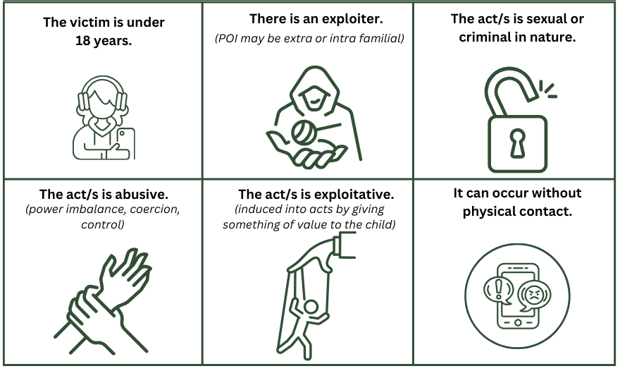

People who exploit children
People who exploit children sexually or criminally are generally adults. They may or may not be related to the child.
What they have in common is their ability and willingness to exert undue influence and abuse their authority over a child for their own gain (such as sexual, financial, commercial).
They use grooming to manipulate the child into believing they are complicit or solely responsible for the behaviour, which helps them to maintain compliance and reduce the chances of disclosure by the child.
In some instances, exploiters may be peers. A response in this instance will require careful assessment of the dynamics of the relationship.
Sometimes a child is exploited and induced to introduce other children to the exploiter. In these circumstances we do not refer to a child as a ‘recruiter’ or POI. Rather they are co-victims of exploitation.

Dynamics of exploitation
POIs use a variety of common strategies to exploit children.

Exploitation strategies are carried out across a continuum
The ‘exploitation continuum’ is an evidence-based model for understanding the strategies used by exploiters. Its 3 parts are set out in Table 1.

Table 1: The 3 parts of the exploitation continuum
Recruitment context | Entrapment methods | Enmeshment
3 necessary elements to exploit children:  - Exploiter or recruiter. A recruiter may be a separate person who introduces the child to the exploiter.  - Access to a child (often targeted).  - Location that gives opportunity to exploit (online and in person). | 2 primary methods of entrapment:  - Exploiter targets the child’s unmet needs for love, belonging and connection (relational methods).  - Exploiter uses control, threats and violence to create a sense of fear (punitive methods).  For more on grooming, see Grooming tactics are used by the exploiter to recruit, entrap and enmesh. | Exploiter uses entrapment and coercive control to create barriers for the child to escape.  They may use comments like ‘You are my soulmate’ or ‘Only I understand you.’

Grooming tactics are used by the exploiter to recruit, entrap and enmesh
Grooming refers to behaviours used to recruit, entrap, enmesh and abuse a child by developing trust and using fear to distort the child’s:
- worldview
- sense of who they can trust
- perception of consent
- sense of ‘normal’.
Grooming commonly starts with acceptable and often intentionally enjoyable interactions and shifts into abusive and inescapable interactions over days, weeks, months or years.
Practice tip
Any change of a child’s behaviour could indicate that they are being groomed by a POI. Remember that their behaviour change may appear positive in the initial stages of the grooming process. It is common for POIs to begin grooming by making all engagements enjoyable to promote ongoing contact with the child and set a foundation for their grooming to continue.
Table 2 has a practice-oriented synthesis of common grooming strategies.
For more information on grooming, refer to the Talking about grooming practitioner toolkit:
- see the CP Learning Hub's Child exploitation SharePoint page.
Table 2: Common grooming tactics
Tactic | Description
Targeting | Targeting children who are vulnerable due to:  - marginalisation  - disability  - having been subjected to other forms of harm
Manipulating | Manipulating the child’s unmet needs or appealing to them using:  - fun  - flattery  - gifts  - attention  - confusion  - sympathy  - promises
Eroding | Eroding the child’s trust in family, friends and professionals and others’ trust in the child
Posing | Posing or making the child believe they have a ‘special’ relationship, such as boyfriend, friend or chosen family
Exposing | Exposing the child to:  - sexualised talk  - touching  - pornography  - talking about or idealising crime culture and so on
Fear | Using coercion and control, including:  - threats  - degradation  - violence  - intimidation

Children are most vulnerable to being targeted when away from protective adults
Children may be pushed or pulled from their caregivers, which may cause them to ‘go missing’ or be absent from their home.
Luring the child can form part of the exploitation strategy. Sometimes children are ‘pushed’ from their home (such as feeling bored, unsafe, disconnected) and end up in situations where they are more likely to be targeted for exploitation.
We have an essential role to protect the child from being pushed and pulled. This is explored further in Noticing and responding to the push and pull factors.

Alcohol and other drug use and supply are used to exploit children
The use and supply of alcohol and other drugs (AOD) is a common tactic for both forms of child exploitation.
There are 5 intersecting ways that AOD may relate to exploitation:
- Targeting: The child may use AODs to cope with their pain or to developmentally experiment. This brings them into contact with POIs who supply AOD.
- Grooming: POIs may use the promise or supply of AOD to lure and entrap the child.
- Intoxication: POIs use alcohol and other drugs to induce intoxication. This reduces the child or young person's ability to resist or report they were exploited during their reduced state of awareness.
- Coerced criminal acts: The POI may induce the child into distributing illicit substances or carrying out other drug-related criminal activities.
- Surviving: The child may use AOD to cope with the effects of their exploitation.

Technology as a facilitator
Online contact (such as social media, online gaming and video streaming) can be primary facilitators for exploiting children.
The child does not need to be away from home to be exploited and they can be targeted across geographical global boundaries.
Children often spend lengthy periods on their devices, which facilitates more intense contact with POIs. This enables them to entrap the child more rapidly. A recent Australian study found that the most common length of time between a POI making initial contact with the child and then making their first threat was one to 3 hours. The entrapment can feel completely inescapable for the child because the POI is ever-present.
Social media may also be the mechanism for the actual abuse (criminal or sexual). For example, Snapchat and Instagram can be used to:
- sell or distribute substances
- seek and share child sexual abuse material
- threaten the release images or video (sexual or financial extortion).

Children are made to believe they consented
Children under the age of 16 years cannot legally consent to sexual behaviour in Victoria.
POIs will deliberately confuse the child’s perception of consent, whether this be sexual consent or consent to commit criminal acts.
Exploited children may genuinely believe they consented, but this is often due to grooming by the POI.
Under Victorian law, a child cannot give sexual consent if:
- they are under the age of 12 years (including sexual touching, being shown sexually explicit images or performing sexual acts in front of others)
- they are aged 12 to 15 (up to their 16th birthday) and the other person is more than 24 months older
- the person is in a caring or supervision role with the child or young person (including teachers and health professionals), including young people aged 16 and 17 years.
No one can give consent if:
- they are under the influence of AOD
- they are not mentally able to decide
- they are not physically able to communicate the decision
- they have been deliberately deceived, coerced, entrapped or made to believe that refusal poses a significant threat to their safety.

Exploitation-informed practice considerations
This guide uses the term ‘exploitation-informed practice’. This is practice informed by evidence-based knowledge, skills and attitudes that help to:
- prevent, detect, respond to and disrupt child exploitation
- support the recovery of victimised children.
These core practice considerations are the foundation of child exploitation-informed practice:
- trauma-informed and child-centred care
- culturally informed practice
- an intersectional lens
- the power of language
- contextual safeguarding
- SAFER children framework

Trauma-informed and child-centred care

Child voice and choice
Centre the experience of the child and recognise them as the victims of exploitation rather than blaming or mutualising responsibility for acts that they are manipulated into.
Facilitate and empower the child’s voice and agency to nurture trust and give a different experience to the dynamics of control used by exploiters.

Connection and care
Prioritise the connection of children with a safe network of adults and peers as a central form of prevention, protection and recovery from exploitation.
Use a trauma-informed approach that emphasises that the child is treasured, important and cared about. Be reliable, trustworthy, transparent and aim to give and role model relational safety.

Curiosity
Use curiosity to explore and build an understanding of the child’s experience, context and experiences, including the exploitation itself.
See:
- the department's Framework for trauma-informed practice web page

Culturally informed practices
Draw on the innate strength and protection of cultures and community when preventing, responding to or disrupting child exploitation.
Belonging in culture, community and Country can guard against and help to disentangle the entrapment of First Nations and culturally and linguistically diverse (CALD) children from POIs.
Recognise that racial discrimination (including poverty, criminalisation and prejudice) make First Nations and CALD children particularly vulnerable to exploitation. Exploitation may impact not only the individual child but their family and community.
Engage in cultural consultation and explore the child’s cultural connections, including family, to understand the exploitation context and opportunities for safety.
For more information, refer to the Culturally informed practice practitioner toolkit:
- see the CP Learning Hub's Child exploitation SharePoint page.

An intersectional lens
Use an intersectional lens to recognise that who is targeted is based on how power and discrimination is used in society. It is influenced by overlapping factors (see Figure 2) like:
- age
- gender identity
- sexuality
- culture
- disability
- social and economic conditions.
The intersections of the child’s identity and oppression affect:
- how they are groomed
- their access to supports to escape being exploited
- the effects of exploitation.
Consult with the child and relevant professionals to inform your analysis and interactions.
Figure 2: Intersectional lens
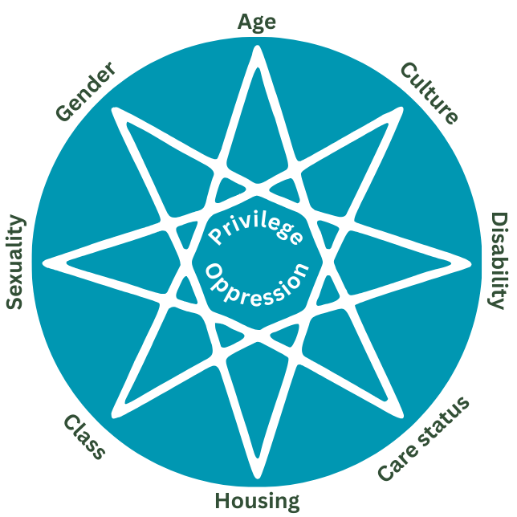

The power of language
Be conscious of the words you use. Your words may:
- leave the child feeling blamed
- collude with exploiters (even unintentionally) by concealing or minimising accountability and harm
- remove mutualised accountability for harm and highlight the child’s strength.
This extends to how information is outlined in the essential information categories (EICs) and analysis in SAFER.
Our words can help to create justice, safety and uphold dignity. We need to keep this in mind throughout our engagement with children at risk of CSE and their families. Examples of language to move towards is in Table 3.

Table 3: Examples of the power of language
Moving from | Moving towards
Mary is engaging in [describe behaviour] | Mary has been coerced or exploited to…
Mary is in a sexual relationship with X | X is sexually exploiting Mary
Mary is absconding from her placement | X is luring Mary away from her home  Mary didn’t return home as expected
Mary refuses to engage | We have not yet found a way to engage Mary
Mary is using drugs | Someone is supplying Mary with drugs
She isn’t being exploited, she is at the age of consent | She has been manipulated to believe she is consenting but his power over her is evident through…
Mark is a young offender or has a criminal history | X induced Mark to carry out criminal activities
Violent or abusive relationship | X is using violence towards Anne

Collaborative and contextual practice
Seek and share information and work closely with:
- the child
- caregivers
- community
- professional network members.
Use a strong team approach to:
- protect the child
- respond to the POI
- reduce location-based opportunities for harm.
Recognise the importance of working with the full context of how children are exploited. This is broadly made up of 3 interrelated systems (see Figure 3):
- The child (and their caregiving context)
- The POI
- The environment that creates opportunity for or protection from the POI.
Figure 3: Circles of analysis
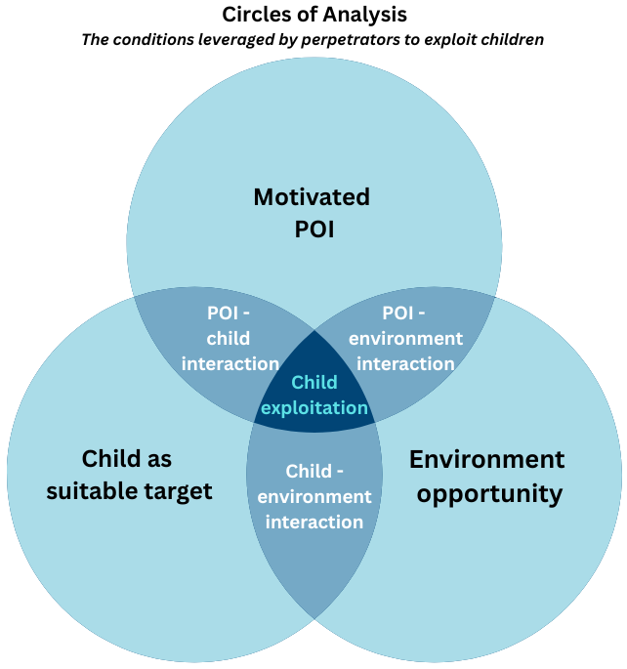
Source: Adapted from Barlow et. al. (2022)

The SAFER children framework
The SAFER children framework (SAFER) is a guided professional judgement approach. The Victorian statutory child protection program uses it to assess and manage risk to children and young people.
A guided professional judgement approach means practitioners use their knowledge, skills and experience within the framework's structure, which is a cyclical process of:
- assessment – seek, analyse (SA)
- planning and review – formulate, enact, review (FER).
The risks and harms related to exploitation form part of your comprehensive and ongoing risk assessments for the children and young people you work with. Therefore, consideration of exploitation harms and risks can and should be embedded across all phases of your work.
The core statutory test about whether a child needs protection is the same – whether:
- the child has suffered or is likely to suffer significant harm, and
- parents have not protected or are unlikely to protect them.

However, in the context of child exploitation, using SAFER to conduct statutory risk assessment bridges the gap between external perpetration and parental protection capacity.
The question is not ‘Are the parents abusive?’ but ‘Can the parents realistically protect the child from this form of harm?’
This is because, in exploitation contexts:
- the source of harm is often external (like peers, adults, networks, online actors, criminal groups)
- parental intent may be protective but parental capacity is constrained
- risk is frequently hidden, coercive, relational and cumulative.
For more information, see CP Manual's SAFER children framework web page.

Chapter 2: Exploitation prevention
Exploitation prevention refers to proactive efforts to stop children from being exploited before it occurs, intervening early and stopping the child being re-exploited.
Key messages
Preventing a child being exploited involves:
- reducing vulnerability to avoid exploitation completely and preventing further or ongoing exploitation
- building up factors of strength, safety and connection
- proactively reducing circumstances that push a child towards exploiters
- reducing opportunities for exploitation and access to children, interrupting the POI’s ability to use pull factors.

Understanding prevention

Prevention is an ongoing practice
Use a prevention lens across all stages of your practice.
Children involved with child protection are particularly vulnerable. If a child has been or is being exploited, do not simply assess and protect them from the current exploitation. Also proactively work to prevent further opportunities for them to be exploited again.
The practices underpinning prevention of exploitation are key to what leads to better outcomes for all children and young people:
- reducing their experiences of abuse and neglect
- equipping caregivers with knowledge and skills
- facilitating a child’s experience of being genuinely loved, cared about and connected.

Noticing and responding to the push and pull factors
Push and pull factors describe the common dynamics that work together to increase the risk of a child being exploited sexually or criminally. Protective factors help to buffer this risk.
Push factors: circumstances that can create the need for a child to seek external connections away from their home (such as feeling unsafe, bored, unwanted).
Pull factors: tactics used by POIs to recruit and entrap the child to exploit them. Enabled through grooming tactics and explicit targeting of unmet needs (such as offering inclusion, ‘connection’, fun).
Understanding push and pull factors means you can prevent exploitation by focusing on:
- increasing factors of strength, safety and protection
- reducing push factors
- interrupting and protecting the child from the exploiter’s use of pull factors.
Figure 4: Prevention, protection, push and pull
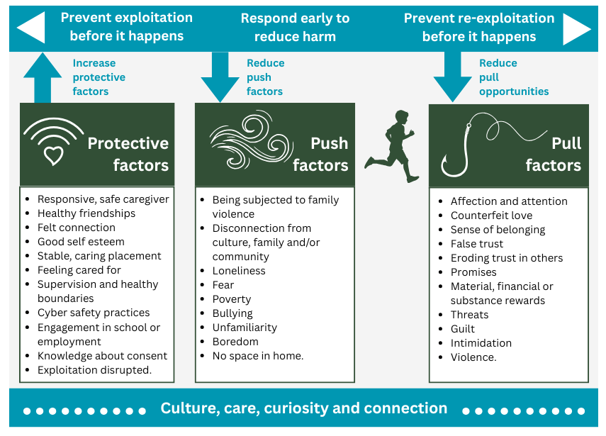

Facilitating prevention

Education as prevention
All children need continuous and supportive education about healthy relationships and safety, including online.
Children who have experienced abuse, neglect or disrupted care may not have had the opportunity to learn about healthy relationships and safety – through conversations, lessons and modelling. Taking every opportunity to teach and show children is important.
Education is a powerful tool to prevent child exploitation and re-exploitation. Encourage caregivers to educate children by having essential conversations, coaching and role modelling.
Equipping children early with knowledge and skills:
- guards against exploitation in childhood
- sets up a safer foundation for their adult relationships.
Practice tip
Explore with each child their understanding of relationships, friendships and safety.
Offer information and resources tailored to the child's development, culture and communication needs.
Educate caregivers, children or both on the following life skills.

Relationships: romantic, sexual and friendships
- Healthy relationships and friendships including love, responsibility, trust, respect, care and equality.
- Sexual development and safe sex.
- Consent: sexual consent as well as consent about choices, actions and behaviours and what can get in the way (such as coercion, entrapment, threat of negative consequences).
- Warning signs of grooming or coercive control, including ‘love bombing’, praise, gifts, promises.

Cyber safety
- Importance of privacy and safety online, and the need for regular discussion to understand the child’s preferences, experiences and concerns.
- Cyber safety practices, including supervision of internet use and parental controls.
- Awareness of online environments where children are at greater risk of being targeted.
- Common tactics for targeting or grooming children online (such as isolating on other platforms).
- What to do or who to tell if they feel unsafe online.

Understanding risk
- Awareness of dangerous locations or targeting strategies used by POIs (online or offline).
- Behavioural signs of grooming or exploitation visible to the child’s network.
Leadership tip
Make education of children and caregivers a core part of your team's practice culture.
Make sure your team has the skills and confidence to give exploitation-informed guidance.

Factors of strength, safety and protection
- People and locations to seek connection and non-judgemental support.
- Access to safe, interesting and engaging environments.
- Age-appropriate supervision and accountability (such as curfew).
- Building the child’s skills and strategies to implement relational boundaries.

Connection as prevention
Create and sustain the child’s sense of connection and belonging as an essential exploitation prevention strategy, particularly:
- the child-caregiver connection
- connection to culture and community.

The child may be pushed from their home or peer group due to:
- loneliness
- yearning for genuine and loving connection
- lacking a sense of belonging.
POIs can use these unmet needs to groom and entrap the child.
Create opportunities for the child to observe and participate in healthy expressions of love and non-exploitative relationships.
Daily experiences of safe relationships act as real-time coaching and education about safe relationships. They develop relationship skills and give a ‘reality check’ or contrast to coercive experiences.
The overall aim is to:
- create or repair healthy child-caregiver relationships
- keep the child actively connected with their family and kin
- support the child’s connection with their culture and community, particularly First Nations and CALD children.
Some ways to achieve this with the child, caregivers and network:
- Help the child develop social skills and build healthy peer relationships, including extracurricular, cultural or social connections that create healthy belonging.
- Carry out Aboriginal family-led decision making and cultural plans – see:
  - CP Manual's Aboriginal family-led decision making web page
  - CP Manual's Cultural plans - advice web page.
- Help the child uncover or explore their interests and give them opportunities for positive learning and mastery.
- Reduce harms that interrupt family connections, such as a child’s experience of family violence.
- Help the child actively engage in school or employment.
- Explore with the child who their important adults are (or have been) and support these connections (for more information, see CP Manual's Contact with significant persons - Practice guide web page).
- Build trust with the child and role model a safe relationship. This way, they will see you as a reliable source of support and non-judgemental safety.
- Help the child access trauma-informed therapeutic interventions.
- Influence the way adults and services view and treat the child. If they have positive help-seeking experiences, they may be more likely to seek help in the future.
Reflective prompt
How often do I talk about love with kids?
How can I centre my practice on the child’s lived experience of genuine belonging and love as a source of healing and safety?

Chapter 3: Exploitation detection
Practitioners need to be adept at detecting warning signs or indicators associated with exploitation. Sound understanding of these warning signs enables practitioners to reflect all available information in the analysis and decision-making process of the SAFER framework assessments.
This chapter will help you:
- recognise the warning signs to prompt you to seek and share information
- map information and evidence against evidence-based factors
- use the SAFER framework to assess, analyse and make decisions, including vulnerabilities and risks associated with exploitation.
Key messages
Detecting if a child is at risk of being or has been exploited by a POI involves:
- knowledge about the factors that increase vulnerability of a child being targeted and increase likelihood of being exploited
- connecting with the child and people who know them best to monitor and detect warning signs
- understanding factors that protect against exploitation
- seeking information about the POI, child warning signs and environmental factors
- curiosity about the child’s unique circumstances, indicators and experiences.

Identify warning signs
Look out for (and educate caregivers about) the warning signs of exploitation.
- Respond with curiosity and a non-judgemental stance to any signs identified.
- Balance asking essential questions and sharing your observations and worries without pushing too hard.
- Children will test to see if you are safe to tell and are likely to share information over time. For more about child disclosure, see Responding to child disclosures.
Understanding warning signs will enable you to recognise whether the child’s behaviour, routines and associations point to them being manipulated or controlled by others for exploitation. Warning signs are listed in Table 4.
These factors can then be appropriately considered in the context of:
- risk assessment
- formulating the case plan.

Table 4: Warning signs of child exploitation
Relationships | Behaviour | Appearance | Location | Health
- Suspicious POI behaviour like avoidant, overly friendly, minimising concerns  - Older boyfriend or girlfriend  - New group of older friends  - Isolated from existing friends or network  - Associating with people known to exploit, or engage in sex work or crime | - Significant changes in behaviour  - More secretive  - More time online  - Sexual or criminally suggestive posts or messages  - Use of alcohol or other substances  - Use of drug or gang-related slang  - Sexualised behaviour or language  - School disengagement  - Someone else seems to be controlling their decisions | - Receiving gifts  - New belongings  - New clothing, including more revealing clothing  - Dressing older than expected  - New or extra phone  - Hair and nails done with unexplained funds  - Extra money  - Changes in hygiene | - Currently or recently absent or missing  - Spending time at hotels, adults' homes or suspicious locations  - Staying at locations they cannot afford  - Accessing bars, pubs or clubs  - Use of encrypted messaging platforms  - Located in or near car with an adult  - Drugs located near or with child | - Increased alcohol or other substance use, or substance dependence  - Unexplained injuries  - Contracted sexually transmitted infection  - Pregnancy  - Poorer mental health including anxiety, low mood  - Use of self-harm to cope
For more prompts, see the Early indicators of child exploitation practitioner tool kit:
- see the CP Learning Hub's Child exploitation SharePoint page.

SAFER children framework
Risk assessment is a core statutory responsibility. Due to its dynamic nature, it is an ongoing duty. In the context of CSE or CCE detection, a SAFER assessment needs to be undertaken or reviewed as usual.
All risk assessments start with the S activity of the SAFER children framework: seeking, sorting and sharing information. The S practice activity reinforces seeking, sharing, sorting and storing new information as a continuous activity.
This is a core practice to detect exploitation. Each member of the child’s network holds small pieces of the ever-changing exploitation context and risk dynamics.

Seek information about the child from a range of sources including:
- the child
- caregivers
- family
- cultural networks
- other professional services
- their environment
- any known POIs.
Practice tip
Incident reports are useful to track patterns of behaviours or other indicators. They can inform case management and care teams.
Remain open to the possibility of sexual exploitation when analysing the content of incident reports.

Each small piece of information builds a bigger picture
Each person and service who has contact with the child or the POI will be holding a variety of big or small pieces of information.
Like a puzzle piece, one piece of information alone may seem insignificant. When brought together with other pieces of information, the whole picture begins to emerge.

Balance care and protection when seeking information from the child
Consider the least intrusive approach to collect this information, while taking reasonable actions to ensure the child’s safety.
For more information, see the CP Manual's Sexual exploitation - advice web page.

Every care team member is responsible
Each member of the care team is responsible for:
- seeking, sharing and storing information
- enacting plans.
Make clear arrangements about who will be responsible for seeking information and from whom. For example, there may be network members who are not in the care team but may be observers or receivers of information.

Essential information categories (EICs)
When storing EICs about CCE and CSE, use the ‘other’ option to ensure all relevant information is added.
The standard EICs are options rather than an exhaustive list. EICs should be appropriately outlined in the subsequent analysis section and addressed in the case plan. Be mindful of using language that appropriately captures the dynamics of CSE or CCE (for example, around grooming).

Identify vulnerability and likelihood of child exploitation

Analysis
The A activity of the SAFER children framework relates to analysis of the evidence and information gathered. It helps to make sense of the information and evidence that has been gathered about CSE and CCE using:
- analysis
- judgements about the consequences and probability of harm now and in the future.
These all inform decision making.
The analysis considers the evidence against 4 dimensions (Figure 5):
- vulnerability of the child
- severity of the harm
- likelihood of harm
- any factors of safety.
Figure 5: The 4 dimensions of analysis
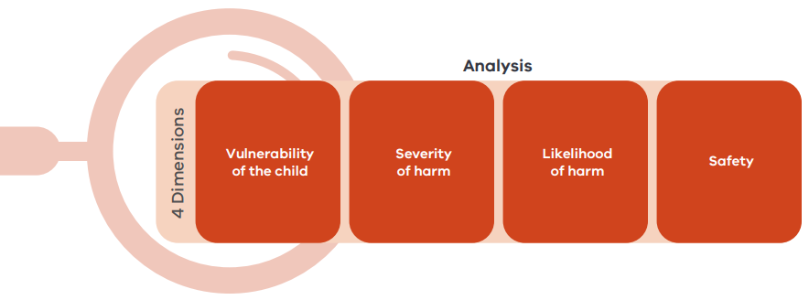
Vulnerability factors are personal characteristics or circumstances that can increase:
- the possibility that certain children will be targeted for CSE or CCE
- its harmful impact.
When analysing the vulnerability to CSE and CCE, consider:
- the child’s unique vulnerabilities (such as sexual abuse trauma, disability)
- the child’s unmet needs, which may include push and pull factors (see Figure 4)
- the parents’ or caregivers’ capacity to meet the child’s needs and protect them – in particular for CSE and CCE, can they protect the child from risk outside the home?
For more information, refer to the SAFER dimension: analysing vulnerability practitioner toolkit:
- includes a table outlining areas to consider when analysing information about the child’s vulnerability and caregivers’ capacity to meet their needs
- identifies where information and evidence may be found in the SAFER EICs
- see the CP Learning Hub's Child exploitation SharePoint page.
When in doubt, reach out to specialist practitioners (that is, sexual exploitation practice leaders). They can give useful tips on how to gather any additional relevant information and give information directly.
Did you know?
Children who are absent or missing are 19 times more likely to be sexually exploited.
Children with intellectual disabilities and developmental delay are most identified in literature as being sexually exploited.

Analysing of severity of harm
In analysing severity of harm specifically resulting from CSE or CCE, you must consider the relationship between:
- the specific vulnerabilities of the child
- the degree or severity of harm.
Analysis of severity relates entirely to the child’s individual experience of CSE, CCE or both.
As outlined in the previous section, there are many complex vulnerabilities that often affect children and young people targeted for CSE and CCE. Consideration of the severity of harm requires analysis of the extent to which the child’s current experience of CSE or CCE contributes to cumulative and long-term harm.
The severe negative impacts of sexual abuse in the short and long-term are well documented. Some of these include:
- poor school attendance
- reduced self-esteem
- nightmares
- sleep disorders
- eating disorders
- possible long-term impacts of post-traumatic stress, AOD misuse, suicidal ideation, anxiety and depression.
In terms of CCE, criminalisation is associated with:
- exposure to violence or injury
- poor school attendance
- criminalisation
- long-term post-traumatic stress, including fear, guilt and erosion of self, safety and security.
This may point to the child having suffered or being likely to suffer harm. That is significant in circumstances where the child’s parents or caregivers have not protected (or are unlikely to protect) them from CSE or CCE (section 162 of the Children, Youth and Families Act 2005 (Vic)).
It is also important to consider that by the time children involved with Child Protection are identified at risk of CSE or CCE (or there are enough indicators for disruption activity), the abuse can include features of escalation over several episodes (and multiple POIs). In some instances, it may appear chronic, as in cases where children are routinely lured from home (many missing episodes) for the purposes of exploitation. All these considerations contribute to the analysis of severity of harm.

Analysing likelihood of harm
Factors that increase the likelihood of a child being exploited or re-exploited:
- prior pattern and behaviour towards the child
- attitudes and beliefs of the parent
- other contributing factors.
For more considerations and guidance on assessing likelihood, refer to the SAFER dimension: analysing likelihood of harm practitioner toolkit:
- see the CP Learning Hub's Child exploitation SharePoint page.

Analysing safety

Draw on strengths
Strengths are the building blocks for increasing a child’s safety – though they do not necessarily reduce the risk of harm.
The positive aspects or attributes of the child, family, culture and community can translate into protection. They may result in demonstrated actions that mitigate the risk of exploitation harm. In turn, strengths demonstrated as protection over time lead to safety.
Balance the full picture of the child’s experience by identifying and weighing up factors that reduce the likelihood of the child being exploited.

Consider the multiple pathways to protection
The protection of a child from the POI’s exploitation, requires 2 key pathways of protection:
- action is taken to interrupt the POI’s exploitation of the child (see Chapter 5: Disrupting child exploitation)
- caregiver is willing and able to reduce the POI’s access to the child. The parent’s or caregiver’s ability to reduce access and harm to the child is key.
Table 5 lists examples of strengths in the child, caregiver and community.

Table 5: Examples of strengths
Category | Factor | Strength
Child | Connection and belonging | Helps guard against child being:  - pushed from their significant people (including parents, caregivers)  - pulled through grooming by POIs.
Child | Healthy self-esteem | - Increased ability to detect manipulation and coercion  - Increased assertiveness and boundary setting  - Hold positive beliefs about self-worth and rights  - Reduced reliance on external approval
Child | Knowledge about consent, sexual health and relationships | Increased ability to detect coercive, manipulative or exploitative behaviours
Caregiver | Protective, responsive and stable caregiver | - Reduces isolation and external connection seeking  - Increased help seeking, early disclosure and prevention from further harm
Caregiver | Appropriate supervision | Reduced opportunity for POIs to groom and exploit child
Caregiver | Basic needs met | Access to resources to provide for child’s housing and financial needs
Caregiver | Cyber safety practices | Reduced opportunity for POIs to groom and exploit child
Community | Healthy peer connections | Reduced isolation and connection seeking from unsafe people
Community | Engagement in school or employment | - Reduced isolation  - Increased self-esteem, support and supervision
Community | Access to safe physical and online environments | Reduced opportunity for POIs to groom and exploit child when access is age-appropriate and supervised
Community | Social cohesion and inclusion | Reduced discrimination leading to improved:  - connection  - self-esteem  - supports  - resources.
Note: Adapted from Literature review, 2025

When the POI is known to the child
Sometimes the POI exploiting the child or facilitating exploitation is known to the child. They may have held a position of trust.

If the POI is a parent
Assess:
- the risks to the child
- the parents’ ability and willingness to stop the exploitation
- the parent’s ability to protect the child from other POIs
In some circumstances this plan may involve bringing the child into care.

If the POI is a carer or residential worker
- Along with an assessment and possible police investigation, reportable conduct investigation will be needed.
- An alternate safe caregiver is likely to be needed to care for the child.

If the POI is another family or kin member
Child protection assessment should closely assess the protectiveness of the caregiver, including their ability and willingness to stop or manage opportunities for the POI to access the child.

If the POI is a friend or peer
Consider your approach carefully. Recognise that their peer may also be a child or young person:
- being exploited and coerced
- likely to need a care response.

The child’s voice: connection and understanding
To detect exploitation of a child we need to connect with them with skill and genuine care.

Use an exploitation-informed approach
When planning for and interacting with the child, use exploitation-informed practices to create opportunities for the child to share, learn and seek support. See Figure 6.
A version of Figure 6 is in the An exploitation-informed approach practitioner toolkit. You may consider sharing it with parents and caregivers care team.
- see the CP Learning Hub's Child exploitation SharePoint page.
Figure 6: Curiosity and care – an exploitation-informed approach
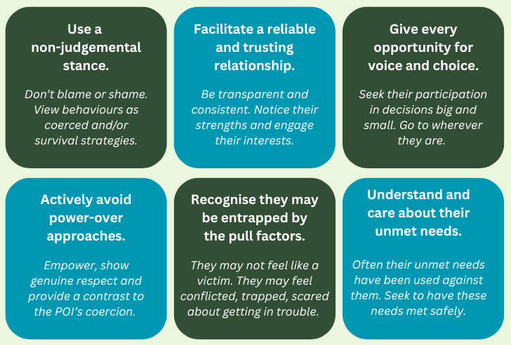

Curiosity is key
- Remain constantly curious about the unique experiences and context of each child.
- Build a trusting relationship with the child and test any professional instincts that something doesn’t feel ‘quite right.’
- Do not make assumptions or minimise possible exploitation risks if the child’s circumstances do not ‘fit in the box’ of the common exploitation factors.
- Draw on the people who know the child the best.

Prepare for common child responses
Children who are exploited may:
- not identify as victims or as being exploited
- not identify or report their abusers – this is a response to grooming, not necessarily being intentionally resistant
- feel shame, fear and pressure to be secretive – reassure the child that they are not in trouble or to blame
- express emotions by avoiding, using aggression, crying or using humour
- have gendered preferences about who to have conversations with based on cultural protocols, previous experiences of gendered violence or personal preferences.

Respectfully explore, ask, listen and ask again
Explore with the child broader themes in open and curious ways. For instance, visually map:
- Connections – people who are important to them and why they are important. If they seem reluctant, say that they do not have to share names
- Locations – places they enjoy, do not enjoy, feel safest, least safe, go to ‘escape’, have good or bad memories about.
- Relationship rules – what they’ve learnt from others about their own boundaries and rules. Ask what shaped these, if there are times these are not respected.
Practice tip
Be creative. Anchor your exploration in their interest.
If they like music, develop a Spotify playlist together with songs that reflect different people in their life.
If they are into a sport, ask them who in their life they would put on their team.
Use art.
Drive around town – often children will share a memory or experience as they pass by a location and do not feel pressured.
See:
- CP Manual's Missing children and young people procedure web page
- CP Manual's Missing children and young people advice web page.

Engaging caregivers
The child’s caregivers are the ones most likely to see evidence of increasing risk. They are central to understanding the child’s context and possible exploitation.
We need to engage them in meaningful partnership to protect the child from harm.
To help detect child exploitation with caregivers, promote:
- open and ongoing communication
- safety from other forms of neglect and abuse in their care
- understanding of warning signs of child exploitation and its possible impacts on the child’s behaviour and relationships
- non-blaming and shaming responses to the child
- expressions of care, love, unconditional and positive regard
- reinforcement of the child’s strengths
- consistent, fair and reliable boundaries and supervision
- the caregivers’ ongoing education of the child
- ways of planning and responding to the risk of exploitation.
All children need to feel cherished. If a POI offers an uncomplicated message of love, this will be a sharp contrast for a child who is only offered a ‘positive working relationship’ by carers or workers.
Exploitation is not love. But if it looks like it, sounds like it and feels like it – even momentarily – children can fall for this counterfeit version. Especially if there is no genuine example of love in their life to compare it with.

Leadership tip
Be flexible about who leads care conversations with the child. Their strongest connection may be with their caregiver rather than workers.
Practitioners or carers can coach and support the main caregiver to be the child’s source of safety and have brave conversations.

Multi-agency collaboration builds safety
The formulate practice activity in SAFER relates directly to the development of a targeted case plan that considers the individual child’s needs. It includes actions that each member of the care team will undertake to create pathways to safety.
The aim of working collaboratively is to decrease risk and increase safety for the child from current and future sexual and criminal exploitation.
The child’s multi-agency network (along with the child, their family, community and cultural network) creates pathways to safety if members are:
- drawn on effectively
- supported to be on the same page.
Did you know?
Children with positive help-seeking experiences:
- tend to show improved mental health outcomes
- are more likely to seek help again in the future.
Engage all relevant systems and services, such as:
- Child Protection
- Community service organisations
- Aboriginal community-controlled organisations
- police
- sexual assault services
- the court system
- family services
- youth justice
- health services
- mental health services
- therapeutic services
- education.
Tips for exploitation-informed multi-agency work
- Establish care teams (no matter the child’s caregiving environment) that:
  - are proactive
  - can strategically manage risks
  - track protection and progress.
- Arrange frequent child-centred case conferences. Invite members who have expertise in the child’s intersectional experiences and child exploitation responses
- Decide on a primary member who will have key conversations with the child based on the child’s trust and relationship.
- Agree on consistent practices about how to respond to the child:
  - how the child will be treated by all professionals
  - wording to be used
  - how risks, issues or behaviours will be handled.
- Establish clear communication pathways and rules.
- Provide relevant information and intelligence to police without delay to ensure that any law enforcement response is informed by the most up-to-date information available.

Chapter 4: Responding to exploitation
Effective responses to child exploitation involve:
- working as a team with the child
- achieving short-term and long-term goals for positive outcomes.
These responses work with disruption measures (see Chapter 5: Disrupting child exploitation).
Key messages
Responding to a child who is at risk of or has been harmed by exploitation involves:
- meaningful collaboration that centres partnership with the child, their family, community, network and multi-agency professionals
- connection planning approach to create safety from exploitation
- a focus on the lived experience of the child – treating the child as a whole human with unique needs, preferences and characteristics
- different strategies across the child’s short-term, medium-term and long-term needs and outcomes.

Create a care response
A care response is the relational, community and practice-based approach for intervention that forms the basis of all our responses with the child.
A care response should be reflected in the case plan, as it occurs along with any statutory response (described further in Chapter 5: Disrupting child exploitation).
An exploitation-informed care response is collaborative and adapted to the child:
- Focus both on safety and recovery.
- Be trauma informed – recognise behaviours as survival strategies or responses to violence.
- Learn how to best connect with the child by getting to know them beyond the problems they are facing.
- Explore their culture, what it means to them and how their culture can be harnessed for safety from current and future exploitation.
- Adjust your language and approach to suit the child’s developmental stage and communication needs or preferences.
- Strengthen the child’s network.

Be culturally informed
Understand Indigenous perspectives about social and emotional wellbeing, including the concept of ‘self’ as being intrinsically linked to others.
Include the Aboriginal and Torres Strait Islander social and emotional wellbeing framework in connection planning (Figure 7).

If the child is First Nations, make sure you:
- consult the Team Leader about arranging an Aboriginal family-led decision making meeting for key decision making in consultation
- consult the Aboriginal cultural advisor responsible for the child’s cultural support plan
- consult with the Aboriginal Child Specialist Advice and Support Service
- consider circuit-breaker activities, such as:
  - referral to a return to country program
  - connection with an Elder or other cultural support person
  - respite with protective extended family or community members.
Figure 7: Aboriginal and Torres Strait Islander social and emotional wellbeing framework
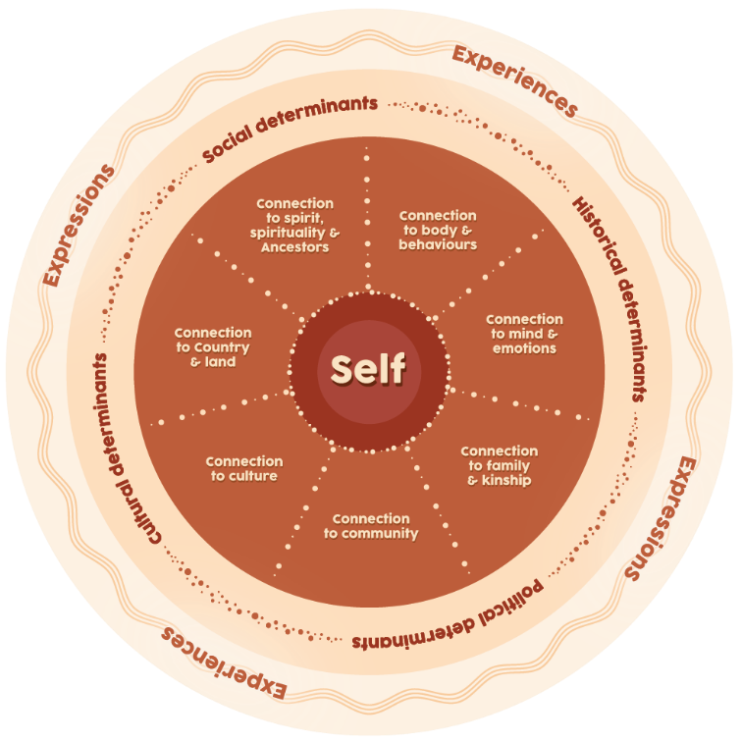
Source: Adapted from Gee et al., (2014)

Shift from reacting to incidents to responding holistically
Responding to child exploitation is not simply about responding to specific or one-off incidents. The child needs us to attend to the push factors that affect their life more broadly. If a child has been exploited, they are at greater risk of re-exploitation unless the underlying push factors are addressed.
Explore their experiences of unmet needs over time (see Figure 8). This includes both:
- their experience of actual safety and connection
- their experience of safety and connection.
Figure 8: Unmet needs and the cycle of planning
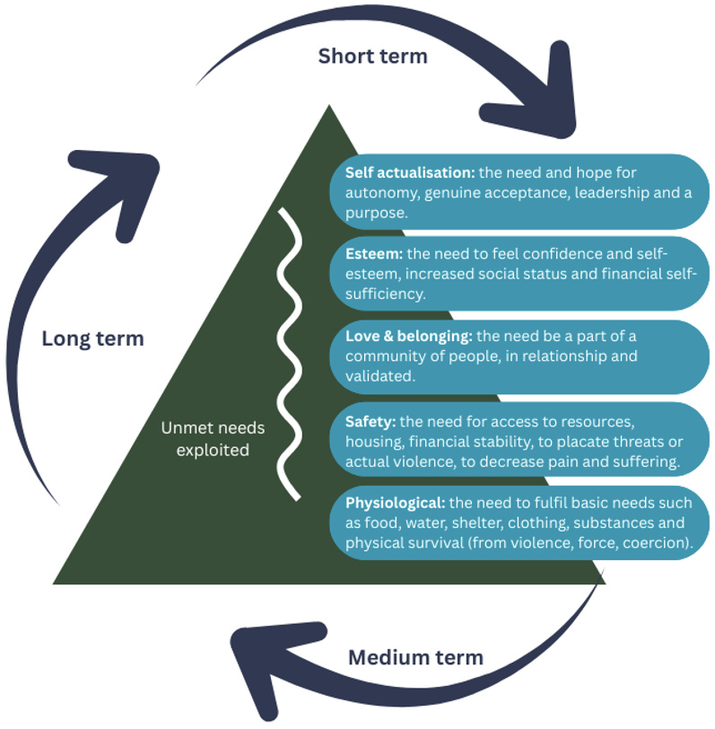
Source: Adapted from McDonald's survival sex hierarchy (McDonald & Middleton, 2019)

Avoid replicating the exploiter’s control
Be mindful not to unintentionally mirror perpetrator tactics or create conditions that make the child feel their only option is to resist to reclaim a sense of autonomy. For example, avoid:
- excessive rules
- surveillance that feels punitive or coercive
- restricting freedom without clear explanation
- telling a child what they ‘must’ do
- minimising their voice or autonomy
- minimising overt displays of authority.
Reflective prompt
Is my response adding to their sense of power and safety, or taking it away?

Draw on the child’s lived experience
The child is the expert in their own experiences.
Draw on their lived experiences to plan for their safety, moving from ‘doing to’ the child to ‘doing with’. The child will often have insights about their safety that can be surprising, creative and more reasonable than adults initially expect.
Prioritise their participation, take their voice seriously and allow them to express their views safely. Allow as many opportunities as possible for them to safely exercise choices. Give ‘recognition and incentives to encourage ongoing engagement’.
Their active involvement is more likely to create sustained safety, as well as building their self-worth and mastery in healthy decision making.
Practice tip
A creative safety strategy suggested by young people in the In our own words report was the role pets can play to:
- support their mental health
- help them feel connected to their care environment.
Pets can be a powerful motivator to stay in, or return to, their care environment.

Understand common reactions to exploitation
The child may not view their experiences as exploitation. They may not identify as victims. They may refer to or identify perpetrators as:
- their boyfriend or girlfriend
- their friend
- ‘the only person who cares about me’.
The child may be distressed by efforts to protect them from the POI. This can lead to other risks emerging (such as absent or missing from home). These risks need to be responded to at the same time using:
- curiosity
- care
- transparency about your worries.
Children may experience emotional pain, shame or feel blamed for the exploitation occurring. Shifting the child’s perception (to help to build safety) requires more than simply educating or telling the child. Develop a trauma-informed plan to explore and address these perceptions while upholding their dignity.
As described by Alderson et al (2022), due to a lack of warmth and care (in their life):
child exploitation victim survivors may view themselves as defective or unwanted, they may experience difficulties in expressing thoughts and feelings and expect others to hurt or abuse them (Fedina et al., 2017).
Children’s reactions to exploitation are survival responses, not signs of consent or wrongdoing. These reactions are normal and do not follow a neat sequence. These can include:
- secrecy (due to threats, promises or eroded trust)
- helplessness or dissociation
- feeling trapped and accommodating the situation
- delayed or conflicted disclosure
- retraction due to shame, fear or confusion.

SAFER case plans through connection planning
The F and E practice activities of the SAFER children framework are formulating and enacting the case plan. These activities respond to child safety and risk concerns, including exploitation. These activities can include connection planning and should be included in the case plan’s actions table.
Connection planning forms part of care team planning (see Figure 9). It centres child connection – helping the child to be connected to safe:
- people
- places
- routines
- activities
- boundaries.
Connection planning provides the scaffold for all aspects of responding to exploitation, including:
- safety planning
- risk management
- case planning goals that build protection, resilience and positive outcomes.
Figure 9: Exploitation-informed connection planning
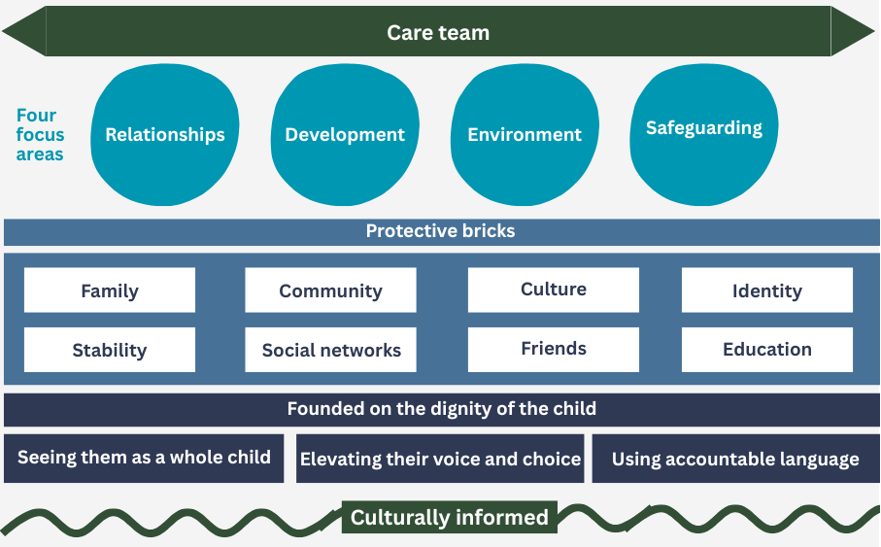

The care team
The care team is the most effective method for proactively mobilising plans and supports, no matter the child’s care arrangements. The care team should include:
- the child
- all professionals with responsibility for the child
- all people in the child’s network or community who care about the child.
Have the family around the table even if the child is in care.
Practice tip
‘Mobility mapping’ is a creative activity that engages a child in mapping out all the people and places they have had connection with over their life.
Track down every person who does or could care about the child.
Motivate them to step in and have a role in the child’s life so the child has a network of people they can rely on in the future.

The foundation of child dignity
The foundation outlines expectations about how the child is:
- treated
- understood
- written about
- talked about.
These expectations shape all other aspects of planning and responding to the child, their context and their experience of harm.
- See the child as a whole person outside of the risks they are facing. Be deeply interested in who they are – their interests, strengths, dreams and experiences.
- Seek the child’s input in decisions and goal setting creatively – rather than seeking their voice simply as a source of information.
- Use language that holds the people who harm accountable and adults responsible. Use words that do not blame, pathologise or de-humanise the child.

Focus areas
The 4 focus areas shape where we place energy in responding to exploitation.

Relationships
- Act with urgency to explore, seek out, connect or reconnect all family, kin and community members who do or could care about the child.

Development
- Give age-appropriate opportunities for the child to
  - develop skills, knowledge and experiences
  - be engaged
  - build mastery and confidence.
- This could be through traditional options (such school or extracurricular activities) or everyday life and interest-based experiences.

Environment
- Create an environment that:
  - demonstrates that the child is seen and cared about
  - they would want to spend time in.
- Consider their sensory preferences and what regulates them.

Safeguarding
- Work collaboratively with police to hold POIs accountable and disrupt or cease their exploitation.
- The child has the right to be able to live in a community where they are not harmed.
Leadership tip
Arrange weekly meetings if the risk to the child is acute and they need intense monitoring.
Try to make it the same time each week to create consistency and momentum.
Be tenacious – strategise creatively if progress isn’t being made and seek additional perspectives and supports.

Protective bricks
These are the factors that should be built and sustained to:
- make exploitation or re-exploitation more difficult
- support the child’s wellbeing.
If one of these bricks is weak or absent then the risk of a POI exploiting the child increases quickly.

Responding to child disclosures

Reduce barriers to disclosure
There are a variety of factors that shape a child’s help-seeking and choices to disclose including:
- Age – younger children are more likely to disclose than older children.
- Gendered beliefs – boys are less likely to seek help than girls, possibly due to stigma related to masculinity.
- Culture – including:
  - racist system responses
  - cultural beliefs and protocols
  - community shame.
- Entrapment and enmeshment – the POI will often:
  - erode the child’s trust in others
  - make threats of retribution
  - induce loyalty and love
  - make the child reliant on them for essentials.
- Poor social responses – such as:
  - previously being treated with disrespect
  - not believed
  - blamed
  - shamed
  - having had adverse consequences from previous disclosures
- Isolation – away from safe and supportive people or access to services and community.
- Fear – previous experience of criminalisation or believing an unjust police response is likely.
Cultural tip
First Nations children may be particularly fearful of being criminalised.
The rate of incarceration of First Nations people and continued numbers of deaths in custody make this a realistic fear.
If the POI is First Nations, the child may be particularly protective and concerned about consequences in community.

Respond flexibly to the child’s disclosure
When a child discloses experiences of exploitation, above all else, our focus is to:
- support their safety
- let them know that they are believed
- help them to feel understood.
If a child is stopped or redirected when sharing, they are unlikely to disclose again.
Guide all members of the child’s care team to know how to respond if the child discloses to them. Give advice such as:
- Do not stop a child’s disclosure – let the child continue sharing.
- Let them know you believe them and that they are not to blame or in trouble.
- Stay calm. Try not to have a big reaction or express shock, anger or distress.
- Use open questions wherever possible.
- Take the child’s lead. Do not continue to push for more details if they seem uncomfortable.
- Reassure them that they have done the right thing. Let them know that some children feel worried later that they should not have shared but you are proud of them.
- Ask if they are worried about anything happening to them because they have shared.
- Let them know what the next steps will be and when you will be in contact next.
Practice tip
Remember that some children may share information about being exploited without recognising it as harm. They may not experience the sharing as a ‘disclosure’.
Keep a relaxed approach so that they feel safe sharing.
Be transparent about what you might need to do with the information and what you are worried about.

Recognise that disclosure is a process
Children are most likely to disclose information about being exploited as a process over time. They will often test out if it is safe to tell and what to share. Create safety in telling, encouraging them to share more so that the care team can build a clearer picture to support their recovery and safety.
Exploitation is not a one-off event. It is often a complicated web of interactions. And some children are exploited by multiple POIs. It is common for children to share snippets of information about different activities, POIs and experiences as a part of disclosure of exploitation. Recording this information is important but not the focus of the conversation with the child. You may wish to establish with the child’s care team how patterns of information will be captured and mapped over time, such as the use of a link chart.
Prepare the care team to be aware that it is common for children to retract disclosures due to fear, shame, loyalty or the facing the protective actions resulting from their disclosure. This needs to be understood by the network members rather than viewed with scepticism about the child’s honesty.

Support the child’s right to healing and recovery
Children heal in relationship – your role is to support this to happen in these interconnected ways.

Nurture the caregiving relationship
Coach and support the caregiver to:
- be attuned, responsive, safe and loving to the child
- role model healthy relationships and coping.
Help the caregiver navigate continued risks and the aftermath of the child’s exploitation.

Nurture connection to important people
Help the child build and sustain healthy relationships with people who are important to them and are safe and supportive of the child.

Engaging with therapeutic supports
Connect the child to trauma-informed, culturally relevant and developmentally appropriate therapeutic supports.
For more information, see Chapter 5: Disrupting child exploitation.

Draw on your relationship with the child
Use your relationship with the child to support recovery.
Remember that you do not need to be a therapist to be therapeutic as your casework approach can support healing.
Practice tip
Help all care team members to continually reorient to this key message in their conversations with the child – ‘the exploitation is about the adult’s behaviour, not the child’s’.

Healing through culture
Connection to culture is a primary pathway of healing. Seek consultation to inform options to support First Nations children’s healing.
Move beyond generalist referrals and narrowly individualised healing strategies. Consider approaches that:
- recognise healing as relational, collective and culturally embedded
- still attend to each child’s unique needs.
Explore with the child, their network and cultural experts’ options for:
- time on Country
- time with family, kin and mob
- engaging in cultural practices and ceremonies
- cultural programs
- culturally relevant ways of healing.

Connect the child to therapeutic supports
The timing of therapeutic supports is important. If the child is currently unsafe, therapeutic supports may be limited to strengthening coping strategies rather than processing or healing from the impact of traumatic experiences.
Be thorough and thoughtful about who you refer the child to. Make sure the practitioner has:
- violence-informed attitudes
- a strong understanding of the effects of exploitative behaviours, such as coercion, control, grooming and entrapment.
If they are not the right fit, look elsewhere.
Consider with the child what therapeutic supports would best meet their needs based on:
- the child’s culture, age, gender and sexuality
- if the child has a disability (including being neurodivergent)
- the evidence base of therapeutic approach – prioritise interventions shown to be effective for trauma
- the child’s preferences and ability to engage in traditional talk therapy
- whether trauma-informed play therapy, ecotherapy, equine therapy or art therapy may connect with them more effectively
- co-occurring issues, such as the use of AOD – often to survive and cope with suffering.

Chapter 5: Disrupting child exploitation
Disruption aims to create a break or interrupt the connection between the exploiter and the child, enabling a sustained sense of safety.
These disruption strategies work along with the therapeutic and healing responses covered in Chapter 4: Responding to exploitation.
Key messages
Disrupting a POI:
- involves a variety of care-based and statutory strategies aimed at reducing the POI’s access to children and their opportunities to harm.
- requires proactive and collaborative multi-agency information sharing, planning and responses.
- shifts our practice from a focus on individuals to a community and location-based approach
- is supported by mapping patterns of information across people and places.

Disrupting 3 points of interaction
As explored earlier, it is useful to understand the 3 systems of focus:
- the POI
- the environment
- the child and their caregiving context.
Figure 10 outlines the 3 points of interaction that need to be targeted for effective disruption. This chapter outlines both statutory and care-based response options.
Figure 10: Points of interaction
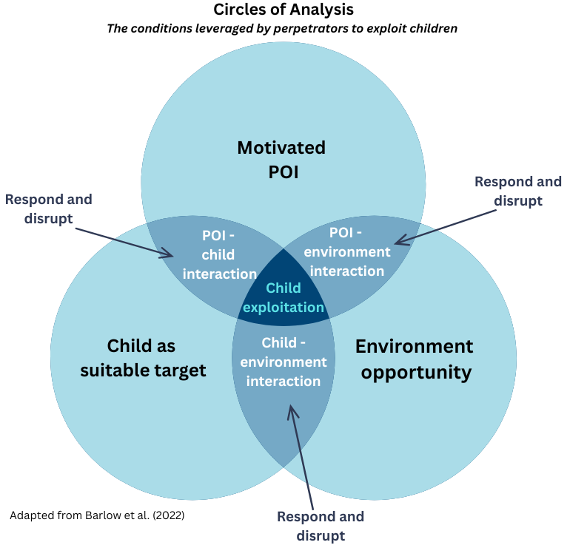
Source: Adapted from Barlow et al., (2022)

Connection and care are central to disruption
Enabling children to develop or maintain meaningful connections is pivotal to disruption. Safeguarding through disruption is one of the 4 focus areas of connection planning (see Safeguarding).
Although it is essential to identify and target POIs and their networks, engaging with victims will further build on disruption strategies to prevent exploitation or re-exploitation. This is because there is some evidence on CSE that:
- POIs may target interconnected peers or groups
- some children are induced by POIs to introduce them to peers.
Connecting a child to safe people, places, routines, activities and boundaries reduces potential POI-child interactions and child-environment interactions (see Figure 10). This disrupts access and opportunities for the POI to harm the child.
This approach to disruption is coordinated by a care team. They should provide a united approach to the child that prioritises:
- culture
- curiosity
- connection (with and for the child)
- an unwavering message that ‘we care’.

Personal safety plans
Proactively responding to child exploitation involves:
- safety planning to mitigate risk to the child
- an accompanying and complementary response to identify and disrupt the POI and prevent contact with the child.
The child is central to safety planning. They should be involved in all planning aspects.
Plans should be nimble – continuously checked for progress and adjusted as required. This should occur weekly when the probability of harm is likely or very likely as the consequences of harm through CSE are significant or severe.
For more on exploitation-informed approach to safety plans, refer to the SMART goals practitioner toolkit:
- see the CP Learning Hub's Child exploitation SharePoint page.

Statutory multi-agency collaboration and oversight
There is strong evidence that multi-agency work improves CSE responses. It supports the protection of children in ways that could not be achieved alone and it helps to challenge narratives about exploitation that are not useful to children.

Support and advocate for a child-centred approach
Continuously focus efforts that centre the child as a protected person, rather than as a source of evidence in a criminal case. Evidence is clear that effective disruption requires professionals, including police to build trust and rapport with children and young people.
Coordinate a partnered approach that assertively views the child as a victim of exploitation rather than as an offender or a problem. Advocating for these practices may be particularly important if the child:
- has been criminally exploited and therefore has been induced, or is suspected to have been induced to carry out criminal acts that police may otherwise charge the child with
- has been criminalised previously
- is from a family that is well known to police
- is frequently absent or missing
- may use aggressive behaviours in response to police contact due to fear, mistrust or previous poor experiences.
Practice tip
Draw on the potential that schools can play. They often:
- have line of sight to detect warning signs
- can be a useful source of information through ongoing interactions with students
- have the opportunity to coordinate education and responsive supports to children and their network.

SAFER: Map patterns with ongoing seeking, sharing, sorting and analysing

Information will be ever evolving
Seeking, sharing, sorting and storing information is a constant process that may evolve from one day to the next. This is particularly important because:
- exploitation is not a one-off event
- exploitation involves a series of interactions
- children are likely to disclose information over time
- some children may be exploited by more than one POI (either at the same time or over time).
Give police any relevant information or intelligence without delay. This ensures that any law enforcement response is informed by the most current information available.

Use a link chart to map and analyse emerging patterns
A sexual exploitation link chart gives a visual overview of sexual exploitation networks between children and POIs.
Care or professional team members can create a link chart for an individual child or for groups of children.
When creating a link chart, get advice as needed from a sexual exploitation practice lead (SEPL) or the Child Exploitation Response Team (CERT).

Be informed about what information to seek, share and store
Help the care team have a consistent understanding about what information is useful to capture, share and store for the purposes of disruption.
Examples of the kind of information useful for disruption is in Table 6.
Table 6: Information to seek, share and store to help disruption
Category | Information
Child | - Direct and indirect disclosures.  - Warning signs that the child is being exploited (see Identify warning signs)
POIs | Known or suspected:  - names, nicknames or initials  - physical descriptions  - car make and model or licence plate  - address or suburb  - job or place of employment  - phone number, social media handles or email address  - other people they know or associate with
Connections | - Peers or adults the child is spending time with  - Peers or adults who are believed to access locations the child or POI visit  - If any peers are being (or suspected of being) exploited or induced to recruit other children
Locations | - Physical locations the child has been to, been taken to or visits  - Physical locations the POI has been to or visits  - Online environment the child accesses (including usernames, handles)
Time | - Date and times the child has been absent or missing  - Date and times the child is believed or known to be at locations  - Date and times the POI is believed or known to be at locations
Modes of contact | - Ways the POI is suspected to be contacting the child
Modes of transportation | - Ways the child travels to POI  - Ways the POI transports or commissions transportation of the child  - Payment for transport (who and how)

CSE template (CSET)
Effective disruption relies on timely and accurate information collation and sharing that informs planned action.
Once child sexual or criminal exploitation is suspected or detected, you must complete a CSE template on CRIS. This enables appropriate collation of exploitation-related information and activates a CSE alert on the system.
Without this central repository of CSE-related information, it can be more difficult to keep track of:
- evolving CSE and CCE dynamics
- POIs
- POI activities
- POI influence over children.
Police Notification – Child Exploitation Risk (PNCER) is a subset of the CSET information. It is specifically designed to be shared securely with police through CRIS (not through personal email).
You should share this information without delay so that police have the latest information to inform their response.

Statutory options to disrupt the POI
Police and the multi-agency network have a variety of ways to disrupt and prevent POIs from being in the child’s circle of influence.
Clear messages need to be sent to POIs that:
- their behaviour is unacceptable
- they must stay away from victims or potential victims.

POI identification
When you need help identifying POIs, their associates or networks, you can engage:
- a SEPL
- the central CERT in the Office of Professional Practice.
They can give practice or analytical support.
They may also help in situations with multiple locations or POIs, where a link chart may be useful to map out what is known and identify any intelligence gaps.
Developing a planned response also involves collaboration with key agency partners, like police, to establish time-limited and targeted actions to prevent further POI contact with the child.

Disruption using harbouring notices and personal safety intervention orders
Legal options to mitigate the risk of exploitation include options under the:
- Children, Youth and Families Act 2005 (Vic)
- Family Violence Protection Act 2008 (Vic)
- Personal Safety Intervention Orders Act 2010 (Vic).

Children, Youth and Family Act 2005 (sections 495 and 497)
- Harbouring notice, no contact letter or loitering letter.
- These notices are served on POIs who are ‘harbouring’ or concealing a child, or otherwise inducing a child to be absent from placement.
- The loitering letter is for POIs entering, lurking or loitering where a child is placed.

Family Violence Protection Act 2008 and Personal Safety Intervention Orders Act 2010
- Family violence or personal safety intervention orders.
- These can be applied for on behalf of the child against the POI.
- The Act has a broad definition of family members that can be considered when lodging the application.
See:
- CP Manual's Application for a family violence or personal safety intervention order on behalf of a child procedure web page
- CP Manual's Sexual exploitation - advice web page.

Working with police
In line with a collaborative multi-agency approach, foster a close collaborative partnership with police.
Contact your local SEPL or the CERT if you require support in liaising with police.

Inform police responses through sharing information
Along with planning meetings and collaborative conversations, carry out other important information sharing strategies (including PNCER template) to support police in their efforts to disrupt the exploitation of children.
While completing the CSET or PNCER template, you can give police critical and time-sensitive information through Crime Stoppers. You can do this even when the information is not complete (such as POI vehicle registration, unknown owner).
This type of report should not be anonymous so that police or police intelligence analysts can contact you for more information.
Remember: Share relevant information and intelligence with police without delay so that law enforcement responses are based on the most up-to-date information available.
The information shared with police can be collated and built on in the police system. It can then be given to the area or police team best suited to respond.
Area-based police responses to CSE and CCE may vary. For the current area-based response with Victoria Police, consult with SEPL or CERT.
Note: If a crime is in progress or a child needs help in an emergency, you should always call Triple Zero (000).
See:
- CP Manual's Sexual exploitation advice web page
- CP Manual's Sexual exploitation procedure web page
- CP Manual's Missing children and young people procedure web page
- CP Manual's Missing children and young people advice web page.

Disruption using persistent presence
A persistent presence in the POI’s life can be a useful method of disruption.
POIs can be made to feel like they are being ‘constantly watched’ through visits from:
- child protection or Aboriginal Children in Aboriginal Care (ACAC) providers
- Corrections Victoria (if the POI is on probation or parole).
Correctional supervision also provides additional avenues for enforcement and crime disruption.
Police may also be involved in maintaining a persistent presence in the POI’s life through law enforcement and crime prevention or disruption activities. In particular, if police suspect the POI is involved in other criminal activity.
Creating an atmosphere of persistent presence may include some or all the following options.

Disruption using exploitation-related criminal charges
An obvious statutory option is for the police to carry out a criminal investigation, which may lead to criminal charge and possible prosecution against the POI.
Criminal prosecutions (that is, for child sex offences and so on) often fail to protect children in the short term because:
- evidence against the POI is hard to obtain
- evidence thresholds are high, especially for sex crimes.
The very nature of the entrapment and enmeshment tactics used by POIs also intentionally interferes with a child’s ability to disclose, give a statement or share evidence.

Disruption using other criminal charges
POIs are often involved in more than one type of crime. Police can use other laws or offences to stop POIs targeting children for exploitation. For example:
- executing outstanding warrants
- arrests and charges for new offences (such as traffic)
- arrests and charges for exploitation-related offences (such as supplying a drug of dependence)
- pursuing breaches (such as intervention orders, parole, sex offender registration).
These can all have tangible impacts on disruption of the child-POI interaction.

Disruption using location-based strategies
Knowing what locations POIs, child victim or peer networks visit is key to deploying additional disruption strategies.
Multi-agency efforts can dissuade POI presence and break down opportunities to physically access children. These may include strategies such as:
- engaging the child’s network to go to locations they visit
- liaising with local youth outreach, community or health organisations that maintain a regular presence
- regular police presence, which can deter and interrupt the opportunities for POIs to engage children
- environmental risk management options, such as increased lighting, can have a deterrent effect.
Strategies for protecting children online involve ongoing education and meaningful discussions on:
- online behaviour
- safe places for children
- what they can do if they feel unsafe online.
Disrupting POIs in online environments may involve collaboration between:
- Victoria Police
- Australian Federal Police
- other options, such as the eSafety Commissioner.
For more information on online safety, see the eSafety Commissioner’s website

SAFER: Continuously review and adapt

Review the risk assessment
Remember to regularly review the risk assessment to reflect new information or evidence as it arises. Also update assessed levels of risk and mitigation plans.
Regular review and update also ensures that relevant actions to monitor, increase safety and decrease risk of exploitation are enacted and recorded.
Consequence and probability of harm judgements should inform all decisions, such as the need to initiate a protection application or an urgent review of the child.

Proactively prevent and manage risks to the child
Risk management is not simply about mitigating active risks. It is also about looking further ahead and anticipating potential risks.
Constantly go back to the risk management strategies as context and dynamics change.
Risk management strategies should:
- increase protective factors (the protective bricks)
- reduce push factors
- disrupt pull factors (see Noticing and responding to the push and pull factors).
You are not alone in this endeavour. The next section outlines a range of specialists who can help throughout the process.

Specialist services and practitioners

Department of Families, Fairness and Housing

Practice leaders and SEPLs
Practice leaders:
- are responsible for giving expert case advice and leadership
- support and develop child protection practitioners (CPPs) in the integration of theory and practice
- demonstrate expertise through case management.
The role:
- supports practitioners to develop plans for changes needed to ensure the safety, stability and development of children and young people
- promotes the achievement of case plan objectives within specified timeframes
- reports to the principal practitioner
- includes a case carrying component in line with other responsibilities.
The SEPL role plays a critical role in protecting children and young people from sexual exploitation. The role is responsible for:
- giving expert practice advice and leadership
- supporting and developing CPPs and other key partners in the integration of theory and practice.
The role demonstrates expertise through:
- case management interventions
- systems development
- relationship building
- bringing about the changes needed to ensure the safety, stability and development of children and young people.
A key purpose of this role is to:
- more effectively identify children at risk of sexual exploitation
- work with Victoria Police to prevent CSE
- help young people recover.
The SEPL role:
- generally reports to the principal practitioner
- includes a case carrying component in line with other responsibilities.

Principal practitioners
Each departmental child protection division and statewide services employs principal practitioners.
Along with SEPLs, principal practitioners give expert advice, guidance and support to CPPs on children at risk of exploitation.

Office of Professional Practice (OPP)
The OPP is a branch of the department’s Community Operations and Practice Leadership division. It works to guide and influence a consistent statewide approach to human services practice that:
- upholds the safeguards and rights of vulnerable Victorians
- is informed by contemporary evidence and leading practice.
The OPP adds value to service delivery and client outcomes through a team of human services specialists from varied disciplines.

Child Exploitation Response team (CERT)
CERT is responsible for executing the department’s enhanced response to CSE and CCE. It comprises:
- specialist principal practice advisors
- an intelligence team to help practitioners with the complexities of collating, analysing and responding to protect children at risk of exploitation.
CERT also creates resources to help practitioners with their work. External stakeholders can get a copy of the practice toolkit resources through CERT or the Child Protection case manager.

Chief Practitioner and Statewide Principal Practitioners
The Chief Practitioner and Statewide Principal Practitioners lead the provision of specialist practice advice and consultation on child protection and service delivery.
They demonstrate evidence-informed practice development, leadership and influence.

Victoria Police

Sex Offences Child Investigation team (SOCIT)
SOCITs include qualified and experienced specialist detectives. The detectives are trained in responding to and investigating sexual offences and child abuse by perpetrators known to the victim or who are readily identifiable.
SOCITs work with other services to:
- make sure victims of sexual offences and child abuse receive an empathetic, professional and comprehensive response
- carry out risk management strategies.

Other police units
Area-based police responses to CSE and CCE may vary. To inform responses, information sharing and coordination is needed between:
- the department
- Victoria Police
- ACAC providers.
For the current area-based response with Victoria Police, consult with SEPL or CERT.
For up-to-date resources and useful links, see the CP Learning Hub's Child exploitation SharePoint page.

Appendix 1: Image descriptions

Figure 1: Child sexual and criminal exploitation
Infographic of shared characteristics of child sexual and criminal exploitation.
- The victim is under 18 years.
- There is an exploiter (POI may be extra or intra familial).
- The act is sexual or criminal in nature.
- The act is abusive (power imbalance, coercion, control).
- The act is exploitative (induces child into acts by giving something of value to the child).
- It can occur without physical contact.
Return to The intersections of child sexual and criminal exploitation.

Figure 3: Circles of analysis
Venn diagram of circles of analysis.
The 3 circles are:
- Motivated POI (circle 1)
- Environment opportunity (circle 2)
- Child as a suitable target (circle 3).
The overlap between circles 1 and 2 is ‘POI-environment interaction’.
The overlap between circles 2 and 3 is ‘Child-environment interaction’.
The overlap between circles 3 and 1 is ‘POI-child interaction’.
The intersection (or overlap) of all 3 circles is ‘Child exploitation’.
Return to Collaborative and contextual practice.

Figure 4: Prevention, protection, push and pull
Diagram of 3 goals:
- prevent exploitation before it happens
- respond early to reduce harm
- prevent re-exploitation before it happens.
Under Prevent exploitation… is an up arrow labelled ‘Increase protective factors.’
The list of protective factors includes:
- responsive, safe caregiver
- healthy friendships
- felt connection
- good self esteem
- stable, caring placement
- feeling cared for
- supervision and healthy boundaries
- cyber safety practices
- engagement in school or employment
- knowledge about consent
- exploitation disrupted.
Under Respond early… is a down arrow labelled ‘Reduce push factors.’
The list of push factors includes:
- being subjected to family violence
- disconnection from culture, family or community
- loneliness
- fear
- poverty
- bullying
- unfamiliarity
- boredom
- no space in home.
Under ‘Prevent re-exploitation…’ is a down arrow labelled ‘Reduce pull opportunities.’
The list of pull factors includes:
- affection and attention
- counterfeit love
- sense of belonging
- false trust
- eroding trust in others
- promises
- material, financial or substance rewards
- threats
- guilt
- intimidation
- violence.
Underpinning everything is ‘Culture, care, curiosity and connection’. This is shown as a rectangle at the bottom of the diagram spanning everything.
Return to Noticing and responding to the push and pull factors.

Figure 6: Curiosity and care – an exploitation-informed approach
Use a non-judgemental stance:
- Don't blame or shame.
- View behaviours as coerced or survival strategies.
Facilitate a reliable and trusting relationship:
- Be transparent and consistent.
- Notice their strengths and engage their interests.
Give every opportunity for voice and choice:
- Seek their participation in decisions big and small.
- Go to wherever they are.
Actively avoid power-over approaches:
- Empower, show genuine respect and provide a contrast to the POl's coercion.
Recognise they may be entrapped by the pull factors:
- They may not feel like a victim.
- They may feel conflicted, trapped, scared about getting in trouble.
Understand and care about their unmet needs:
- Often their unmet needs have been used against them.
- Seek to have these needs met safely.
Return to Use an exploitation-informed approach.

Figure 7: Aboriginal and Torres Strait Islander social and emotional wellbeing framework
4-ringed circle representing the Aboriginal and Torres Strait Islander social and emotional wellbeing framework.
At the centre is ‘Self’.
The next ring represents dimensions of Aboriginal social and emotional wellbeing – connection to:
- body and behaviours
- mind and emotions
- family and kinship
- community
- culture
- Country and land
- spirit, spirituality and Ancestors
The next ring contains determinants:
- social determinants
- historical determinants
- political determinants
- cultural determinants.
The outermost ring contains:
- expressions
- experiences.
Return to Be culturally informed.

Figure 8: Unmet needs and the cycle of planning
3 arrows representing short-term, medium-term and long-term planning circle a triangle.
The triangle is labelled ‘Unmet needs exploited’.
Unmet needs listed in the triangle:
- Self-actualisation: the need and hope for autonomy, genuine acceptance, leadership and a purpose.
- Esteem: the need to feel confidence and self-esteem, increased social status and financial self-sufficiency.
- Love and belonging: the need be a part of a community of people, in relationship and validated.
- Safety: the need for access to resources, housing, financial stability, to placate threats or actual violence, to decrease pain and suffering.
- Physiological: the need to fulfil basic needs such as food, water, shelter, clothing, substances and physical survival (from violence, force, coercion).
Return to Shift from reacting to incidents to responding holistically.

Figure 9: Exploitation-informed connection planning
Overview of exploitation-informed connection planning in 5 layers.
Top layer is ‘Care team’.
Second layer is 4 focus areas:
- relationships
- development
- environment
- safeguarding.
Third layer is ‘Protective bricks’:
- family
- community
- culture
- identity
- stability
- social networks
- friends
- education.
Fourth layer is ‘Founded on the dignity of the child’:
- seeing them as a whole child
- elevating their voice and choice
- using accountable language.
Bottom layer is ‘Culturally informed’.
Return to SAFER case plans through connection planning.

References
Anderson, P., Bamblett, M., Bessarab, D., Bromfield, L., Chan, S., Maddock, G., Menzies, K., O'Connell, M., Pearson, G., Walker, R., & Wright, M. (2017). Aboriginal and Torres Strait Islander children and child sexual abuse in institutional contexts: Report for the Royal Commission into Institutional Responses to Child Sexual Abuse. Royal Commission into Institutional Responses to Child Sexual Abuse.
Barlow, Craig & Heys, Alicia & Green, Simon & Darby, Bethany. (2021). Circles of analysis: a systemic model of child criminal exploitation. Journal of Children's Services. ahead-of-print. 10.1108/JCS-04-2021-0016.
Department of Families, Fairness and Housing. (2021, November 19). Best interests case practice summary guide. Child Protection Manual. Accessed at https://www.cpmanual.vic.gov.au/our-approach/best-interests-case-practice-model/best-interests-case-practice-summary-guide.
Department of Families, Fairness and Housing. (2017, December 22). Child sexual exploitation prevention guide (Document ID 3144.1, Version 1). Victorian Child Protection Manual. Accessed at https://www.cpmanual.vic.gov.au/sites/default/files/documents/202407/3144.1 Child sexual exploitation prevention guide v1.pdf.
Department of Families, Fairness and Housing. (2020, December 22). Cultural plans – advice. Child Protection Manual. Accessed at https://www.cpmanual.vic.gov.au/advice-and-protocols/advice/aboriginal-children/cultural-plans-advice.
Department of Families, Fairness and Housing. (2023). Framework for trauma-informed practice. Victorian Government. Accessed at https://www.dffh.vic.gov.au/publications/framework-trauma-informed-practice.
Department of Families, Fairness and Housing. (2016, June 20). Interagency collaboration. Child Protection Manual. Accessed at https://www.cpmanual.vic.gov.au/our-approach/multi-disciplinary-practice/interagency-collaboration.
Department of Families, Fairness and Housing. (2025, October). Literature review: Understanding and responding to child sexual and criminal exploitation. Accessed at https://www.cpmanual.vic.gov.au/advice-and-protocols/specialist-resources/child-sexual-exploitation/child-sexual-exploitation.
Department of Families, Fairness and Housing. (2024, December 9). Missing children and young people. Child Protection Manual. Accessed at https://www.cpmanual.vic.gov.au/policies-and-procedures/critical-incidents/missing-children-and-young-people.
Department of Families, Fairness and Housing. (2024, July 1). Responding to Aboriginal children – advice. Child Protection Manual. Accessed at https://www.cpmanual.vic.gov.au/advice-and-protocols/advice/aboriginal-children/responding-aboriginal-children.
Department Families Fairness and Housing. (2021). SAFER children framework guide: The 5 practice activities of risk assessment in child protection. State Government of Victoria. Accessed at https://www.vic.gov.au/victorias-anti-racism-strategy-2024-2029/acknowledgement-country.
Department of Families, Fairness and Housing. (2025, August 22). Sexual exploitation. Child Protection Manual. Accessed at https://www.vic.gov.au/victorias-anti-racism-strategy-2024-2029/acknowledgement-country.
Department of Premier and Cabinet. (2024, November 27). Acknowledgement of Country. Victoria’s anti-racism strategy 2024–2029. Accessed at https://www.vic.gov.au/victorias-anti-racism-strategy-2024-2029/acknowledgement-country.
Gee, G., Dudgeon, P., Schultz, C., Hart, A., & Kelly, K. (2014). Aboriginal and Torres Strait Islander social and emotional wellbeing. In P. Dudgeon, H. Milroy, & R. Walker (Eds.), Working together: Aboriginal and Torres Strait Islander mental health and wellbeing principles and practice (2nd ed., pp. 55–68). Commonwealth of Australia.
National Office for Child Safety. (n.d.). Responding to child sexual abuse disclosures. Australian Government. Accessed at https://www.childsafety.gov.au/about-child-sexual-abuse/responding-child-sexual-abuse-disclosures.
Summit, R. C. (1983). The child sexual abuse accommodation syndrome. Child Abuse & Neglect, 7(2), 177–193. https://doi.org/10.1016/0145-2134(83)90070-4.
The National Centre for Action on Child Sexual Abuse. (2024). Perpetrators and grooming (Understanding child sexual abuse quick reference). Accessed at https://nationalcentre.org.au/wp-content/uploads/2024/05/Understanding-CSA_Perpetrators-and-Grooming.pdf.
Wolbers, H., Katz, I., Lala, G., & Heywood, L. (2025). Sexual extortion of Australian adolescents: Results from a national survey. Trends and Issues in Crime and Criminal Justice, 712, 1–25.

Department of Families, Fairness and Housing. (2025, October). Literature review: Understanding and responding to child sexual and criminal exploitation, pp. 2–6; hereafter, ‘Literature review’
Literature review, p.25
Literature review, p.72
Baird & Connolly, 2023 in Literature review, p.28
The National Centre for Action on Child Sexual Abuse. (2024). Perpetrators and grooming (Understanding child sexual abuse quick reference).
Literature review, pp.29–30
Suarez 2017 in Literature review, p.14
Arnull et al., 2025 in Literature review, p.39
Zeyzus Johns et al., in Literature review, p.31
Wolbers et al., 2025
McKibbin & Humphreys, 2019 in Literature review, p.109
Anderson et al., 2017
https://www.vic.gov.au/victorias-anti-racism-strategy-2024-2029/acknowledgement-country
Literature review, p.117
Plowright, 2024 in Literature review, p.63
O'Brien, 2018 in Literature review, p.49
Table draws on research in Literature review, pp:31–48 and 74–88
Department of Families Fairness and Housing, 2021
Literature Review, 2025
Table draws on research in Literature review, pp:31–48 and 74–88
Department of Human Services 1999
O'Brien et al., 2024
Gee et al., 2013 in Gee et al., 2014
Cody & D’Arcy, 2019 in Literature review, p.63
Alderson et al., 2022 in Literature review, p.36
Summit, R. C. (1983). The child sexual abuse accommodation syndrome. Child Abuse & Neglect, 7(2), pp. 177–193. https://doi.org/10.1016/0145-2134(83)90070-4
Literature review
National Office for Child Safety, (n.d.)
Gee et al., 2013 in Gee et al., 2014
Barlow et al., 2022 in Literature review, p.8
Dixon, 2024 in Literature review, p.58
Crawford & L’Hoiry, 2017 in Literature review, p.61
Abrams et al., 2020 in Literature review, p.61
McVeigh & Heward-Belle, 2024 in Literature review, p.59
Lefevre et al., 2017 in Literature review, p.59

