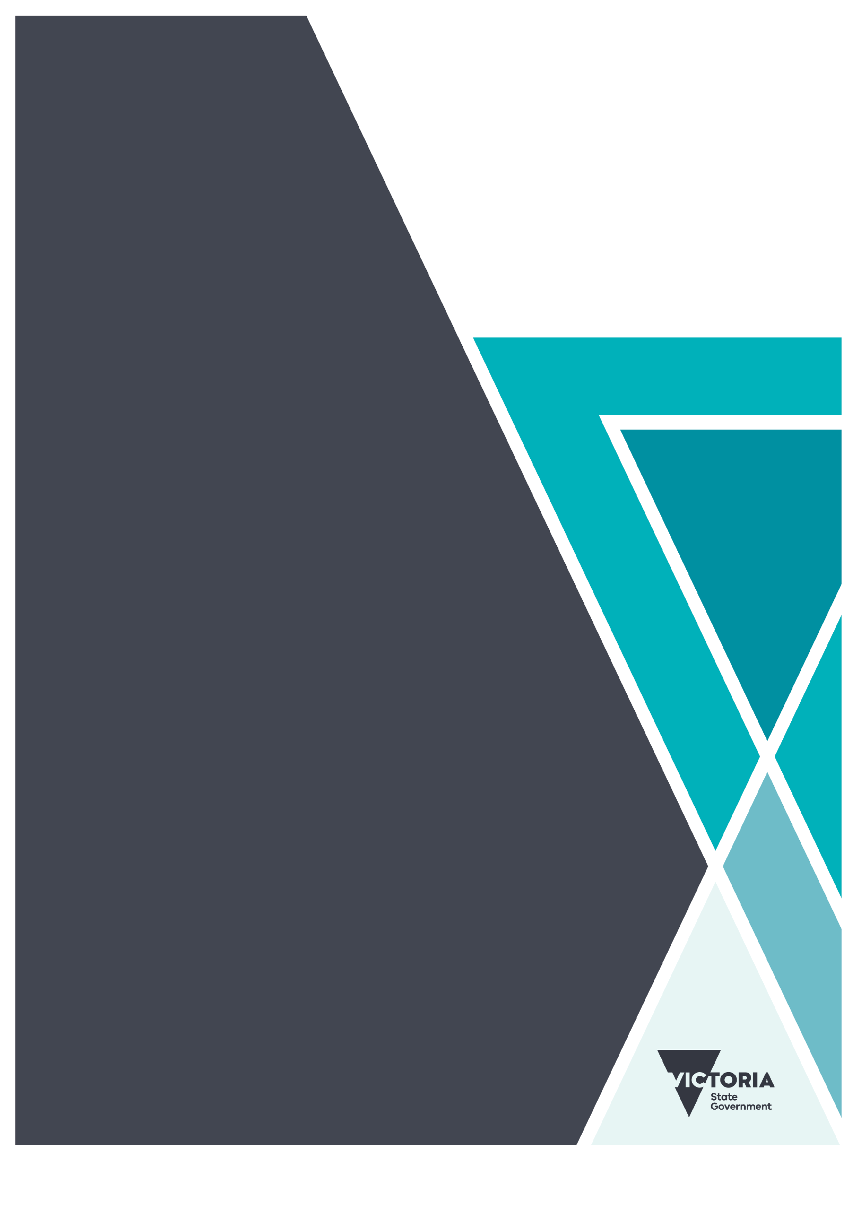
As one: our way of working
Collaboration between child protection and mental health services
OFFICIAL

Contact us to receive this document in another format. Please email the OPP Directorate OPPDirectorate@dffh.vic.gov.au
Authorised and published by the Victorian Government, 1 Treasury Place, Melbourne.
© State of Victoria, Australia, Department of Families, Fairness and Housing, February 2026.
In this document, ‘young person’ refers to both a child and young person and ‘young people’ refers to both children and young people.
In this document, ‘Aboriginal’ and ‘First Nations’ refers to both Aboriginal and Torres Strait Islander people. ‘Indigenous’ or ‘Koori/Koorie’ is retained when part of the title of a report, program or quotation.
Unless otherwise noted, images in this document show models and illustrative settings only. The images may not depict actual services, facilities or recipients of services.
ISBN 978-1-76130-919-9 (pdf/online/MS word)
Available at Mental health | Child Protection Manual | CP Manual Victoria https://www.cpmanual.vic.gov.au/advice-and-protocols/protocols/education-medical/mental-health
(2510465)

Contents
Introduction 4
Purpose 5
Guiding principles 5
Roles and responsibilities 6
Child Protection 6
Mental Health and Wellbeing Services 8
Child Protection and ICYAMHWS: our shared responsibility 9
Our processes are reciprocal and connected 11
How do we work routinely and responsively? 11
The As One way of working model 15

Please note
As one: our way of working – information pack complements this guide. It provides additional resources for child protection and infant, child and youth area mental health and wellbeing services.

Introduction
Children, young people and families involved with child protection are some of the most vulnerable members of our community.
They have often experienced trauma, abuse and neglect. They may have lost connection to family and community, which compounds their disadvantage.
These experiences can profoundly affect their development, functioning and overall wellbeing.
Children and young people in contact with child protection are often involved with many different government departments and organisations. The whole service system needs to provide prompt, skilful and integrated responses.
Collaborative, cross-sector partnerships are the foundation of these responses.
As one: our ways of working (As one) focuses on the interface between child protection and Infant, Child, Youth Area Mental Health and Wellbeing Services (ICYAMHWS).
These partnerships include collaborations to achieve the best possible outcomes for children and young people.
Partnerships with the Department of Education, the Department of Justice and Community Safety, disability services, housing agencies, private practitioners and other non-government organisations should also form part of the response.
As one is a partnership between the Department of Families, Fairness and Housing (Community Operations and Practice Leadership Division) and the Department of Health (Mental Health and Wellbeing Division).
Figure 1: Key components of the service system
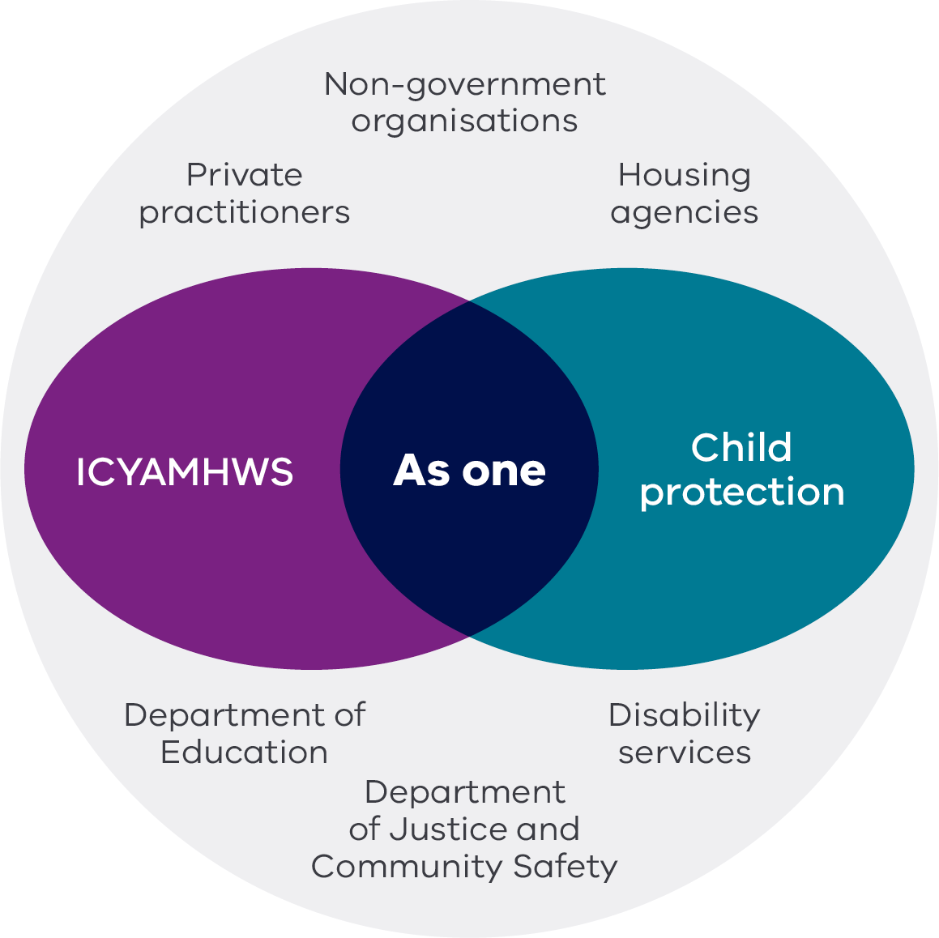

Purpose
As one provides guidance to child protection and ICYAMHWS in Victoria. It helps both service systems work together to support children and young people.
It sets out the key roles, responsibilities, guiding principles and governance arrangements that support both sectors to work more effectively together.
It aims to provide better outcomes for children and young people.

Guiding principles
Four guiding principles underpin As one:
- Child-centred approach: Actions and decision by child protection and ICYAMHWS will prioritise the safety, wellbeing and best interests of the child or young person. Wherever possible, the voice of the child, their families, carers and supporters will be at the forefront of all thinking, discussion and decisions.
- Collaborative practice: Child protection and ICYAMHWS will work collaboratively to provide integrated services.
- Respect and confidentiality: Child protection and ICYAMHWS will respect confidentiality and will only use shared information for the purpose of providing support and protection.
- Continuous improvement: As one will be regularly reviewed and updated to reflect emerging best practices across the state, as well as the changing policy and funding environments of both child protection and ICYAMHWS.

Roles and responsibilities

Child protection
Child protection in Victoria is delivered by the Department of Families Fairness and Housing. Services operate within 4 divisions (North, South, East and West). These 4 divisions comprise 17 areas. Statewide services provides an additional layer.
All operational areas respond to concerns about the safety and wellbeing of infants, children and young people up to 17 years of age (continuing up to their 18th birthday if they are on a final order).
Areas aim to ensure the safety and wellbeing of children and young people.
Statewide services provide child protection intake, Secure Care Services, Hurstbridge Farm and after-hours services (refer to Appendix 1 in the Information pack).
The main functions of child protection are to:
- investigate matters where it is alleged that a child is at risk of significant harm
- refer children and families to services that assist in providing the ongoing safety and wellbeing of children
- make applications to the Children’s Court if the child’s safety cannot be ensured within the family
- administer protection orders granted by the Children’s Court.

Children Youth and Families Act 2005
The Children, Youth and Families Act 2005 (CYFA) is the legislative framework that underpins the role and responsibility of child protection to protect children and provide the widest available supports to children and families.
Section 10 of the CYFA sets out the best interests principles. These mandate that the best interests of the child must always be paramount when making decisions or taking actions related to them.
The best interest principles focus on:
- protecting children from harm
- safeguarding their rights
- promoting their development
- protect and supporting parent–child relationships.
Section 7E of the CYFA outlines the recognition principles that guide decision-making regarding Aboriginal children and families in Victoria.
These principles uphold the right of Victorian children, families and communities to self-determination and ensure cultural rights are respected.

Aboriginal Children in Aboriginal Care
Section 18 of the CYFA allows the Secretary of the Department of Families, Fairness and Housing to authorise an Aboriginal community-controlled organisation (ACCO) to perform functions related to Aboriginal children under protection orders.
Under Aboriginal Children in Aboriginal Care, ACCOs actively work with the child’s family, community and other professionals to develop a case plan.
Case plans address protective concerns and achieve long-term objectives. They are self-determined by Aboriginal people themselves. They acknowledge risk, cultural safety and the best interests of the child.

Secure Care Service
Secure Care Service is a specialist statewide service for children and young people aged 10–17 years who:
- are subject to a child protection intervention
- are at substantial and immediate risk of harm.
The CYFA provides for children and young people to be placed in Secure Care for the purpose of crisis stabilisation.
The following criteria must be met to place a child in Secure Care:
- A child or young person (aged 10–17 years) is at substantial and immediate risk of harm.
  - If the child or younger person is on a family reunification order, care by Secretary order or a long-term care order, the Secretary of the Department of Families, Fairness and Housing must be satisfied that there is a substantial and immediate risk of harm to the child.
  - If the child or young person is on an interim accommodation order or any other court order, the court must be satisfied that there is a substantial and immediate risk of harm to the child.
  - If the child or young person is Aboriginal or Torres Strait Islander person, the Aboriginal Child Specialist Advice and Support Service (ACSASS) must be consulted. Where possible, this should occur before authorisation for admission to secure care services is sought.
- The child or young person’s freedom of movement in the community needs to be restricted to ensure their protection from harm.
- Placement in a secure setting is the only option to ensure the child or young person’s safety and wellbeing.

Mental health and wellbeing services
The Department of Health provides funding for health services to deliver ICYAMHWS across Victoria.
ICYAMHWS provide intensive and specialist mental health and wellbeing treatment, care and support for people aged 0–25 experiencing significant mental health challenges or psychological distress.
ICYAMHWS aim to improve or support a person’s mental health and wellbeing. They also provide care and support to family members, carers and supporters.
Specialised multidisciplinary infant, child and youth teams deliver individually tailored services. These include assessment and crisis intervention, care coordination and case management, psychological interventions, peer support, family support, group work, vocational interventions, educational assistance and intensive outreach.
ICYAMHWS offer both community-based and bed-based options. These are networked across the state.
Coordinated practice between community and bed-based ICYAMHWS teams – as well as collaboration with other care team members – ensures continuity and integrated care when a young person needs bed-based support.
ICYAMHWS prioritise accessibility, equity and family-centred approaches. This aligns with the recommendations of the Royal Commission into Victoria’s Mental Health System
The mental health and wellbeing system emphasises:
- community-based care
- reducing stigma and integrating mental health support with education, social services and cultural supports to address the unique needs of young people.
Key initiatives include:
- expanding multidisciplinary teams
- improving access
- ensuring culturally safe care for First Nations people and diverse communities.
ICYAMHWS recognise the importance of early life interventions to prevent long-term mental health challenges. They use trauma-informed, recovery-oriented and rights-based frameworks that empower young people and their families.

Mental Health and Wellbeing Act 2022
ICYAMHWS are informed by Victoria’s Mental Health and Wellbeing Act 2022 (the Act), which commenced on 1 September 2023.
Most children and young people access mental health and wellbeing services voluntarily but some are subject to compulsory assessment or treatment.
There are strict criteria for people under involuntary care via assessment or treatment orders. This safeguards human rights. Appendix 7 in the Information pack provides more information about compulsory assessment and treatment.
The Act sets out principles for mental health and wellbeing services.
These guide service providers to:
- uphold the dignity and autonomy of people living with mental illness or psychological distress
- make all reasonable efforts to comply with the principles and consider them when making decisions about whom they provide support to
- provide treatment and care in the least-restrictive way possible,
- address medical and other health needs while actively considering diverse needs
- prioritise gender safety and cultural safety, including families, carers and supporters
- support consumers to make decisions about their treatment and care.
There are 3 principles that focus on families, children and young people:

Family and carers principle
Families, carers and supporters (including children) of a person receiving mental health and wellbeing services are supported in their contribution to decision-making about the person's assessment, treatment and recovery.

Wellbeing of young people principle
The health, wellbeing and autonomy of children and young people receiving mental health and wellbeing services are promoted and supported. This includes providing treatment and support appropriate for the individual’s age and developmental state.
The lived experience of children and young people who have received, or are receiving, mental health and wellbeing services qualifies them to be valuable partners in the mental health and wellbeing service system.

Wellbeing of dependents principle
The children and dependents of people receiving services must have their needs, wellbeing and safety protected.
Appendix 3 in the Information pack provides a full list of MHWA principles.

Child protection and ICYAMHWS: our shared responsibility
Child protection and ICYAMHWS have a shared responsibility for the safety and wellbeing of children and young people. This shared responsibility often involves other sector partners, and it relies on joined-up, collaborative planning.
Children and young people living in residential care often have increased complexity. This makes information sharing and collaborative planning vital. Both child protection and ICYAMHWS need a shared understanding of what other services can provide.
When required, they also need to know what tailored responses each other can provide to meet the safety and wellbeing needs of the child or young person. This is particularly important for children and young people with multiple complex needs who pose a high risk of harm to self or others.

Our shared responsibility – keeping children and young people at the centre of everything we do
Child protection and ICYAMHWS provide services to children and families who face complex challenges that require a nuanced and coordinated approach. These children often present with needs that span both mental health and safety domains.
For instance, a child with a history of trauma may need specialised mental health support due to significant behavioural and emotional difficulties. They may also need protective interventions because they are exposed to risk factors like family violence or neglect.
The overlapping nature of these needs requires a holistic approach that addresses safety, mental health and developmental requirements at the same time.
Children with these intersecting needs are at greater risk of adverse outcomes. Mental health challenges, coupled with abuse or neglect, can affect their emotional and psychological development.
This can lead to long-term issues such as poor educational attainment, social difficulties and a greater chance of youth justice involvement. The stress and trauma associated with their experiences can exacerbate existing mental health conditions, making effective intervention even more important.
The families and caregivers of these children also often face significant stress and challenges.
They may struggle with their own mental health issues, substance abuse or socioeconomic disadvantages. These issues can make it harder for them to provide a stable and supportive environment for the child and to access clinical interventions. The stigma associated with mental health issues and child protection involvement can also create barriers to seeking help and support.
In addition, navigating multiple service systems can be overwhelming for families. This requires a coordinated, collaborative and supportive approach from professionals.
It is important to maintain consistent and flexible case management for children and young people who experience placement changes. These practices must respect the child or young person’s preferences wherever practicable.
Procedures should also ensure timely and effective information sharing between health services and child protection teams whenever placements change. This supports continuity of care and safeguards wellbeing.

Effective care is integrated and coordinated
Given the interrelated challenges faced by these children and their families, we need to provide integrated and coordinated services.
This requires effective communication and collaboration between child protection and ICYAMHWS to ensure that interventions are aligned and mutually reinforcing.
Shared-care planning and regular interagency meetings are part of an integrated service model that responds to these children’s needs. However, these processes can be affected by a lack of resources and regular staff turnover.
Service systems may also parallel the dynamics of the families they work with. This is a phenomenon where systems mirror patterns and behaviours. It suggests that the dynamics observed in one part of the system can be reflected in other parts.
Psychodynamic theory tells us that this mirroring can be unconscious and be driven by emotional responses.
For example, the communication styles, power dynamics and conflict resolution within a family may also be seen within the care team working to support that family.
This concept underscores the interconnectedness of various components within a system.
It highlights how changes or issues in one area can have ripple effects throughout the entire system.

Our processes are reciprocal and connected
Regular planned communication and connection between child protection and mental health and wellbeing services in Victoria is vital.
This enables each service system to have a shared understanding of the children and young people and their families they both work with.
Responsive opportunities for connection ensure integration and collaboration.
This is especially true when a child or young person’s needs change unexpectedly, risk increases, and the service system is challenged in its efforts to maintain safety and wellness for the child or young person.

How we work routinely and responsively
A layered model of consultation and connection creates seamless and effective collaboration between child protection and ICYAMHWS. The model had 3 intersecting layers:
- case-specific layer
- local area leadership layer
- statewide leadership layer.
Each layer is supported by 2 sets of processes and ways of working that underpin integrative and relational practice: routine and responsive.

1. Case-specific layer
This layer focuses on individual matters. It relates to children, young people and families involved with ICYAMHWS and child protection. The processes below enable tailored and timely supports.

Routine bi-directional consultation
Bi-directional consultation between ICYAMHWS managers and consultant psychiatrists and child protection principal practitioners and practice leaders fosters collaboration.
Bi-directional consultation involves structured, regular consultation sessions. These sessions exchange expertise and insights in both directions – from ICYAMHWS to child protection and vice versa.
Consultations are 1–2 hours long and held once a month.
If required, complex situations and matters can be escalated to local area leadership.

Responsive care teams
Care team meetings for young people involved with both services foster effective collaboration.
This ensures integrated care, role clarity, consistent communication, strengthened relationships and coordinated crisis management. Ultimately, responsive care teams provide better outcomes for vulnerable children.
Care teams working with young people involved with both services provide the infrastructure to activate crisis meetings as well as escalation to more senior levels of oversight as needed.
Figure 2: Case-specific layer
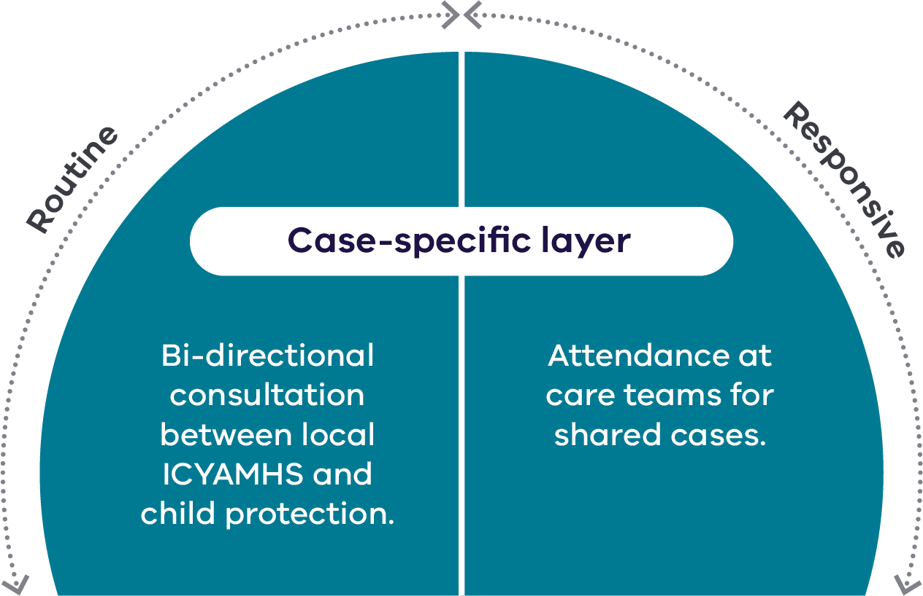

2. Local area leadership layer
This layer provides leadership and oversight at an area level. It ensures local services are coordinated and responsive to community needs.

Routine meetings with child protection and clinical services
Area clinical services meetings improve collaboration and service delivery for vulnerable families.
These meetings are chaired by senior leaders such as a unit head from ICYAMHWS, principal practitioner from child protection or directors from either service.
High-level representatives ensure that meetings are guided by experienced professionals who can make informed decisions and provide strategic direction.
These meetings include other clinical and therapeutic services from the catchment, such as:
- Headspace (youth mental health services)
- Children’s Health and Wellbeing Locals
- Take Two (a therapeutic program for children in out-of-home care)
- Centre Against Sexual Assault
- providers of Multisystemic Therapy – Psychiatric
- Primary Health Networks Mental Health Stepped Care (a model that provides different levels of mental health support based on need).
These area clinical services meetings provide regular interagency communication to discuss local trends, challenges and opportunities for improvement.
Regular meetings allow participants to identify emerging issues, share best practices and develop coordinated responses to complex cases.

Responsive panel attendance
Child protection and ICYAMHWS representatives should attend each other's internal panel meetings. These include:
- intensive infant response panels (IIR)
- high-risk youth (HRY) panels
- complex clinical case panels (ICYAMHWS).
In addition to the IIR and HRY panels, child protection holds area-based governance meetings to discuss individual matters that require specific attention.
These meetings allow for the rapid mobilisation of resources and coordination of local response plans. Local response plans involve multiple agencies working together on shared oversight and risk mitigation.
Information and insights from the various panels and area-based governance meetings then inform routine area clinical services meetings. These integrated meetings regularly discuss and address emerging issues and common themes across cases.
Figure 3: Local area leadership layer
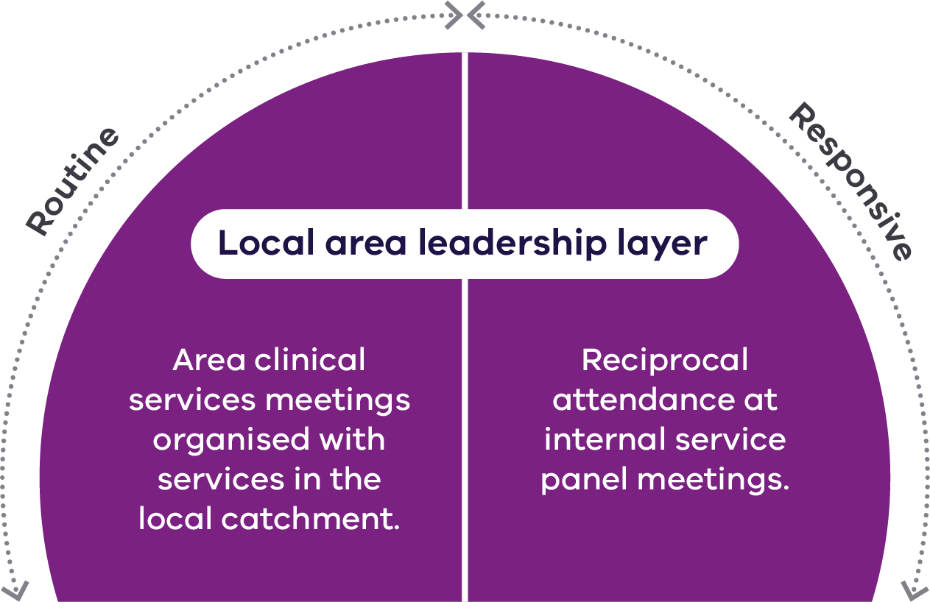

3. Statewide leadership
The statewide leadership layer provides strategic oversight and practice direction at the state level. This ensures a consistent and integrated approach to service delivery for children and young people, as well as their families, carers and supporters involved with both child protection and ICYAMHWS in Victoria.

Routine statewide leadership meetings
Statewide leadership meetings provide high-level oversight and strategic leadership for area-based child protection and ICYAMHWS services. These quarterly meetings are co-chaired by senior staff from the Office of the Chief Psychiatrist (OCP) and the Office of Professional Practice (OPP).
Statewide leadership meetings provide strategic oversight for area-based clinical services meetings. This includes:
- reviewing the effectiveness of the meetings
- ensuring they achieve their objectives
- making any necessary adjustments to improve their impact.
Statewide leadership meetings also ensure that area clinical services meetings:
- align with relevant policies and strategic priorities
- exchange experiences from across the state.
Statewide leadership meetings are informed by comprehensive data on service access. They also consider the frequency of routine bi-directional consultations within each region. This data is reported by both ICYAMHWS and child protection leadership in area.
The leadership group analyses this information to identify trends, gaps and areas for improvement. This ensures that decisions are informed by evidence and enhance service delivery.

Responsive complex case panels
As part of the usual process, the OCP often establishes case panels with various stakeholders to support people with complex needs.
These panels are a statewide escalation point. They bring together experts from across departments and services.
The panels provide multidisciplinary, clinical and lived-experience advice for people with complex needs who pose a serious risk to themselves or others.
They are for children and young people whose needs fall outside standard service responses. This may be due to system barriers, a lack of appropriate options or because existing pathways are ineffective, exhausted or unsustainable.
The panels discuss and review service responses, service delivery issues and systemic barriers. They develop coordinated, flexible and evidence-based service responses.
They also address challenging matters and situations that lie at the intersection of mental health and child protection.
The panels are chaired by the Deputy Chief Psychiatrist from the OCP. The Statewide Principal Practitioner for Children and Families from the OPP is invited.
The panels aim to improve practice and provide objective, expert consultation on complex situations and matters. These situations and matters may involve intricate and multifaceted issues that local area leadership has struggled to resolve.
ICYAMHWS and child protection jointly complete the referral form as part of a structured consultation request process.
Panel meetings include sharing information and reviewing outcomes and insights during routine statewide leadership meetings.
Figure 4: Statewide leadership layer
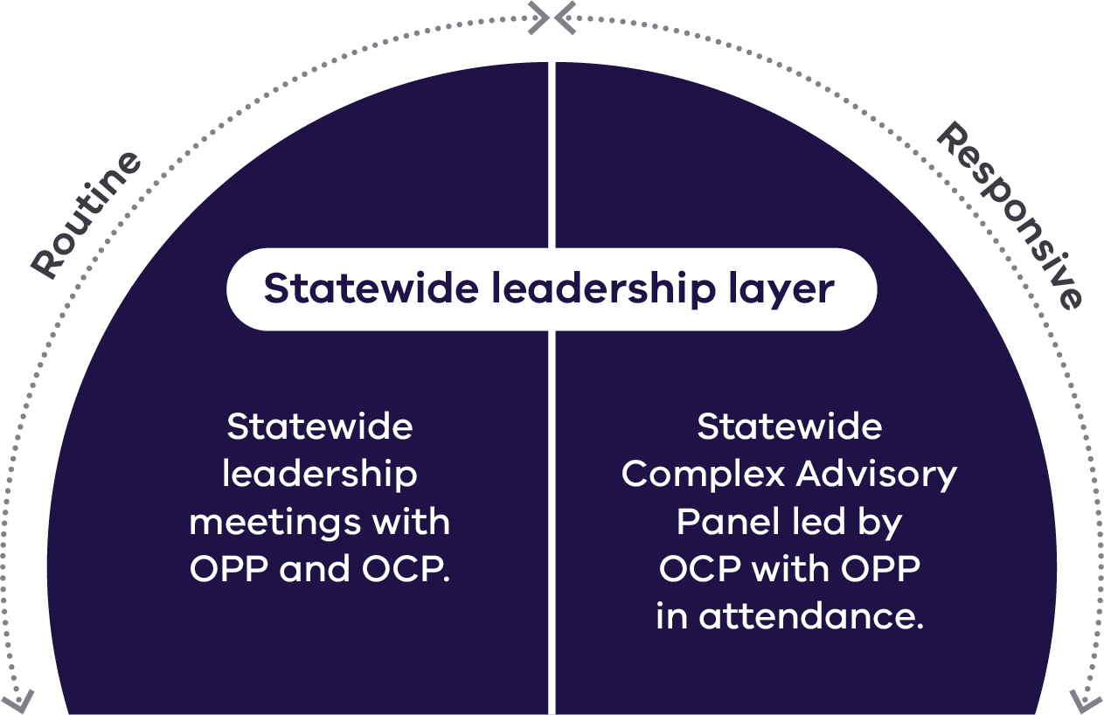

The As one model
The As one model includes the OPP and ICYAMHWS processes across the 3 different oversight levels.
The model shows how a combination of both routine and response initiatives contribute to the core objective of As one.
This fosters collaborative partnerships between child protection and ICYAMHWS.
Figure 5: The As one model
