

|  |
| --- |
| Child Protection capability framework |
| User guide |
|  |

To receive this document in another format [email Child Protection Learning](mailto:childprotection.learning@dffh.vic.gov.au) <childprotection.learning@dffh.vic.gov.au>.

Authorised and published by the Victorian Government, 1 Treasury Place, Melbourne.

© State of Victoria, Australia, Department of Families, Fairness and Housing, March 2021.

In this document, ‘Aboriginal’ refers to both Aboriginal and Torres Strait Islander people.

ISBN 978-1-76096-336-1(pdf/online/MS word)

Available at [Child protection manual – Learning and development for child protection staff](https://www.cpmanual.vic.gov.au/our-workforce/learning-and-development) <https://www.cpmanual.vic.gov.au/our-workforce/learning-and-development>

(2102907 – figures)

Contents

Introduction 4

The purpose of this guide and how it can be used 4

Professional development 5

Capability framework structure 6

Domains of practice 6

Capabilities 7

Personal qualities and attributes 9

Knowledge and skills 10

Bringing your learning plan to life 11

Capability framework materials 11

Building capability 13

Contemporary learning practices 14

Learning opportunities 14

Appendix 1: Child protection capability framework poster 15

Appendix 2: Capability by classification 17

CPP2 Supporting practice: core capabilities 17

CPP3 Beginning practice: core capabilities 18

CPP3 Beginning practice: classification-specific capabilities 19

CPP4 Advanced practice: core capabilities 20

CPP4 Advanced practice: classification-specific capabilities 21

CPP5 Leading practice: core capabilities 22

CPP5 Leading practice: classification-specific capabilities 23

CPP6 Expert practice: core capabilities 24

CPP6 Expert practice: classification-specific capabilities 25

Appendix 3: Capability by proficiency 27

Appendix 4: Success profiles 37

Child protection practitioner: success profile 37

Advanced child protection practitioner: success profile 38

Senior child protection practitioner –success profile 39

Child protection team manager: success profile 40

Child protection practice leader: success profile 41

Child protection principal practitioner: success profile 42

Child protection deputy/area operations manager: success profile 43

Appendix 5: Learning and development opportunities 46

# Introduction

Outcomes of the Royal Commission into Family Violence, the Senate Inquiry into Out-of-Home Care, the Royal Commission to Investigate Institutional Responses to Child Sex Abuse, and the National framework for protecting Australia’s children 2009–2020 outline clear actions that need to be taken in Australia and Victoria to provide children with the services they need. These reviews also set the scene for major reforms within Victoria.

The Department of Families, Fairness and Housing is responding to better meet the needs of some of the most vulnerable people in our community – Victorian children, young people and their families. In three years, our workforce has grown by a quarter, and there are currently more than 2,100 child protection practitioners in the state.

The work of a child protection practitioner is challenging, complex and rewarding. Practitioners need to have specialist child welfare knowledge and the ability to engage children, young people and their families. They also need to work in a statutory environment where they must exercise legal delegations and functions pursuant to the *Children, Youth and Families Act 2005*.

The *Child Protection capability framework* was co-designed with child protection practitioners and leaders across the department. It has been developed to provide practitioners with a holistic, contemporary approach to their learning and development that enables them to grow and develop the capabilities they need over their career in child protection.

The capabilities outlined in the framework are those that:

* the practitioner may be demonstrating already in their work
* describe what’s required at different levels and in different roles.

The *Child Protection capability framework* materials that accompany this guide have been developed to support professional development and career planning conversations and to help practitioners identify targeted learning and development opportunities.

## The purpose of this guide and how it can be used

This guide provides a clear picture of the capabilities, personal qualities, knowledge and skills that child protection practitioners and case practice support workers must demonstrate in their day-to-day work. As practitioners gain more experience, move into new roles or advance to higher levels, different levels of capability and depth of knowledge and skill is expected.

The *Child Protection* *capability framework* can be used to identify the knowledge and skills required to do their current job well and to support future development and growth into different roles. This guide provides information and tools for how to apply the framework in practice, supervision and professional development as well as providing a basis for an effective performance and development plan and career conversations.

### When to use the capability framework

The capability framework can be used:

* to agree on learning and development needs as part of the professional development process
* as a guide to the capabilities required for effective practice
* to identify capabilities required for a specific or different role and to align capabilities with the objectives of the Children, Youth and Families Act
* to identify workforce development needs
* to guide development of learning programs.

Table 1 summarises who the capability framework is for and how it can be used.

Table 1: Who the *Child protection* *capability framework* is for

| Who is it for? | How can it be used? |
| --- | --- |
| Managers | * Identify the strengths of an individual or a team to enable sharing of ‘best practice’ across teams, areas and divisions * Decide on learning and development programs that develop or enhance a team’s capabilities * Inform learning and development plans for individuals * Support staff to identify learning and development opportunities and career planning activities |
| Child protection practitioners and support workers | * Identify areas of strength and how to maintain or leverage these * Guide discussions about skills/capabilities to develop and how to do this * Select suitable learning and development opportunities * Confirm what is expected in your current role, what high performance looks like, and the capabilities required to progress to the next level |

## Professional development

Learning and development opportunities should be realistic, available and achievable during the performance cycle.

The capability framework informs the professional development process. It encourages staff to identify their learning and development needs and opportunities for ongoing development.

Learning pathways are designed to guide individuals through mandatory learning and professional development programs required at different stages of their career. The department has identified specific learning pathways for child protection practitioners that can be accessed at [Child Protection Learning Pathways (sharepoint.com)](https://dhhsvicgovau.sharepoint.com/sites/PDW/SitePages/Learning-Pathways.aspx) https://dhhsvicgovau.sharepoint.com/sites/PDW/SitePages/Learning-Pathways.aspx

For more information to support your learning and development refer to the department’s dedicated [Career management program SharePoint page](https://dhhsvicgovau.sharepoint.com/sites/dffh/SitePages/Career-management-program.aspx) <https://dhhsvicgovau.sharepoint.com/sites/dffh/SitePages/Career-management-program.aspx>.

# Capability framework structure

The capability framework comprises **core elements** required in child protection practice and work:

* **domains of practice** describing key areas of capability for child protection
* **core capabilities** outlining capabilities that all staff are expected to demonstrate consistently for CPP2–CPP6 levels (these are aligned to the domains of practice)
* **classification-specific capabilities** outlining capabilities that CPP2–CPP6 practitioners demonstrate to the level expected of their CPP classification (these are aligned to the domains of practice)
* **personal qualities and attributes** outlining the six personal qualities and attributes considered important for child protection practice
* **knowledge and skills** outlining the 10 knowledge and skills considered important for child protection practice.

## Domains of practice

The framework comprises **four domains of practice** that describe key areas of capability for child protection:

* Critical assessment and reflection
* Engaging others
* Delivering results
* Leading and inspiring.

|  |  |  |  |
| --- | --- | --- | --- |
| Critical assessment and reflection | Engaging others | Delivering results | Leading and inspiring |

**Core capabilities and classification-specific capabilities** are identified under one of these four domains of practice (see Table 2).

## Capabilities

Capability defines what a staff member needs to be able to do to meet the requirements of a role. It is an integration of knowledge, skills and personal qualities.

The *Child Protection capability framework* outlines five core capabilities for **CPP2** workers, with seven core and 10 classification-specific capabilities for **CPP3–CPP6** workers. The CPP2 capability framework does not include classification-specific capabilities due to the nature of the CPP2 role.

All staff are expected to demonstrate the core capabilities and display the classification-specific capabilities in line with their classification and level of practice (see **Appendix 2**).

Table 2:Core capabilities and classification-specific capabilities by domain of practice

|  |  |  |  |  |
| --- | --- | --- | --- | --- |
| Capability | Critical assessment and reflection | Engaging others | Delivering results | Leading and inspiring |
| **CPP2**  **Core capabilities** | Accurate reporting | Child-centred and family-focused relationship-based practice  Collaboration  Knowledge sharing | Business operations |  |
| **CPP3–6**  **Core capabilities** | Risk assessment and analysis  Case planning review and case management | Child-centred and family-focused relationship-based practice  Collaboration | Problem solving  Culturally informed practice and safety | Practice leadership |
| **CPP3–6**  **Classification-specific capabilities** | Critical inquiry  Standardised reporting  Reflective practice | Knowledge sharing | Business operations  Evaluating and delivering program improvements  Packaging of support | Collective leadership  Developing others  System leadership |

### Levels

Each capability is detailed in the following sections. The capabilities by domain and the capability cards describe how each capability progresses through five levels. These capability levels are consistent with the Child Protection Practitioner (CPP) grade and value range descriptors in the *Victorian Public Service Enterprise Agreement 2016*.

Each level of capability assumes competence at the preceding level. Further, each role may vary in proficiency at different levels, depending on the nature of the work.

The five capability levels are:

|  |  |
| --- | --- |
| Level | Descriptor |
| **CPP2**  **Supporting practice** | * The CPP2 capability framework is for case practice support workers only * Developing and building their practical experience under supervision |
| **CPP3**  **Beginning practice** | * Defines the baseline level of capability of child protection practitioners and may describe those early in their career or operating in foundational roles * Developing and building their practical experience in this area and can demonstrate this capability in their work * Demonstrates application of this capability in some settings and situations |
| **CPP4**  **Advanced practice** | * Has significant practical experience in this area and demonstrates this capability consistently in all settings and situations * Supports, advises and guides other colleagues on the application of this capability in their work |
| **CPP5**  **Leading practice** | * Being known as an expert in this capability * Consistently demonstrates this capability in all settings and situations * Actively coach’s colleagues in the application and practice relating to this capability * Engages and leads colleagues and clients in this capability |
| **CPP6**  **Expert practice** | * Significant and deep experience in applying this capability * Recognised around the state as an expert in applying this capability with colleagues and external stakeholders * Strategically plans for how colleagues and staff can continue to develop in this area and successfully operationalises these plans |

## Personal qualities and attributes

The capability framework is underpinned by the six priority personal qualities and attributes that can be developed throughout an individual’s career. This list is not static and will develop over time; it represents the personal qualities and attributes that are important to child protection practice.

|  |  |
| --- | --- |
| Attribute | Description |
| **Adaptable** | Is flexible and adaptable to change and accepts and integrates new information as a matter of course |
| **Emotionally regulated** | Regulates emotions in the face of distressing and alarming circumstances to ensure the best outcomes for clients |
| **Open and curious** | Adopts an open and curious approach to child protection work |
| **Decisive** | Makes rational and sound decisions based on the facts and alternatives |
| **Resilient** | Responds thoughtfully and reflectively to distressing information  Appropriately seeks guidance and support  Communicates effectively with others to undertake child-centred work in the face of challenging situations |
| **Takes initiative** | Works proactively in creating solutions and solving problems |

## Knowledge and skills

The following list is not static and will develop over time. It represents the knowledge and skills that are critical to child protection practice.

|  |  |
| --- | --- |
| Personal quality | Description |
| **Understands child development** | Identifies normal developmental stages within a child’s life  Understands attachment and trauma theories as they relate to child protection practice |
| **Identifies risks to children** | Identifies factors that place a child at risk of abuse or neglect  Articulates this risk verbally and in writing to a range of stakeholders including parents, children and other professionals |
| **Understands the legislative and statutory framework** | Understands and embeds the Child, Youth and Families Act in practice, including the core responsibilities and principles of the Act |
| **Works confidently with families affected by drug or alcohol abuse** | Demonstrates an understanding of the legislative, policy and practice requirements relating to families affected by drug or alcohol abuse and can apply these skills in practice |
| **Works confidently with families affected by family violence** | Demonstrates an understanding of the legislative, policy and practice requirements relating to family violence, and can apply these skills in practice |
| **Works confidently with Aboriginal children and families** | Demonstrates an understanding of the legislative, policy and practice requirements relating to Aboriginal children, families and communities, and the ability to apply case practice and decision making |
| **Operates effectively in a fast-paced and changing environment** | Routinely prioritises workload and activities  Negotiates and suggests alternative (workable) approaches/strategies  Summarises actions taken and future tasks  Regularly checks in with key stakeholders to deliver high-quality outcomes for children and families |
| **Confidently prepares for court** | Demonstrates competence as a protective intervener in all jurisdictions and functions (courts, tribunals, oversight bodies, inquiries, interstate and interdivisional counterparts)  Carefully considers consequences for potential courses of action to achieve safety for children  Consults appropriately with supervisors, legal practitioners and others  Uses an evidence-informed, methodical approach to preparing for, presenting at and initiating proceedings |
| **Communicates risk and risk-related concepts verbally** | Confidently conveys relevant ideas, information and assessments in a clear and articulate way  Understands and meets the needs of target audiences (delivers the right information to the right people at the right time)  Welcomes alternative views  Sees things from others’ points of view and confirms understanding |
| **Writes professionally and convincingly** | Prepares complex briefs, letters, emails and reports using clear, concise and grammatically correct language  Edits written communications to ensure they contain the information necessary to achieve their purpose and meet audience needs  Ensures appropriate style and formats are used |

# Bringing your learning plan to life

Practitioners can use the [Child Protection capability framework self-assessment tool](https://teams.microsoft.com/l/entity/a6b63365-31a4-4f43-92ec-710b71557af9/_djb2_msteams_prefix_3215829107?context=%7B%22subEntityId%22%3Anull%2C%22channelId%22%3A%2219%3ANa8q3ZiaOxl0fbxqExnmgiqke7gOayKG4vFccyeBJvc1%40thread.tacv2%22%7D&groupId=c098f57a-1142-4950-8820-2fc30964fada&tenantId=c0e0601f-0fac-449c-9c88-a104c4eb9f28) to identify skills that are required in their current role, to explore how to progress to another role, to recognise their own capabilities and identify any gaps and to identify opportunities for professional development.

# Capability framework materials

A range of tools and resources have been developed to help apply the capability framework. These include:

* a capability framework poster that describes each capability by domain (Figure 1 and **Appendix 1**)
* capability cards that demonstrate levels of proficiency by capability within each domain (Figure 2 and **Appendix 3**)
* success profiles to help you identify capabilities required to perform at a high level (Figure 3 and **Appendix 4**)
* an online self-assessment tool to help identify key strengths and development opportunities; aligned to each domain and capability by proficiency (Figure 4)
* a learning program guide.

Figure 1: Capability framework poster

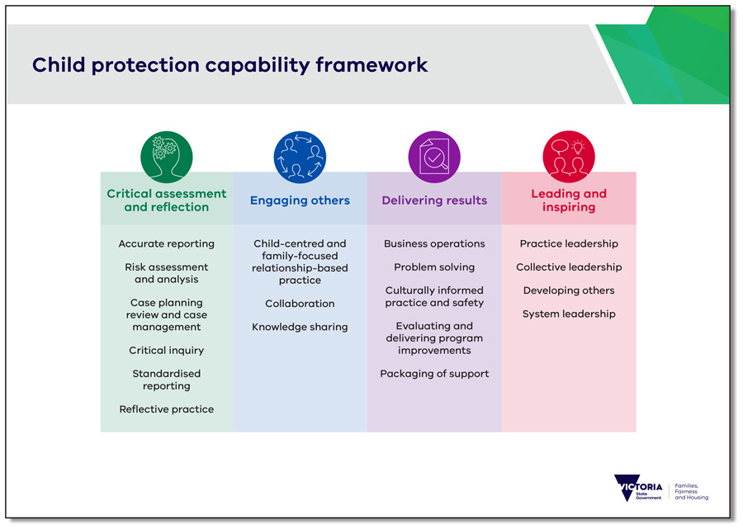

Figure 2: Capability cards

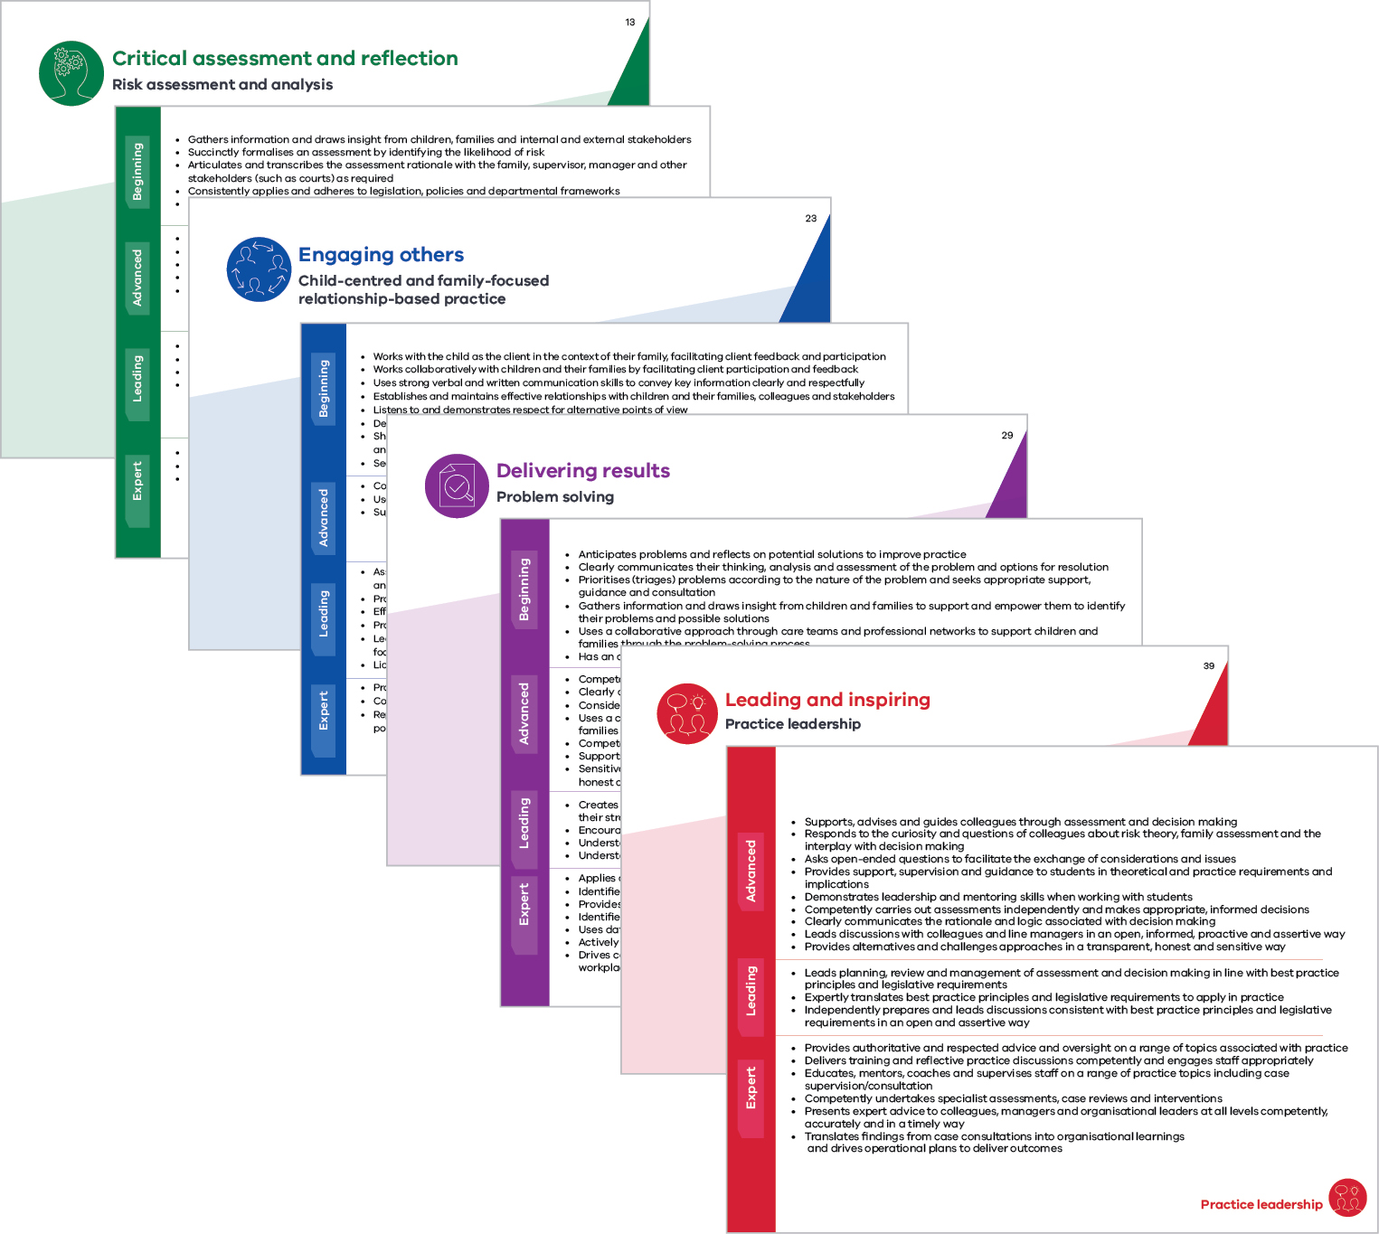  
**Figure 3: Success profiles**

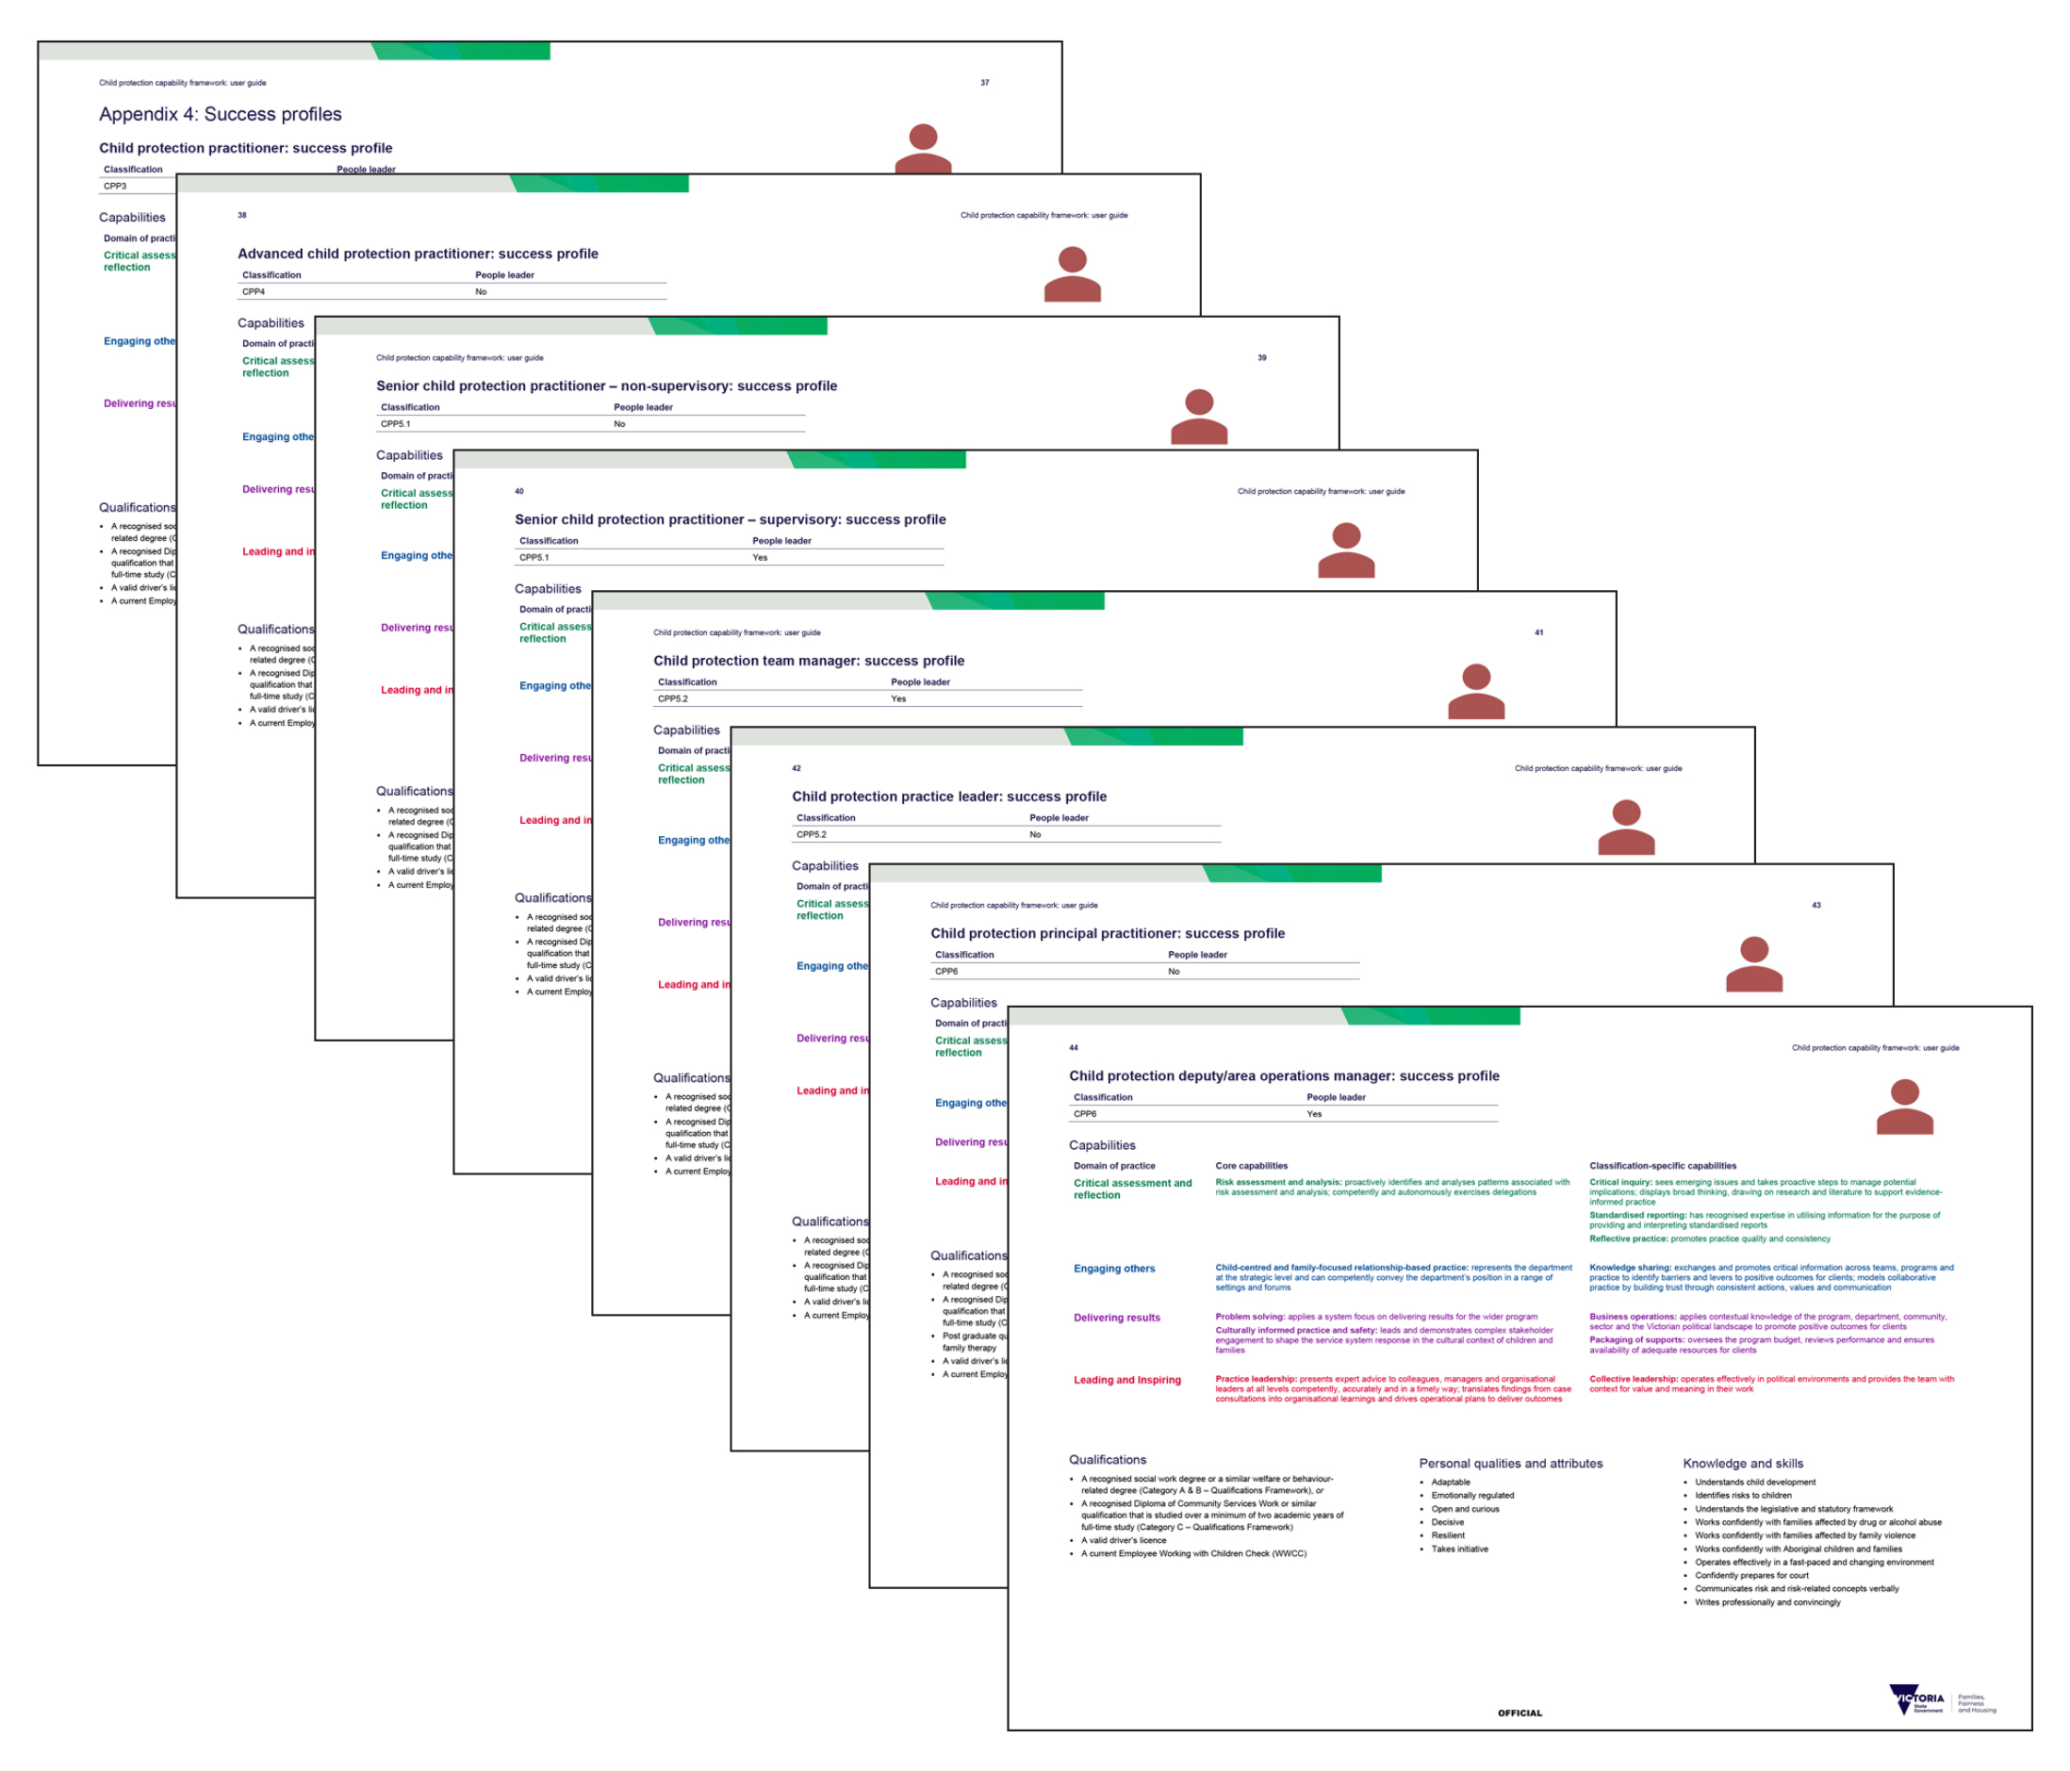

**Figure 4: Self-assessment tool**

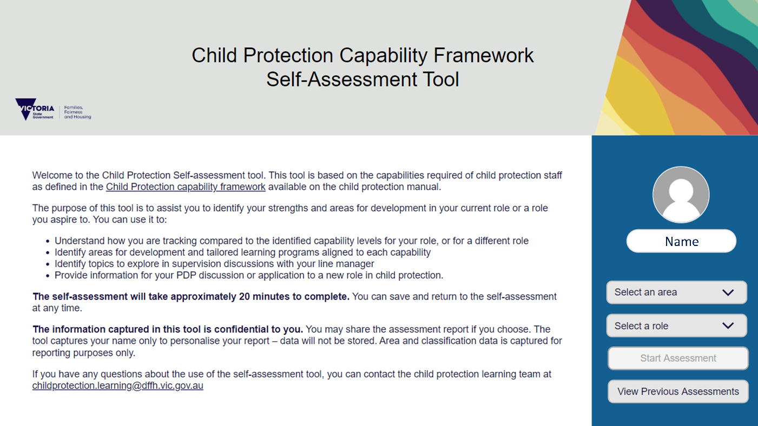

## Building capability

The capability framework self-assessment tool or capability cards help to determine the capabilities needed for a current or future role, and to identify opportunities for development.

1. **Choose the role** – this could be the practitioner’s current role or an aspired future role.
2. **Review the capabilities** listed for the relevant role profile (including required proficiency levels).
3. **Complete a self-assessment** – using the [Child Protection capability framework self-assessment tool](https://teams.microsoft.com/l/entity/a6b63365-31a4-4f43-92ec-710b71557af9/_djb2_msteams_prefix_3215829107?context=%7B%22subEntityId%22%3Anull%2C%22channelId%22%3A%2219%3ANa8q3ZiaOxl0fbxqExnmgiqke7gOayKG4vFccyeBJvc1%40thread.tacv2%22%7D&groupId=c098f57a-1142-4950-8820-2fc30964fada&tenantId=c0e0601f-0fac-449c-9c88-a104c4eb9f28) or capability cards, practitioners should review the capabilities and assess whether they currently perform at the proficiency level listed for the role:

* Is the capability a ‘key strength’?
* Do they perform the capability to a ‘satisfactory’ level?
* Is the capability a ‘development opportunity’?

1. **Discuss and explore the strengths and learning and development opportunities** with the line manager and match these to the [Child Protection Learning Pathways](https://dhhsvicgovau.sharepoint.com/sites/PDW/SitePages/Learning-Pathways.aspx).
2. **Record agreed learning opportunities** in the practitioner’s professional development plan.
3. **Regularly review** **progress** with the line manager.

## Contemporary learning practices

Contemporary learning theory suggests that formal training is not enough to embed essential mindsets, behaviours and practices over time. Rather, a range of learning approaches must be used.

In addition to formal learning programs and to get the best out of learning and development experiences, practitioners are encouraged to consider a range of learning opportunities.

A detailed glossary of informal learning and development strategies can be found in **Appendix 5**.

## Learning opportunities

Three distinct opportunities for learning are:

1. **Formal learning** – formal educational training, either online, facilitated or blended, and qualification-based learning (for example, a diploma, bachelor’s degree or master’s).
2. **Learning from others** – informal learning that occurs through exposure to others (including peers, managers and clients). This includes coaching, mentoring, communities of practice and facilitated reflective practice.
3. **Job-related experiences** – informal learning that occurs on the job. A high percentage of what we learn occurs through (intended and unintended) on-the-job experiences. The role of line managers is critical to the success of any learning strategy because they greatly influence the conditions and environment that can support application.

# Appendix 1: Child protection capability framework poster

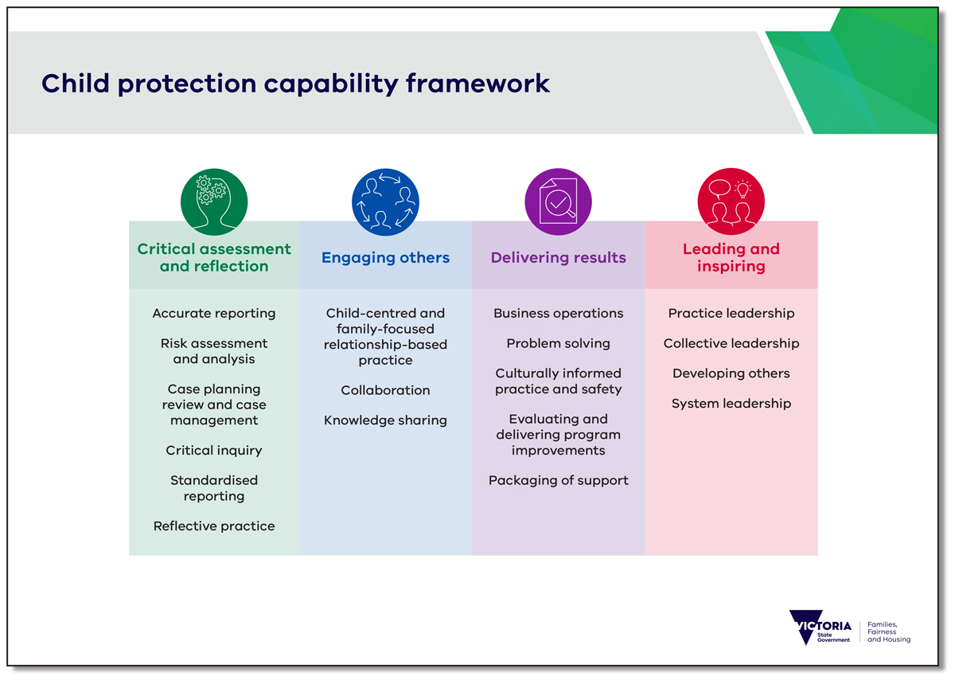

Notes

|  |
| --- |
|  |

# Appendix 2: Capability by classification

## CPP2 Supporting practice: core capabilities

|  |  |  |
| --- | --- | --- |
| Critical assessment and reflection | Engaging others | Delivering results |
| Accurate reporting   * Maintains accurate and complete records of all work activities in accordance with legislative, departmental information security and privacy policies * Prepares case notes and routine correspondence for others to consider * Records information using the appropriate departmental systems (such as the Client Relationship Information System – CRIS) | Child-centred and family-focused relationship-based practice   * Facilitates supervision, access visits and family contact sessions in line with best practice principles and legislative requirements * Seeks guidance and consultation from the team manager and other senior staff * Applies and adheres to statutory frameworks | Business operations   * Records information using the appropriate departmental systems (such as the Client Relationship Information System – CRIS) * Uses IT and web-based applications as required, and in line with departmental guidelines and privacy principles * Seeks guidance from the supervisor, team manager and other team members when unsure of appropriate action |
| Blank square | Collaboration   * Engages well with children and their families, other practitioners and teams, agencies, services and the community * Establishes and maintains strong relationships with service providers and case managers * Is polite and considerate in dealing with others * Demonstrates the ability to engage with professionals in matters relating to transport and access * Develops knowledge about relevant services in the area/division | Blank square |
| Blank square | Knowledge sharing   * Accurately records case notes on family observations and assessments of contact sessions, ensuring they are shared with the necessary team members and stakeholders in a timely way * Contributes to, and shares information at, staff meetings and forums * Actively listens and passes on relevant information | Blank square |

## CPP3 Beginning practice: core capabilities

| Critical assessment and reflection | Engaging others | Delivering results |
| --- | --- | --- |
| Risk assessment and analysis   * Gathers information and draws insight from children, families and internal and external stakeholders * Succinctly formalises an assessment by identifying the likelihood of risk * Articulates and transcribes the assessment rationale with the family, supervisor, manager and other stakeholders (such as courts) as required * Consistently applies and adheres to legislation, policies and departmental frameworks * Seeks endorsement and review of risk assessment with their supervisor | Child-centred and family-focused relationship-based practice   * Works with the child as the client in the context of their family, facilitating client feedback and participation * Works collaboratively with children and their families by facilitating client participation and feedback * Uses strong verbal and written communication skills to convey key information clearly and respectfully * Establishes and maintains effective relationships with children and their families, colleagues and stakeholders * Listens to and demonstrates respect for alternative points of view * Develops solutions in collaboration with children and their families, colleagues, supervisors and stakeholders * Shares critical information across the system, both internally and externally, to ensure shared understanding and safety of the child * Seeks guidance and consultation from the team manager and other senior staff | Problem solving   * Anticipates problems and reflects on potential solutions to improve practice * Clearly communicates their thinking, analysis and assessment of the problem and options for resolution * Prioritises (triages) problems according to the nature of the problem and seeks appropriate support, guidance and consultation * Gathers information and draws insight from children and families to support and empower them to identify their problems and possible solutions * Uses a collaborative approach through care teams and professional networks to support children and families through the problem-solving process * Has an awareness of theoretical approaches that drive practice and problem solving |
| Case planning review and case management   * Consistently applies, understands and adheres to legislation, policies and departmental frameworks * Creates child-focused plans with the child, family and other stakeholders * Ensures case plans are culturally aligned * Drafts case plans in consultation with their supervisor * Drives daily case management activities to implement the case plan * Regularly reviews case progress and outcomes * Seeks and shares further information to review case plans and progress if required * Seeks information about potential referral pathways to support implementation of the case plan * Uses action tables to analyse and assess case plans | Collaboration   * Seeks out all relevant stakeholders involved with a child and their family to gather and share information * Engages and consults with children, their families and relevant services * Seeks out information about potential referral pathways to implement additional wraparound services * Establishes and maintains strong partnerships with service providers and care teams * Maintains currency of knowledge about all relevant services in their area/division | Culturally informed practice and safety   * Adapts engagement approaches to suit children and families from different backgrounds * Demonstrates culturally informed practice that focuses on the child in the context of their family and culture * Understands their own culture and how this may affect client engagement and participation * Consistently applies and adheres to legislation, policies and departmental frameworks * Consults with specialist positions to support culturally informed decision making |

## CPP3 Beginning practice: classification-specific capabilities

|  |  |  |
| --- | --- | --- |
| Critical assessment and reflection | Engaging others | Delivering results |
| Critical inquiry   * Thinks clearly and systematically, using self-awareness and analytical techniques to solve issues * Applies a forensic lens to analysing issues * Reflects on the root cause of issues, potential implications and resolutions * Seeks guidance and consultation from the team manager and other senior staff * Ensures issues are identified and reported appropriately | Knowledge sharing   * Competently contributes to and shares information at staff meetings and forums * Works with internal and external partnerships to achieve positive client outcomes * Actively listens and passes on relevant information * Identifies opportunities to do things better, and develops ideas with others | Business operations   * Competently uses departmental IT and recording systems and other web-based applications in line with departmental guidelines and privacy principles * Applies awareness of the department’s internal business practices * Seeks guidance from their team manager, child protection administration and others |
| Standardised reporting   * Demonstrates knowledge to use reporting frameworks when recording case data * Competently and efficiently uses departmental systems (such as CRIS) when documenting care solutions * Records accurate and relevant data * Seeks guidance and consultation from the team manager and other senior staff | Blank square | Evaluating and delivering program improvements   * Uses formal and informal networks to achieve outcomes * Contributes to discussion for improved ways of working * Considers activities, decisions and outcomes from the perspective of making things work better |
| Reflective practice   * Critically reflects on practice and articulates assessment outcomes with their supervisor * Uses reflective practice to develop and build on existing knowledge and skills * Seeks guidance and consultation from the team manager and other senior staff | Blank square | Packaging of support   * Consistently applies and adheres to legislation, policies and departmental frameworks * Researches the market and attains value-for-money and sustainable options * Makes value-for-money purchases |

## CPP4 Advanced practice: core capabilities

| Critical assessment and reflection | Engaging others | Delivering results | Leading and inspiring |
| --- | --- | --- | --- |
| Risk assessment and analysis   * Competently works with complex cases * Competently and autonomously assesses the nature and level of risk * Competently and autonomously applies theoretical frameworks to make decisions * Supports, advises and guides colleagues to understand and apply frameworks as required * Listens and provides support, guidance and advice to peers | Child-centred and family-focused relationship-based practice   * Competently deals with complex situations autonomously * Uses strong communication and interpersonal skills to resolve issues and ensure child safety and wellbeing * Supports and guides colleagues with less experience | Problem solving   * Competently anticipates and identifies problems and appropriate solutions before consulting with manager * Clearly and competently articulates and critically reflects on a problem and relevant solutions * Considers suggestions, alternatives and feedback * Uses a combination of theoretical and practiced risk assessment frameworks to address problems with families or practice standards * Competently identifies and applies legislation when problem solving with families * Supports staff and students to identify and resolve problems, identifying learning opportunities as appropriate * Sensitively challenges families about consequences or outcomes using communication that is transparent, honest and family-sensitive | Practice leadership   * Supports, advises and guides colleagues through assessment and decision making * Responds to the curiosity and questions of colleagues about risk theory, family assessment and the interplay with decision making * Asks open-ended questions to facilitate the exchange of considerations and issues * Provides support, supervision and guidance to students in theoretical and practice requirements and implications * Demonstrates leadership and mentoring skills when working with students * Competently carries out assessments independently and makes appropriate, informed decisions * Clearly communicates the rationale and logic associated with decision making * Leads discussions with colleagues and line managers in an open, informed, proactive and assertive way * Provides alternatives and challenges approaches in a transparent, honest and family-sensitive way |
| Case planning review and case management   * Coordinates and leads planning, review and management of their own case work * Supports and guides colleagues with less experience | Collaboration   * Works with stakeholders to deliver outcomes in a collaborative way * Supports and models collaborative practice with stakeholders and colleagues * Models best practice conflict resolution by active listening and negotiating a course of action that is mutually beneficial | Culturally informed practice and safety   * Demonstrates ongoing learning of culturally informed practice and safety * Develops positive partnerships with stakeholders of different cultural backgrounds * Reconciles differing cultural perspectives in developing culturally informed assessments and decision making * Supports, advises and guides other colleagues on culturally informed practice | Blank square |

## CPP4 Advanced practice: classification-specific capabilities

| Critical assessment and reflection | Engaging others | Delivering results | Leading and inspiring |
| --- | --- | --- | --- |
| Critical inquiry   * Supports, advises and guides others to apply evidence-based frameworks to resolve issues * Uses outcomes from critical inquiry to develop and build on existing knowledge and skills * Applies understanding of standards, techniques, practices and approaches to issue resolution | Knowledge sharing   * Participates effectively in internal and external networks to promote appropriate action for clients * Uses evidence-based logical arguments to share information and advocate for positive client outcomes | Business operations   * Supports, advises and guides others in effective business operations according to departmental guidelines and privacy principles | Collective leadership   * Develops leadership skills via learning from the senior leadership team and other departmental learning and development opportunities * Demonstrates active listening, empathy and emotional intelligence * Offers constructive feedback to peers and team members * Provides a balanced and informed perspective * Recognises differences and works towards resolutions |
| Standardised reporting   * Supports, advises and guides others to use standardised reporting * Supports the introduction of new technology and develops their own and others’ skills to master new systems or system changes * Produces a range of documents in a confident manner * Ensures reporting obligations are fulfilled * Recommends improvements to frameworks and systems to better meet client needs | Blank square | Evaluating and delivering program improvements   * Applies understanding of community, organisation and workforce needs * Supports others to work more effectively and identify opportunities for improved service delivery * Generates and shares ideas, encouraging others to reflect on activities and develop solutions | Developing others   * Supports, advises and guides others to actively learn and develop * Is aware of their skills, strengths and development needs, actively working to address skill gaps * Supports others to identify their strengths and development needs |
| Reflective practice   * Supports, advises and guides others to develop via reflective practice * Critically reflects on their own practice and implements changes where required * Competently demonstrates reflective and evidence-based practice in regular interactions with staff and stakeholders | Blank square | Packaging of support   * Effectively plans for purchasing services, managing to establish budgets and allocating finances to achieve the best outcomes | System leadership   * Supports, advises and guides others in how to create effective working relationships * Encourages a culture of continuous improvement * Understands the needs and concerns of the community and workplace |

## CPP5 Leading practice: core capabilities

|  |  |  |  |
| --- | --- | --- | --- |
| Critical assessment and reflection | Engaging others | Delivering results | Leading and inspiring |
| Risk assessment and analysis   * Provides case conferencing and case planning as required * Authorises plans and decisions in relation to risk assessment, analysis and mitigation/intervention * Provides support, guidance and advice to the broader sector and community partners/stakeholders * Further develops and coach’s others in their understanding of risk assessment and analysis | Child-centred and family-focused relationship-based practice   * Assists others to reflect on interpersonal interactions, encouraging self-reflection to enhance relationships and communication * Provides advice on client-centred practice to peers and team members * Effectively responds to and manages complaints from children, families and other stakeholders * Provides oversight and leads practice that is child-centred and family-focused * Leads and articulates the department’s position at meetings and forums using a conciliatory approach, focusing on client safety and wellbeing * Liaises with principal practitioners and practice leaders about their learning and development goals | Problem solving   * Creates an environment that allows for proactive and shared problem solving, supporting the team to use their strengths to resolve issues * Encourages staff to use reflective practice and theoretical frameworks when analysing problems * Understands the breadth and scope of problems and can identify when consultation is necessary * Understands the broader issues and political dimensions of a problem | Practice leadership   * Leads planning, review and management of assessment and decision making in line with best practice principles and legislative requirements * Expertly translates best practice principles and legislative requirements to apply in practice * Independently prepares and leads discussions consistent with best practice principles and legislative requirements in an open and assertive way |
| Case planning review and case management   * Leads planning, review and management of their own and team members’ case work * Provides case planning advice, guidance and support to others * Guides and endorses the quality of team members’ case plans in line with KPIs, practice standards and expected timelines * Directly supports and provides input into cases where there is unacceptable risk to the child | Collaboration   * Establishes and maintains strong relationships with their team, colleagues and other stakeholders * Encourages participation from team members to contribute to decision making * Actively manages conflict resolution in an increasingly complex and broad environment * Models best practice in co-design, providing advice, guidance and expertise to internal and external stakeholders * Further develops and coach’s others in collaborative practice | Culturally informed practice and safety   * Demonstrates leadership in applying culturally informed practice * Develops and reviews case plans that reflect culturally informed practice, providing feedback, guidance and support to enhance awareness * Demonstrates evidence-based, culturally informed practices across teams, programs and practice * Further develops and coach’s others in culturally informed practice | Blank square |

## CPP5 Leading practice: classification-specific capabilities

|  |  |  |  |
| --- | --- | --- | --- |
| Critical assessment and reflection | Engaging others | Delivering results | Leading and inspiring |
| Critical inquiry   * Leads planning, review and management of issues in line with best practice principles and legislative requirements | Knowledge sharing   * Represents the organisation and promotes awareness of systemic issues across teams, programs and practice * Makes convincing presentations using a range of media to communicate key issues and options * Articulates clear and persuasive messages | Business operations   * Creates awareness of any changes in business operations and ensures implementation of new practice/processes * Identifies the processes, tasks and resources required to achieve business outcomes * Translates the strategic direction into day-to-day activities | Collective leadership   * Helps create a collective leadership culture where leaders are developed, valued and supported at all levels * Actively shares and delegates responsibility to develop team members * Fosters an environment where people feel their contribution counts * Encourages, celebrates and rewards team performance and collaboration * Manages team dynamics, supports productive working relationships and work-life balance and is actively involved in team issue resolution * Selects diverse team members with strong and appropriate skills |
| Standardised reporting   * Reviews team documents including court reports, case plans and assessments, ensuring reporting obligations are met * Provides critical feedback and opportunities for development * Adapts data and develops reports for broad and varied audiences * Supports the team to implement changes, upgrades and new technologies to improve business practice | Blank square | Evaluating and delivering program improvements   * Routinely reviews and manages services in response to changing needs * Encourages the team to look for ways to improve outcomes * Captures, communicates and shares innovative ideas with internal and external stakeholders as appropriate | Developing others   * Facilitates staff coaching, mentoring and practice development and provides leadership * Encourages a learning environment for team members, promoting the need for gaining new knowledge, insights and skills * Offers secondary consultation and live supervision |
| Reflective practice   * Demonstrates expertise in reflective practice through interactions and communication with staff and stakeholders * Facilitates reflective practice for team members | Blank square | Packaging of support   * Prepares program and complex budgets * Reviews financial performance and implements remedies where issues are identified * Reviews and monitors probity protocols, rectifying issues as they are identified | System leadership   * Uses expert knowledge and leadership to drive effective relationships both internally and externally * Uses formal and informal relationships to build buy-in and support from key internal and external clients or stakeholders * Uses expert knowledge and understanding of the client or stakeholder’s situational context to review and improve standards and challenge the status quo * Constructively deals with service issues in a timely manner |

## CPP6 Expert practice: core capabilities

|  |  |  |  |
| --- | --- | --- | --- |
| Critical assessment and reflection | Engaging others | Delivering results | Leading and inspiring |
| Risk assessment and analysis   * Proactively identifies and analyses patterns associated with risk assessment and analysis * Competently and autonomously exercises delegations * Clearly articulates expert analysis and complex reasoning to support and extend practitioner skills in risk assessment | Child-centred and family-focused relationship-based practice   * Provides expert advice on best practice and supervision * Coach’s others to drive child-centred and family-focused practice * Represents the department at the strategic level and can competently convey the department’s position in a range of settings and forums | Problem solving   * Applies a system focus on delivering results for the wider program * Identifies and addresses problems that are occurring across teams, programs and practice * Provides constructive divisional and statewide perspectives to issue identification and resolution * Identifies and escalates operational issues and barriers to inform policy and legislation development * Uses data effectively to identify trends to improve systems and deliver improved practice outcomes * Actively facilitates and resolves complicated case flow issues between regions * Drives continuous improvement through addressing programmatic issues and influencing change in workplace culture and problem solving at the area level | Practice leadership   * Provides authoritative and respected advice and oversight on a range of topics associated with practice * Delivers training and reflective practice discussions competently and engages staff appropriately * Educates, mentors, coach’s and supervises staff on a range of practice topics including case supervision/consultation * Competently undertakes specialist assessments, case reviews and interventions * Presents expert advice to colleagues, managers and organisational leaders at all levels competently, accurately and in a timely way * Translates findings from case consultations into organisational learnings and drives operational plans to deliver outcomes |
| Case planning review and case management   * Provides effective decision making in the context of reviews and appeals * Proactively identifies and analyses patterns and themes associated with case management across the team and broader area * Competently and autonomously exercises delegations | Collaboration   * Provides expertise on best practice in collaboration, co-design and program leadership * Strategically collaborates with internal and external colleagues and stakeholders to improve operational plans and processes * Builds trust through consistent actions, values and communication * Promotes consensus through diplomatic handling of disagreements | Culturally informed practice and safety   * Maintains an ongoing focus on the unique needs of Aboriginal children and families * Provides advice and oversight on culturally informed practice * Leads and demonstrates complex stakeholder engagement to shape the service system response in the cultural context of children and families * Identifies and responds to emerging patterns in culturally diverse clients to improve outcomes for children, their families and communities * Implements strategies for continuous improvement in the way services are provided to culturally diverse populations | Blank square |

## CPP6 Expert practice: classification-specific capabilities

|  |  |  |  |
| --- | --- | --- | --- |
| Critical assessment and reflection | Engaging others | Delivering results | Leading and inspiring |
| Critical inquiry   * Provides expert advice and oversight to issue investigation * Implements strategies for continuous improvement in using evidence-based frameworks across teams, programs and practice * Sees emerging issues and takes proactive steps to manage potential implications * Displays broad thinking, drawing on research and literature to support evidence-informed practice | Knowledge sharing   * Exchanges and promotes critical information across teams, programs and practice to identify barriers and levers to positive outcomes for clients * Builds and maintains productive partnerships with internal and external stakeholders at all levels * Models collaborative practice by building trust through consistent actions, values and communication * Promotes harmony and consensus through diplomatic handling of disagreements * Proactively seeks out multiple stakeholders to maintain rapport, build trust and create the opportunity for information exchange | Business operations   * Applies contextual knowledge of the program, department, community, sector and the Victorian political landscape to promote positive outcomes for clients * Identifies connections between activities or information that may not obviously appear to have a connection * Understands the organisation’s current and future role and applies this to consider the ramifications of issues and long-term impacts on the workforce and clients * Actively promotes and drives change using broad influencing skills to overcome barriers and gain support | Collective leadership   * Fosters encouragement of employees at all levels to broaden their perspective and develop leadership skills * Actively participates in area-based child protection leadership teams * Motivates others through personal interactions * Mentors emerging leaders * Models collaboration, productive relationships and work-life balance * Operates effectively in political environments and provides the team with context for value and meaning in their work |
| Standardised reporting   * Has recognised expertise in utilising information for the purpose of providing and interpreting standardised reports * Promotes the use of new/improved technologies to enhance business processes * Articulates the background, purpose and need for new and existing frameworks | Blank square | Evaluating and delivering program improvements   * Creates and sustains productive strategic relationships * Envisions new possibilities and implements those with significant organisational benefit * Models, rewards and promotes creativity and innovation | Developing others   * Implements strategies for continuous improvements based on best practice * Encourages a learning environment for all staff * Encourages and models ongoing learning, promoting the need for gaining new knowledge, insights and skills |
| Reflective practice   * Promotes practice quality and consistency * Offers practical solutions to time-management issues, prioritising reflective practice for practitioners * Supports and coach’s managers to establish a reflective practice culture in their teams | Blank square | Packaging of support   * Oversees the program budget, reviews performance and ensures the availability of adequate resources for clients * Is transparent and accountable in achieving value for money | System leadership   * Implements continuous improvement strategies based on best practice * Encourages and supports others in taking calculated risks to deliver service excellence * Creates a climate of service and practice excellence by challenging and supporting others to deliver outstanding service * Encourages new and different approaches that will deliver benefits beyond client or stakeholder expectations |

Notes

|  |
| --- |
|  |

# Appendix 3: Capability by proficiency

Critical assessment and reflection: core capabilities

| Level | Risk assessment and analysis | Case planning review and case management |
| --- | --- | --- |
| Beginning | * Gathers information and draws insight from children, families and internal and external stakeholders * Succinctly formalises an assessment by identifying the likelihood of risk * Articulates and transcribes the assessment rationale with the family, supervisor, manager and other stakeholders (such as courts) as required * Consistently applies and adheres to legislation, policies and departmental frameworks * Seeks endorsement and review of risk assessment with their supervisor | * Consistently applies, understands and adheres to legislation, policies and departmental frameworks * Creates child-focused plans with the child, family and other stakeholders * Ensures case plans are culturally aligned * Drafts case plans in consultation with their supervisor * Drives daily case management activities to implement the case plan * Regularly reviews case progress and outcomes * Seeks and shares further information to review case plans and progress if required * Seeks information about potential referral pathways to support implementation of the case plan * Uses action tables to analyse and assess case plans |
| Advanced | * Competently works with complex cases * Competently and autonomously assesses the nature and level of risk * Competently and autonomously applies theoretical frameworks to make decisions * Supports, advises and guides colleagues to understand and apply frameworks as required * Listens and provides support, guidance and advice to peers | * Coordinates and leads planning, review and management of their own case work * Supports and guides colleagues with less experience |
| Leading | * Provides case conferencing and case planning as required * Authorises plans and decisions in relation to risk assessment, analysis and mitigation/intervention * Provides support, guidance and advice to the broader sector and community partners/stakeholders * Further develops and coach’s others in their understanding of risk assessment and analysis | * Leads planning, review and management of their own and team members’ case work * Provides case planning advice, guidance and support to others * Guides and endorses the quality of team members’ case plans in line with KPIs, practice standards and expected timelines * Directly supports and provides input into cases where there is unacceptable risk to the child |
| Expert | * Proactively identifies and analyses patterns associated with risk assessment and analysis * Competently and autonomously exercises delegations * Clearly articulates expert analysis and complex reasoning to support and extend practitioner skills in risk assessment | * Provides effective decision making in the context of reviews and appeals * Proactively identifies and analyses patterns and themes associated with case management across the team and broader area * Competently and autonomously exercises delegations |

Critical assessment and reflection: classification-specific capabilities

| Level | Critical inquiry | Standardised reporting | Reflective practice |
| --- | --- | --- | --- |
| Beginning | * Thinks clearly and systematically using self-awareness and analytical techniques to solve issues * Applies a forensic lens to analysing issues * Reflects on the root cause of issues, potential implications and resolutions * Seeks guidance and consultation from the team manager and other senior staff * Ensures issues are identified and reported appropriately | * Demonstrates knowledge to use reporting frameworks when recording case data * Competently and efficiently uses departmental systems (such as CRIS) when documenting care solutions * Records accurate and relevant data * Seeks guidance and consultation from the team manager and other senior staff | * Critically reflects on practice and articulates assessment outcomes with their supervisor * Uses reflective practice to develop and build on existing knowledge and skills * Seeks guidance and consultation from the team manager and other senior staff |
| Advanced | * Supports, advises and guides others to apply evidence-based frameworks to resolve issues * Uses outcomes from critical inquiry to develop and build on existing knowledge and skills * Applies understanding of standards, techniques, practices and approaches to issue resolution | * Supports, advises and guides others to use standardised reporting * Supports the introduction of new technology and develops their own and others’ skills to master new systems or system changes * Produces a range of documents in a confident manner * Ensures reporting obligations are fulfilled * Recommends improvements to frameworks and systems to better meet client needs | * Supports, advises and guides others to develop via reflective practice * Critically reflects on their own practice and implements changes where required * Competently demonstrates reflective and evidence-based practice in regular interactions with staff and stakeholders |
| Leading | * Leads planning, review and management of issues in line with best practice principles and legislative requirements | * Reviews team documents including court reports, case plans and assessments, ensuring reporting obligations are met * Provides critical feedback and opportunities for development * Adapts data and develops reports for broad and varied audiences * Supports the team to implement changes, upgrades and new technologies to improve business practice | * Demonstrates expertise in reflective practice through interactions and communication with staff and stakeholders * Facilitates reflective practice for team members |
| Expert | * Provides expert advice and oversight to issue investigation * Implements strategies for continuous improvement in using evidence-based frameworks across teams, programs and practice * Sees emerging issues and takes proactive steps to manage potential implications * Displays broad thinking, drawing on research and literature to support evidence-informed practice | * Has recognised expertise in utilising information for the purpose of providing and interpreting standardised reports * Promotes the use of new/improved technologies to enhance business processes * Articulates the background, purpose and need for new and existing frameworks | * Promotes practice quality and consistency * Offers practical solutions to time-management issues, prioritising reflective practice for practitioners * Supports and coach’s managers to establish a reflective practice culture in their teams |

Engaging others: core capabilities

|  |  |  |
| --- | --- | --- |
| Level | Child-centred and family-focused relationship-based practice | Collaboration |
| Beginning | * Works with the child as the client in the context of their family, facilitating client feedback and participation * Works collaboratively with children and their families by facilitating client participation and feedback * Uses strong verbal and written communication skills to convey key information clearly and respectfully * Establishes and maintains effective relationships with children and their families, colleagues and stakeholders * Listens to and demonstrates respect for alternative points of view * Develops solutions in collaboration with children and their families, colleagues, supervisors and stakeholders * Shares critical information across the system, both internally and externally, to ensure shared understanding and safety of the child * Seeks guidance and consultation from the team manager and other senior staff | * Seeks out all relevant stakeholders involved with a child and their family to gather and share information * Engages and consults with children, their families and relevant services * Seeks out information about potential referral pathways to implement additional wraparound services * Establishes and maintains strong partnerships with service providers and care teams * Maintains currency of knowledge about all relevant services in their area/division |
| Advanced | * Competently deals with complex situations autonomously * Uses strong communication and interpersonal skills to resolve issues and ensure child safety and wellbeing * Supports and guides colleagues with less experience | * Works with stakeholders to deliver outcomes in a collaborative way * Supports and models collaborative practice with stakeholders and colleagues * Models best practice conflict resolution by active listening and negotiating a course of action that is mutually beneficial |
| Leading | * Assists others to reflect on interpersonal interactions, encouraging self-reflection to enhance relationships and communication * Provides advice on client-centred practice to peers and team members * Effectively responds to and manages complaints from children, families and other stakeholders * Provides oversight and leads practice that is child-centred and family-focused * Leads and articulates the department’s position at meetings and forums using a conciliatory approach, focusing on client safety and wellbeing * Liaises with principal practitioners and practice leaders about their learning and development goals | * Establishes and maintains strong relationships with their team, colleagues and other stakeholders * Encourages participation from team members to contribute to decision making * Actively manages conflict resolution in an increasingly complex and broad environment * Models best practice in co-design, providing advice, guidance and expertise to internal and external stakeholders * Further develops and coach’s others in collaborative practice |
| Expert | * Provides expert advice on best practice and supervision * Coach’s others to drive child-centred and family-focused practice * Represents the department at the strategic level and can competently convey the department’s position in a range of settings and forums | * Provides expertise on best practice in collaboration, co-design and program leadership * Strategically collaborates with internal and external colleagues and stakeholders to improve operational plans and processes * Builds trust through consistent actions, values and communication * Promotes consensus through diplomatic handling of disagreements |

Engaging others: classification-specific capabilities

|  |  |
| --- | --- |
| Level | Knowledge sharing |
| Beginning | * Competently contributes to and shares information at staff meetings and forums * Works with internal and external partnerships to achieve positive client outcomes * Actively listens and passes on relevant information * Identifies opportunities to do things better, and develops ideas with others |
| Advanced | * Participates effectively in internal and external networks to promote appropriate action for clients * Uses evidence-based logical arguments to share information and advocate for positive client outcomes |
| Leading | * Represents the organisation and promotes awareness of systemic issues across teams, programs and practice * Makes convincing presentations using a range of media to communicate key issues and options * Articulates clear and persuasive messages |
| Expert | * Exchanges and promotes critical information across teams, programs and practice to identify barriers and levers to positive outcomes for clients * Builds and maintains productive partnerships with internal and external stakeholders at all levels * Models collaborative practice by building trust through consistent actions, values and communication * Promotes harmony and consensus through diplomatic handling of disagreements * Proactively seeks out multiple stakeholders to maintain rapport, build trust and create the opportunity for information exchange |

Delivering results: core capabilities

|  |  |  |
| --- | --- | --- |
| Level | Problem solving | Culturally informed practice and safety |
| Beginning | * Anticipates problems and reflects on potential solutions to improve practice * Clearly communicates their thinking, analysis and assessment of the problem and options for resolution * Prioritises (triages) problems according to the nature of the problem and seeks appropriate support, guidance and consultation * Gathers information and draws insight from children and families to support and empower them to identify their problems and possible solutions * Uses a collaborative approach through care teams and professional networks to support children and families through the problem-solving process * Has an awareness of theoretical approaches that drive practice and problem solving | * Adapts engagement approaches to suit children and families from different backgrounds * Demonstrates culturally informed practice that focuses on the child in the context of their family and culture * Understands their own culture and how this may affect client engagement and participation * Consistently applies and adheres to legislation, policies and departmental frameworks * Consults with specialist positions to support culturally informed decision making |
| Advanced | * Competently anticipates and identifies problems and appropriate solutions before consulting with manager * Clearly and competently articulates and critically reflects on a problem and relevant solutions * Considers suggestions, alternatives and feedback * Uses a combination of theoretical and practiced risk assessment frameworks to address problems with families or practice standards * Competently identifies and applies legislation when problem solving with families * Supports staff and students to identify and resolve problems, identifying learning opportunities as appropriate * Sensitively challenges families about consequences or outcomes using communication that is transparent, honest and family-sensitive | * Demonstrates ongoing learning of culturally informed practice and safety * Develops positive partnerships with stakeholders of different cultural backgrounds * Reconciles differing cultural perspectives in developing culturally informed assessment and decision making * Supports, advises and guides other colleagues on culturally informed practice |
| Leading | * Creates an environment that allows for proactive and shared problem solving, supporting the team to use their strengths to resolve issues * Encourages staff to use reflective practice and theoretical frameworks when analysing problems * Understands the breadth and scope of problems and can identify when consultation is necessary * Understands the broader issues and political dimensions of a problem | * Demonstrates leadership in applying culturally informed practice * Develops and reviews case plans that reflect culturally informed practice, providing feedback, guidance and support to enhance awareness * Demonstrates evidence-based culturally informed practices across teams, programs and practice * Further develops and coach’s others in culturally informed practice |
| Expert | * Applies a system focus on delivering results for the wider program * Identifies and addresses problems that are occurring across teams, programs and practice * Provides constructive divisional and statewide perspectives to issue identification and resolution * Identifies and escalates operational issues and barriers to inform policy and legislation development * Uses data effectively to identify trends to improve systems and deliver improved practice outcomes * Actively facilitates and resolves complicated case flow issues between regions * Drives continuous improvement through addressing programmatic issues and influencing change in workplace culture and problem solving at the area level | * Maintains an ongoing focus on the unique needs of Aboriginal children and families * Provides advice and oversight on culturally informed practice * Leads and demonstrates complex stakeholder engagement to shape the service system response in the cultural context of children and families * Identifies and responds to emerging patterns in culturally diverse clients to improve outcomes for children, their families and communities * Implements strategies for continuous improvement in the way services are provided to culturally diverse populations |

Delivering results: classification-specific capabilities

|  |  |  |  |
| --- | --- | --- | --- |
| Level | Business operations | Evaluating and delivering program improvements | Packaging of support |
| Beginning | * Competently uses departmental IT and recording systems and other web-based applications in line with departmental guidelines and privacy principles * Applies awareness of the department’s internal business practices * Seeks guidance from their team manager, child protection administration and others | * Uses formal and informal networks to achieve outcomes * Contributes to discussion for improved ways of working * Considers activities, decisions and outcomes from the perspective of making things work better | * Consistently applies and adheres to legislation, policies and departmental frameworks * Researches the market and attains value-for-money and sustainable options * Makes value-for-money purchases |
| Advanced | * Supports, advises and guides others in effective business operations according to departmental guidelines and privacy principles | * Applies understanding of community, organisation and workforce needs * Supports others to work more effectively and identify opportunities for improved service delivery * Generates and shares ideas, encouraging others to reflect on activities and develop solutions | * Effectively plans for purchasing services, managing to establish budgets and allocating finances to achieve the best outcomes |
| Leading | * Creates awareness of any changes in business operations and ensures implementation of new practice/processes * Identifies the processes, tasks and resources required to achieve business outcomes * Translates the strategic direction into day-to-day activities | * Routinely reviews and manages services in response to changing needs * Encourages the team to look for ways to improve outcomes * Captures, communicates and shares innovative ideas with internal and external stakeholders as appropriate | * Prepares program and complex budgets * Reviews financial performance and implements remedies where issues are identified * Reviews and monitors probity protocols, rectifying issues as they are identified |
| Expert | * Applies contextual knowledge of the program, department, community, sector and the Victorian political landscape to promote positive outcomes for clients * Identifies connections between activities or information that may not obviously appear to have a connection * Understands the organisation’s current and future role and applies this to consider the ramifications of issues and long-term impacts on the workforce and clients * Actively promotes and drives change using broad influencing skills to overcome barriers and gain support | * Creates and sustains productive strategic relationships * Envisions new possibilities and implements those with significant organisational benefit * Models, rewards and promotes creativity and innovation | * Oversees the program budget, reviews performance and ensures the availability of adequate resources for clients * Is transparent and accountable in achieving value for money |

Leading and inspiring: core capabilities

|  |  |
| --- | --- |
| Level | Practice leadership |
| Advanced | * Supports, advises and guides colleagues through assessment and decision making * Responds to the curiosity and questions of colleagues about risk theory, family assessment and the interplay with decision making * Asks open-ended questions to facilitate the exchange of considerations and issues * Provides support, supervision and guidance to students in theoretical and practice requirements and implications * Demonstrates leadership and mentoring skills when working with students * Competently carries out assessments independently and makes appropriate, informed decisions * Clearly communicates the rationale and logic associated with decision making * Leads discussions with colleagues and line managers in an open, informed, proactive and assertive way * Provides alternatives and challenges approaches in a transparent, honest and sensitive way |
| Leading | * Leads planning, review and management of assessment and decision making in line with best practice principles and legislative requirements * Expertly translates best practice principles and legislative requirements to apply in practice * Independently prepares and leads discussions consistent with best practice principles and legislative requirements in an open and assertive way |
| Expert | * Provides authoritative and respected advice and oversight on a range of topics associated with practice * Delivers training and reflective practice discussions competently and engages staff appropriately * Educates, mentors, coach’s and supervises staff on a range of practice topics including case supervision/consultation * Competently undertakes specialist assessments, case reviews and interventions * Presents expert advice to colleagues, managers and organisational leaders at all levels competently, accurately and in a timely way * Translates findings from case consultations into organisational learnings and drives operational plans to deliver outcomes |

Leading and inspiring: classification-specific capabilities

|  |  |  |  |
| --- | --- | --- | --- |
| Level | Collective leadership | Developing others | System leadership |
| Beginning | * Demonstrates working within a team * Demonstrates active listening and asks appropriate questions * Maintains enthusiasm and understands their own role contribution * Openly shares information and participates and contributes to team meetings and discussions * Considers the views of others and aims for cohesion | * Is open to learning and reflection with peers and supervisors to build on practical experience and capabilities * Plans their own development in discussion with their supervisor * Initiates formal and informal learning opportunities * Understands their own learning style and identifies appropriate opportunities | * Uses existing skills and experience to collaborate and build relationships within the department * Demonstrates openness to learn from others |
| Advanced | * Develops leadership skills via learning from the senior leadership team and other departmental learning and development opportunities * Demonstrates active listening, empathy and emotional intelligence * Offers constructive feedback to peers and team members * Provides a balanced and informed perspective * Recognises differences and works towards resolutions | * Supports, advises and guides others to actively learn and develop * Is aware of their skills, strengths and development needs, actively working to address skill gaps * Supports others to identify their strengths and development needs | * Supports, advises and guides others in how to create effective working relationships * Encourages a culture of continuous improvement * Understands the needs and concerns of the community and workplace |
| Leading | * Helps create a collective leadership culture where leaders are developed, valued and supported at all levels * Actively shares and delegates responsibility to develop team members * Fosters an environment where people feel their contribution counts * Encourages, celebrates and rewards team performance and collaboration * Manages team dynamics, supports productive working relationships and work-life balance and is actively involved in team issue resolution * Selects diverse team members with strong and appropriate skills | * Facilitates staff coaching, mentoring and practice development and provides leadership * Encourages a learning environment for team members, promoting the need for gaining new knowledge, insights and skills * Offers secondary consultation and live supervision | * Uses expert knowledge and leadership to drive effective relationships, both internally and externally * Uses formal and informal relationships to build buy-in and support from key internal and external clients or stakeholders * Uses expert knowledge and understanding of the client or stakeholder’s situational context to review and improve standards and challenge the status quo * Constructively deals with service issues in a timely manner |
| Expert | * Fosters encouragement of employees at all levels to broaden their perspective and develop leadership skills * Actively participates in area-based child protection leadership teams * Motivates others through personal interactions * Mentors emerging leaders * Models collaboration, productive relationships and work-life balance * Operates effectively in political environments and provides the team with context for value and meaning in their work | * Implements strategies for continuous improvements based on best practice * Encourages a learning environment for all staff * Encourages and models ongoing learning, promoting the need for gaining new knowledge, insights and skills | * Implements continuous improvement strategies based on best practice * Encourages and supports others in taking calculated risks to deliver service excellence * Creates a climate of service and practice excellence by challenging and supporting others to deliver outstanding service * Encourages new and different approaches that will deliver benefits beyond client or stakeholder expectations |

Notes

|  |
| --- |
|  |

# Appendix 4: Success profiles

## Child protection practitioner: success profile

| Classification | People leader |
| --- | --- |
| CPP3 | No |

### Capabilities

| Domain of practice | Core capabilities | Classification-specific capabilities |
| --- | --- | --- |
| Critical assessment and reflection | **Risk assessment and analysis:** articulates and transcribes the assessment rationale with the family, supervisor, manager and other stakeholders (such as courts) as required  **Case planning review and case management:** creates child-focused plans with the child, family and other stakeholders; ensures case plans are culturally aligned; drafts case plans in consultation with their supervisor; drives daily case management activities to implement the case plan | **Critical inquiry:** thinks clearly and systematically, using self-awareness and analytical techniques to solve issues  **Standardised reporting:** competently and efficiently uses departmental systems (such as CRIS) when documenting care solutions  **Reflective practice:** critically reflects on practice and articulates assessment outcomes with their supervisor |
| Engaging others | **Child-centred and family-focused relationship-based practice:** develops solutions in collaboration with children and their families, colleagues, supervisors and stakeholders  **Collaboration:** seeks out all relevant stakeholders involved with a child and their family to gather and share information | **Knowledge sharing:** works collaboratively with internal and external partnerships to achieve positive client outcomes |
| Delivering results | **Problem solving:** gathers information and draws insight from children and families to support and empower them to identify their problems and possible solutions; clearly communicates their thinking, analysis and assessment of the problem and options for resolution; prioritises (triages) problems according to the nature of the problem and seeks appropriate support, guidance and consultation  **Culturally informed practice and safety:** demonstrates culturally informed practice that is focused on the child in the context of their family and culture |  |

### Qualifications

* A recognised social work degree or a similar welfare or behaviour-related degree (Category A & B – Qualifications Framework), *or*
* A recognised Diploma of Community Services Work or similar qualification that is studied over a minimum of two academic years of full-time study (Category C – Qualifications Framework)
* A valid driver’s licence
* A current Employee Working with Children Check (WWCC)

### Personal qualities and attributes

* Adaptable
* Emotionally regulated
* Open and curious
* Decisive
* Resilient
* Takes initiative

### Knowledge and skills

* Understands child development
* Identifies risks to children
* Understands the legislative and statutory framework
* Works confidently with families affected by drug or alcohol abuse
* Works confidently with families affected by family violence
* Works confidently with Aboriginal children and families
* Operates effectively in a fast-paced and changing environment
* Confidently prepares for court
* Communicates risk and risk-related concepts verbally
* Writes professionally and convincingly

## Advanced child protection practitioner: success profile

| Classification | People leader |
| --- | --- |
| CPP4 | No |

### Capabilities

| Domain of practice | Core capabilities | Classification-specific capabilities |
| --- | --- | --- |
| Critical assessment and reflection | **Risk assessment and analysis:** competently works with complex cases  **Case planning review and case management:** coordinates and leads planning, review and management of own case work | **Critical inquiry:** uses outcomes from critical inquiry to develop and build on existing knowledge and skills  **Standardised reporting:** produces a range of documents in a confident manner  **Reflective practice:** critically reflects on their own practice and implements changes where required |
| Engaging others | **Child-centred and family-focused relationship-based practice:** uses strong communication and interpersonal skills to resolve issues and ensure child safety and wellbeing  **Collaboration:** supports and models collaborative practice with stakeholders and colleagues | **Knowledge sharing:** uses evidence-based logical arguments to share information and advocate for positive client outcomes |
| Delivering results | **Problem solving:** uses a combination of theoretical and practiced risk assessment frameworks to address problems with families or practice standards  **Culturally informed practice and safety:** reconciles differing cultural perspectives in developing culturally informed assessment and decision making |  |
| Leading and inspiring | **Practice leadership:** provides support, supervision and guidance to students in theoretical and practice requirements and implications | **Developing others:** is aware of their skills, strengths and development needs, actively working to address skill gaps  **System leadership:** understands the needs and concerns of the community and workplace |

### Qualifications

* A recognised social work degree or a similar welfare or behaviour-related degree (Category A & B – Qualifications Framework), *or*
* A recognised Diploma of Community Services Work or similar qualification that is studied over a minimum of two academic years of full-time study (Category C – Qualifications Framework)
* A valid driver’s licence
* A current Employee Working with Children Check (WWCC)

### Personal qualities and attributes

* Adaptable
* Emotionally regulated
* Open and curious
* Decisive
* Resilient
* Takes initiative

### Knowledge and skills

* Understands child development
* Identifies risks to children
* Understands the legislative and statutory framework
* Works confidently with families affected by drug or alcohol abuse
* Works confidently with families affected by family violence
* Works confidently with Aboriginal children and families
* Operates effectively in a fast-paced and changing environment
* Confidently prepares for court
* Communicates risk and risk-related concepts verbally
* Writes professionally and convincingly

## Senior child protection practitioner – success profile

| Classification |  | People leader |
| --- | --- | --- |
| CPP5.1 |  | Yes |

### Capabilities

| Domain of practice | Core capabilities | Classification-specific capabilities |
| --- | --- | --- |
| Critical assessment and reflection | **Risk assessment and analysis:** further develops and coach’s others in their understanding of risk assessment and analysis  **Case planning review and case management:** provides case planning advice, guidance and support to others; directly supports and inputs into cases where there is unacceptable risk to the child | **Critical inquiry:** leads planning, review and management of issues in line with best practice principles and legislative requirements  **Standardised reporting:** provides critical feedback and opportunities for development  **Reflective practice:** facilitates reflective practice for team members |
| Engaging others | **Child-centred and family-focused relationship-based practice:** assists others to reflect on interpersonal interactions, encouraging self-reflection to enhance relationships and communication  **Collaboration:** establishes and maintains strong relationships with their team, colleagues and other stakeholders |  |
| Delivering results | **Problem solving:** encourages staff to use reflective practice and theoretical frameworks when analysing problems  **Culturally informed practice and safety:** demonstrates leadership in applying culturally informed practice | **Evaluating and delivering program improvements:** captures, communicates and shares innovative ideas with internal and external stakeholders as appropriate |
| Leading and inspiring | **Practice leadership:** expertly translates best practice principles and legislative requirements to apply in practice | **Collective leadership:** fosters an environment where people feel their contribution counts  **Developing others:** facilitates staff coaching, mentoring and practice development and provides leadership; offers secondary consultation and live supervision |

### Qualifications

* A recognised social work degree or a similar welfare or behaviour-related degree (Category A & B – Qualifications Framework), *or*
* A recognised Diploma of Community Services Work or similar qualification that is studied over a minimum of two academic years of full-time study (Category C – Qualifications Framework)
* A valid driver’s licence
* A current Employee Working with Children Check (WWCC)

### Personal qualities and attributes

* Adaptable
* Emotionally regulated
* Open and curious
* Decisive
* Resilient
* Takes initiative

### Knowledge and skills

* Understands child development
* Identifies risks to children
* Understands the legislative and statutory framework
* Works confidently with families affected by drug or alcohol abuse
* Works confidently with families affected by family violence
* Works confidently with Aboriginal children and families
* Operates effectively in a fast-paced and changing environment
* Confidently prepares for court
* Communicates risk and risk-related concepts verbally
* Writes professionally and convincingly

## Child protection team manager: success profile

| Classification | People leader |
| --- | --- |
| CPP5.2 | Yes |

### Capabilities

| Domain of practice | Core capabilities | Classification-specific capabilities |
| --- | --- | --- |
| Critical assessment and reflection | **Risk assessment and analysis:** authorises plans and decisions in relation to risk assessment, analysis and mitigation/intervention  **Case planning review and case management:** leads planning, review and management of their own and team members’ case work | **Critical inquiry:** leads planning, review and management of issues in line with best practice principles and legislative requirements  **Standardised reporting:** reviews team documents including court reports, case plans and assessments, ensuring reporting obligations are met  **Reflective practice:** demonstrates expertise in reflective practice through interactions and communication with staff and stakeholders |
| Engaging others | **Child-centred and family-focused relationship-based practice:** provides oversight and leads practice that is child-centred and family-focused; leads and articulates the department’s position at meetings and forums, using a conciliatory approach, focusing on client safety and wellbeing  **Collaboration:** establishes and maintains strong relationships with their team, colleagues and other stakeholders |  |
| Delivering results | **Problem solving:** creates an environment that allows for proactive and shared problem solving, supporting the team to use their strengths to resolve issues  **Culturally informed practice and safety:** demonstrates leadership in applying culturally informed practice | **Business operations:** creates awareness of any changes in business operations and ensures implementation of new practice/processes  **Evaluating and delivering program improvements:** captures, communicates and shares innovative ideas with internal and external stakeholders as appropriate |
| Leading and inspiring | **Practice leadership:** leads planning, review and management of assessment and decision making in line with best practice principles and legislative requirements; expertly translates best practice principles and legislative requirements to apply in practice | **Developing others:** encourages a learning environment for team members, promoting the need for gaining new knowledge, insights and skills |

### Qualifications

* A recognised social work degree or a similar welfare or behaviour-related degree (Category A & B – Qualifications Framework), *or*
* A recognised Diploma of Community Services Work or similar qualification that is studied over a minimum of two academic years of full-time study (Category C – Qualifications Framework)
* A valid driver’s licence
* A current Employee Working with Children Check (WWCC)

### Personal qualities and attributes

* Adaptable
* Emotionally regulated
* Open and curious
* Decisive
* Resilient
* Takes initiative

### Knowledge and skills

* Understands child development
* Identifies risks to children
* Understands the legislative and statutory framework
* Works confidently with families affected by drug or alcohol abuse
* Works confidently with families affected by family violence
* Works confidently with Aboriginal children and families
* Operates effectively in a fast-paced and changing environment
* Confidently prepares for court
* Communicates risk and risk-related concepts verbally
* Writes professionally and convincingly

## Child protection practice leader: success profile

| Classification | People leader |
| --- | --- |
| CPP5.2 | Yes |

### Capabilities

| Domain of practice | Core capabilities | Classification-specific capabilities |
| --- | --- | --- |
| Critical assessment and reflection | **Risk assessment and analysis:** provides support, guidance and advice to the broader sector and community partners/stakeholders  **Case planning review and case management:** directly supports and inputs into cases where there is unacceptable risk to the child | **Critical inquiry:** leads planning, review and management of issues in line with best practice principles and legislative requirements  **Standardised reporting:** provides critical feedback and opportunities for development  **Reflective practice:** demonstrates expertise in reflective practice through interactions and communication with staff and stakeholders |
| Engaging others | **Child-centred and family-focused relationship-based practice:** leads and articulates the department’s position at meetings and forums using a conciliatory approach, focusing on client safety and wellbeing  **Collaboration:** models best practice in co-design, providing advice, guidance and expertise to internal and external stakeholders |  |
| Delivering results | **Problem solving:** understands the broader issues and political dimensions of a problem  **Culturally informed practice and safety:** demonstrates leadership in applying culturally informed practice | **Evaluating and delivering program improvements:** captures, communicates and shares innovative ideas with internal and external stakeholders as appropriate |
| Leading and inspiring | **Practice leadership:** expertly translates best practice principles and legislative requirements to apply in practice | **Collective leadership:** helps create a collective leadership culture where leaders are developed, valued and supported at all levels; fosters an environment where people feel their contribution counts  **Developing others:** facilitates staff coaching, mentoring and practice development and provides leadership; encourages a learning environment for team members, promoting the need for gaining new knowledge, insights and skills  **System leadership:** uses formal and informal relationships to build buy-in and support from key internal and external clients or stakeholders |

### Qualifications

* A recognised social work degree or a similar welfare or behaviour-related degree (Category A & B – Qualifications Framework), *or*
* A recognised Diploma of Community Services Work or similar qualification that is studied over a minimum of two academic years of full-time study (Category C – Qualifications Framework)
* A valid driver’s licence
* A current Employee Working with Children Check (WWCC)

### Personal qualities and attributes

* Adaptable
* Emotionally regulated
* Open and curious
* Decisive
* Resilient
* Takes initiative

### Knowledge and skills

* Understands child development
* Identifies risks to children
* Understands the legislative and statutory framework
* Works confidently with families affected by drug or alcohol abuse
* Works confidently with families affected by family violence
* Works confidently with Aboriginal children and families
* Operates effectively in a fast-paced and changing environment
* Confidently prepares for court
* Communicates risk and risk-related concepts verbally
* Writes professionally and convincingly

## Child protection principal practitioner: success profile

| Classification | People leader |
| --- | --- |
| CPP6 | Yes |

### Capabilities

| Domain of practice | Core capabilities | Classification-specific capabilities |
| --- | --- | --- |
| Critical assessment and reflection | **Risk assessment and analysis:** proactively identifies and analyses patterns associated with risk assessment and analysis  **Case planning review and case management:** provides effective decision making in the context of reviews and appeals | **Critical inquiry:** implements strategies for continuous improvement in using evidence-based frameworks across teams, programs and practice; displays broad thinking, drawing on research and literature to support evidence-informed practice  **Reflective practice:** promotes practice quality and consistency |
| Engaging others | **Child-centred and family-focused relationship-based practice:** coach’s others to drive child-centred and family-focused practice | **Knowledge sharing:** builds and maintains productive partnerships with internal and external stakeholders at all levels |
| Delivering results | **Problem solving:** identifies and escalates operational issues and barriers to inform policy and legislation development |  |
| Leading and inspiring | **Practice leadership:** provides authoritative and respected advice and oversight on a range of topics associated with practice; competently undertakes specialist assessments, case reviews and interventions | **Collective leadership:** actively participates in area-based child protection leadership teams  **System leadership:** creates a climate of service and practice excellence by challenging and supporting others to deliver outstanding service |

### Qualifications

* A recognised social work degree or a similar welfare or behaviour-related degree (Category A & B – Qualifications Framework), *or*
* A recognised Diploma of Community Services Work or similar qualification that is studied over a minimum of two academic years of full-time study (Category C – Qualifications Framework), *and*
* Post graduate qualification in child and adolescent family practice, family therapy
* A valid driver’s licence
* A current Employee Working with Children Check (WWCC)

### Personal qualities and attributes

* Adaptable
* Emotionally regulated
* Open and curious
* Decisive
* Resilient
* Takes initiative

### Knowledge and skills

* Understands child development
* Identifies risks to children
* Understands the legislative and statutory framework
* Works confidently with families affected by drug or alcohol abuse
* Works confidently with families affected by family violence
* Works confidently with Aboriginal children and families
* Operates effectively in a fast-paced and changing environment
* Confidently prepares for court
* Communicates risk and risk-related concepts verbally
* Writes professionally and convincingly
* Significant operational knowledge of child protection practice
* Specialist practical knowledge and clinical experience in areas relevant to child protection practice work

## Child protection deputy/area operations manager: success profile

| Classification | People leader |
| --- | --- |
| CPP6 | Yes |

### Capabilities

| Domain of practice | Core capabilities | Classification-specific capabilities |
| --- | --- | --- |
| Critical assessment and reflection | **Risk assessment and analysis:** proactively identifies and analyses patterns associated with risk assessment and analysis; competently and autonomously exercises delegations | **Critical inquiry:** sees emerging issues and takes proactive steps to manage potential implications; displays broad thinking, drawing on research and literature to support evidence-informed practice  **Standardised reporting:** has recognised expertise in utilising information for the purpose of providing and interpreting standardised reports  **Reflective practice:** promotes practice quality and consistency |
| Engaging others | **Child-centred and family-focused relationship-based practice:** represents the department at the strategic level and can competently convey the department’s position in a range of settings and forums | **Knowledge sharing:** exchanges and promotes critical information across teams, programs and practice to identify barriers and levers to positive outcomes for clients; models collaborative practice by building trust through consistent actions, values and communication |
| Delivering results | **Problem solving:** applies a system focus on delivering results for the wider program  **Culturally informed practice and safety:** leads and demonstrates complex stakeholder engagement to shape the service system response in the cultural context of children and families | **Business operations:** applies contextual knowledge of the program, department, community, sector and the Victorian political landscape to promote positive outcomes for clients  **Packaging of supports:** oversees the program budget, reviews performance and ensures availability of adequate resources for clients |
| Leading and Inspiring | **Practice leadership:** presents expert advice to colleagues, managers and organisational leaders at all levels competently, accurately and in a timely way; translates findings from case consultations into organisational learnings and drives operational plans to deliver outcomes | **Collective leadership:** operates effectively in political environments and provides the team with context for value and meaning in their work |

### Qualifications

* A recognised social work degree or a similar welfare or behaviour-related degree (Category A & B – Qualifications Framework), *or*
* A recognised Diploma of Community Services Work or similar qualification that is studied over a minimum of two academic years of full-time study (Category C – Qualifications Framework)
* A valid driver’s licence
* A current Employee Working with Children Check (WWCC)

### Personal qualities and attributes

* Adaptable
* Emotionally regulated
* Open and curious
* Decisive
* Resilient
* Takes initiative

### Knowledge and skills

* Understands child development
* Identifies risks to children
* Understands the legislative and statutory framework
* Works confidently with families affected by drug or alcohol abuse
* Works confidently with families affected by family violence
* Works confidently with Aboriginal children and families
* Operates effectively in a fast-paced and changing environment
* Confidently prepares for court
* Communicates risk and risk-related concepts verbally
* Writes professionally and convincingly

Notes

|  |
| --- |
|  |

Notes

|  |
| --- |
|  |

# Appendix 5: Learning and development opportunities

| Term | Definition | Benefits of use | Considerations for use |
| --- | --- | --- | --- |
| **Action learning** | An approach to learning involving individuals working on real projects with the support of a group that meets regularly to help members reflect on their experience and to plan next actions.  (Source: Fry H, Ketteridge S, Marshall S 2009, *A handbook for teaching and learning in higher education: enhancing academic practice*, 3rd edn, Routledge, New York, pp. 391–401) | * Promotes collaboration in learning * The group provides support and a safe environment for the learner to test ideas * Learning is tailored to the individual’s and group’s needs * Learning focuses on finding solutions to real problems * Encourages collaboration between individuals and groups | * Suitable only for people who are comfortable with self-directed learning * Requires a group of peers who understand action learning principles and can meet at agreed times * Usual duration of a program is four to nine months |
| **Coaching** | Individual or small group instruction. Usually a short- to medium-term activity to develop a skill or increase the knowledge base. | * Improves skills and knowledge for the current job * Develops skills or experience to expand career prospects | * Must ensure the coach has appropriate skills * Need to determine the timeframe and desired outcomes * Progress should be monitored to ensure the objectives of the coaching are achieved |
| **Communities of practice** | A group of people who share a concern or a passion for something they do and learn how to do it better as they interact regularly. | * Encourages employees to share knowledge and how skills can be applied to the workplace * Increases insights about the wider environment and how skills can be used and transferred to different settings * Builds networks of support * Especially useful when combined with reflection | * Requires a method to connect staff working in similar roles who are spread across various locations * Requires a space for continuous inflow of knowledge and learning * Requires a willingness to share ideas and learn from others |
| **Conferences** | Large meetings that focus on a theme or topic of special interest. Can involve a series of lectures or workshops and run for a day or more. | * Brings current knowledge to groups * Individuals meet others who have the same interests * Offers networking | * Use to provide updates on specialised or expert knowledge * Professional development for specialist employees |
| **Critical friendships** | Relationships with people the employee considers friends and who they can trust to give constructive criticism when asked or when the friends think the employee needs it.  Not any friend or colleague is automatically a ‘critical friend’. It is important to address the purpose of reflection clearly and to give good feedback. | * Learning is tailored to the individual’s needs * Develops skills in reflection | * The ‘critical friend’ needs to be willing to reflect on the work situation with the learner * The learner needs to be able to trust the critical friend * Requires skills in giving and receiving feedback |
| **e-Learning** | Interactive, internet-based instruction (not face-to-face learning). | * Participants can learn at times that suit them * No travel costs | * Requires employees to have computer access * Doesn’t suit some learning topics * Requires employees to be self-motivated learners |
| **Extracurricular positions** | Positions on committees, working within voluntary business networking, doing presentations and the like. | * Helps to develop a wide range of skills and knowledge * Broadens the individual’s understanding of branches, culture and operations | * Can be used to increase motivation |
| **Feedback** | Information about performance that helps individuals to identify areas for improvement and to improve in specific areas.  It tells learners how their actual performance compares with planned performance or expected standards.  Feedback can be in the form of constructive criticism or positive feedback. Feedback might be received from a variety of people. | * Reinforces good skills * Helps support self-esteem when done well * Increases motivation * Increases skill level * Can be incorporated into regular supervision | * Needs to be specific and timely * Requires skills in giving and receiving feedback * Needs to focus on behaviour and not on personalities * Should be sincere, relevant and immediate |
| **Group reflection or employee meetings** | A group of employees working together to discuss and reflect on a situation or scenario. | * Provides an environment to explore issues and share a range of ideas | * The group can discuss relevant issues and reach consensus on strategies * Requires open communication and trust * Requires skills in giving and receiving feedback |
| **Guest speakers** | Invited speakers who address employees. | * Provides a forum for discussion and information gathering * Capacity to cover specific topics * Increases knowledge and motivation * Fosters new ideas | * Useful to support an event or significant change |
| **Higher duties assignments or secondments** | Situations in which an employee performs a different job for a specified time. | * Can renew motivation and growth * Gives experience in new skills and knowledge * Improves understanding of other roles * Can expand career prospects | * Can involve a selection process * Needs to consider any backfill that might be required * Might require more support and/or coaching * Might be a lag time in performance outcomes |
| **Induction** | A process tailored to familiarise new employees with the work environment and the requirements of their job.  Induction provides a detailed introduction to a specific program area and the relevant legislation, policy and procedures. | * Shortens the time new employees take to get up to speed * Establishes a positive foundation for future success in the role | * Requires development of a planned process for induction * Need to determine who is the most appropriate person to conduct the induction |
| **Job rotation** | Two or more employees swapping roles for a set period to develop an understanding of other roles and to gain knowledge or experience that might improve career options. | * Improves skills and knowledge * Fosters reciprocal skills transfer * Increases the number of people available to provide back-up or to act as relief at short notice * Allows the employee to apply existing skills in a different environment | * Does not require the employee to attend courses to learn extra skills * Might require previous shadowing or coaching experiences in preparation for a role * Individuals need to be able to do the job they are rotating into or they should be provided with appropriate support |
| **Mentoring** | Encouragement and support to an employee to reflect on situations and learnings, usually provided by someone outside the employee’s direct work area.  Mentoring is often long term and can be either highly structured or informal. Mentors are listeners and sounding boards and do not necessarily do the problem solving. | * Particularly useful in complex work and management situations where a variety of behaviours are needed at different times * Often an external support | * Requires going through a process of locating a mentor who has more experience in a relevant area than the mentee * Confidentiality is paramount * Cost (if the mentor is external) * Time |
| **Myers-Briggs Type Indicator** | A widely used personality inventory. Understanding characteristics unique to each personality type provides insight into how they influence an individual’s way of communicating and interacting with others.  An individual can complete an MBTI assessment at any time. It is particularly useful when people want to learn to more effectively work together and can be administered to entire teams if necessary. | * Helps individuals develop insights into their behaviour and its effect on others * Helps individuals understand how other people might think and behave differently from them * Helps people appreciate and value individual differences * Helps individuals understand their preferred working and learning styles * A useful guide for self-development | * Needs to be administered by an MBTI-accredited facilitator * Might be confronting for some people * Cost |
| **Orientation** | A program to provide new starters with an introduction to the operations of the department and to familiarise them with its culture and values.  An effective orientation should:   * explain the organisation’s structure, goals and key strategies * explain conditions of employment, rights and responsibilities, and key workplace policies   positively affirm the new starter’s decision to join the department and provide support. | * Speeds up the time to productivity * Boosts morale * Prevents or reduces ‘new job remorse’ if done early * Provides employees with a context for working in government | * Can use a variety of subject matter experts to cover a range of topics |
| **Reflection** | Can be thought of as the skill of ‘thinking about thinking’.  Adults learn best when they can reflect on their strengths or weaknesses in order to monitor and enhance their learning.  Instead of concentrating on what skills to acquire, reflection is an attempt to think about how to acquire them. One method of putting reflection into practice is using a journal to record thoughts, observations, feelings, activities, questions or problems resolved. | * Enhances observational skills * Explores feelings and increases insight into emotional and behavioural responses * Assesses progress * Enhances communication skills | * Suitable for people who are comfortable with learning independently * Requires support and sufficient time * Use reflection to consider an outside perspective |
| **Release to industry (or other work locations)** | Being released from a role to work in industry for a set time to work in the same field but under a different operating framework.  Can be done in blocks or on a one- or two-day-a-week basis. | * Gives employees knowledge and an understanding of the wider environment that they can share with the department | * Cost * Possible conflict of interest * Provides networking opportunities, new contacts and access to different/new ideas |
| **Reverse mentoring** | Matching young mentors with older, more senior employees.  An example of reverse mentoring is providing young mentors to teach executives about social media. | * Valuable for situations where employees might become so isolated or specialised through their seniority that it becomes difficult for them to access other learning opportunities | * Requires locating a mentor, which can be difficult * Confidentiality concerns |
| **Self-assessment** | A process in which learners or teams assess their own performance against set standards or criteria.  In competency-based training, learners assess their own performance against competency standards. | * Allows learners to identify priorities for learning and development | * Requires the employee to have access to and an understanding of relevant competencies for the job * Requires the employee to understand self-assessment processes * Might require the employee to have discussions with their manager to form a rounded assessment |
| **Self-directed learning** | A process in which the learner has control over educational decisions, goals, resources, methods and criteria for judging success.  It is often used to simply mean any learning situation in which the learner has some influence on some of these aspects. | * Flexible * Better meets the individual’s learning needs | * Requires the individual to be comfortable with learning independently and to be able to set their own goals * Might require the individual to be self-motivated |
| **Self-paced training** | A process in which the learner works through a manual or a training package without having to attend a classroom. | * Gives the employee an opportunity to learn and practise skills in the workplace * Flexible | * Requires flexibility in time and place for learning * If computer-based, the package needs to be compatible with available software and hardware * Requires adequate support systems |
| **Shadowing** | A process in which the learner is assigned to work beside or ‘shadow’ a skilled employee. The focus can be on specific job skills development.  Shadowing deals with day-to-day situations as they arise and provides an opportunity for employees to reflect on different ways of working. | * Provides insight into the skills required to achieve competence in a job * Aids career development decisions | * Should be flexible and individually tailored to the needs of the learner * The learner determines the objectives to be achieved |
| **Short courses** | Courses that are usually skill-based and experiential. Short courses often take place in a classroom or workshop environment. | * Gives employees practical skills or general knowledge to perform specific tasks | * Content should cater specifically to the needs of the learner * Cost * Requires time away from work |
| **Special projects** | Projects that are an extension of a person’s job or that would not normally be part of their job. | * Encourages employees to develop new skills or to use skills they are not using | * Employees feel motivated by taking on something different * Projects are completed |
| **Tertiary education** | University courses or post-secondary education that provides the employee with more recognition or qualifications.  Many courses now have assignments based on the workplace. These are reasonably long term, ranging from one to several years. | * Gives an in-depth understanding of the theory underpinning practical applications * Learnings from assignments based on the workplace directly reflect the knowledge or skills needed to do the job * Results in extra qualifications | * Cost * Time (can be lengthy) * Need to ensure it supports learning and development objectives * Employees might need to access study assistance to support their attendance at lectures and classes |
| **360° feedback** | A process in which an employee’s peers, co-workers, managers, direct reports and customers are surveyed to evaluate the performance of the employee. | * Can provide valuable feedback, which is useful guidance for development plans * Can provide recognition and motivation | * Requires confidentiality * Needs appropriate survey design and administration * The employee needs to be open to feedback * The employee needs to be committed to the process and to acting on feedback * Requires skills in giving and receiving feedback |
| **Work placements** | Placements in other roles that provide employees with an opportunity to review service delivery, work practices and local priorities.  Work placements are useful for employees who have had narrow experience (limited variety) in an office or within a team. | * Practical learning experience * Especially useful when combined with reflection, coaching or mentoring | * Requires going through a process of arranging suitable replacements * Employees might require ongoing support during the placement |