

Child Protection Community Education Pack
Facilitator’s Guide
OFFICIAL
Contents
Key messages 4
Learning outcomes 4
Activity 4
References 4
Presentation preparation 4
Prior to the session 5
What you will need 5
Training room preparation 5
Consider your training session plan. 5
Prerequisites – who is presenting? 5
Length 6
Materials 6
Training methods 6
Presentation – slide pack guide 7
Slide 1: 7
Slide 2 8
Slide 3 9
Slide 3 speaking notes. 9
Slide 4 10
Slide 4 speaking notes. 10
Slide 5 11
Slide 6 12
Slide 6 speaking notes. 12
Slide 7 14
Slide 8 15
Slide 8 speaking notes. 15
Slide 9 17
Slide 9 speaking notes. 17
Slide 10 18
Slide 10 speaking notes. 18
Slide 11 20
Slide 11 speaking notes. 20
Slide 12 21
Slide 13 22
Slide 13 speaking notes. 22
Slide 14 23
Slide 14 speaking notes. 23
Slide 15 25
Slide 15 speaking notes. 25
Slide 16 28
Slide 16 speaking notes. 28
Slide 17 30
Slide 17 speaking notes. 30
Slide 18 31
Slide 19 32
Slide 20 33
Slide 20 speaking notes. 33
Slide 21 34
Slide 22 36
Slide 22 speaking notes. 36
Slide 23 37
Slide 23 speaking notes. 37
Slide 24 38
Slide 25 39
Slide 25 speaking notes. 39
Slide 26 41
Slide 26 talking notes. 41
Slide 27 42
Slide 27 speaking notes. 42
Slide 28 43
Slide 29 44
Slide 29 speaking notes. 44
Slide 30 46
Slide 30 speaking notes. 46
Slide 31 48
Slide 32 49
Slide 33 50
Slide 33 speaking notes. 50
Slide 34 51
Slide 34 speaking notes. 51
Slide 35 52
Slide 35 speaking notes. 52
Slide 36 53
Slide 37 54
Slide 37 speaking notes. 54
Slide 38 56
Slide 39 57
Slide 40 58
Slide 41 59
Slide 41 speaking notes. 59
Slide 42 61
Slide 43 62
Slide 43 speaking notes. 62
Slide 44 64
Slide 45 65
Slide 46 66
Slide 46 speaking notes. 66
Slide 47 68
Slide 47 speaking notes. 68
Slide 48 69
Slide 48 speaking notes. 69
Slide 49 71
Slide 49 speaking notes. 71
Slide 50 73
Slide 50 speaking notes. 73
Slide 51 76
Slide 51 speaking notes. 76
Slide 52 78
Slide 52 speaking notes. 78
Slide 53 80

Key messages
The aim is to provide information to participants on how to effectively utilise the child and family service system to promote children’s wellbeing and safety.

Learning outcomes
- How to best assist children and families access services and support.
- Knowing the appropriate service to contact about a child or young person for whom you hold wellbeing or safety concerns.
- Understanding when it is appropriate to make a referral when you identify child wellbeing concerns, and the family requires support.
- Understanding when to make a report to child protection.
- Understanding mandatory reporting, your obligations and duty of care.
- Identifying indicators when a child or young person has suffered harm or is at significant risk of being harmed.

Activity
- PowerPoint presentation

References
Weblinks can be provided to the group and are included in the presentation.
Classroom and multimedia equipment, computer-based information that can be used during the presentation:


Presentation preparation
The Child Protection Community Education guide is intended to support and equip Child Protection operations and others to deliver community education on the Child Protection program and Victoria’s service continuum.
Some tips to keep in mind when delivering the training:
- Familiarise yourself with the PowerPoint presentation.
- Reassure participants at the beginning of the session that there will be time to ask questions.
- Be clear about the aims of the session and what, as facilitator, you hope to achieve.
- Explain the structure of the session and time allocated to each part of the session.
Maintain time allocations for delivery of each slide to make sure there is sufficient time for interaction among participants and reinforcement of learning.
- While ‘Facilitator Notes’ are provided, they are only to be used as a guide and each facilitator should feel free to put the information in their own words, using their own unique presentation skills and style.
- Participants will come to this training with different understandings of child wellbeing, child safety and child protection.
- Dependent on the audience you may need to spend more time on some topics.
- You can tailor the presentation to meet the needs of the group by selecting only relevant slides for a specific group or using all the slides from the slide pack. You may find that not all the facilitator talking notes are required dependant on the group you are presenting to.
- Participants should be encouraged to read material prepared by the Commission for Children and Young People (CCYP), Department of Family Fairness and Housing (the department/DFFH) and their own internal organisational policies related to child wellbeing, child safety, Reportable Conduct and the Child Safe Standards.
- Encourage the participants to take notes and to ask questions during the session.
- Do not respond to questions if you are unsure of the answer. Keep a log of any questions and inform participants when you have the answers after the session via email.
- Where the term ‘Aboriginal’ is used throughout the presentation it refers to First Nations People.
- Always have a back-up plan in case there is a technical hitch. For example, download the presentation on the computer hard drive or send it to the organisation in advance of the presentation and keep it on a USB that you carry.

Prior to the session
The presentation has been designed to let the presenter select what slides are used according to the audience and purpose. As such, review the presentation and delete/adjust slides to accommodate the audience and purpose.

What you will need
Arrive at least 15 minutes prior to the session start time to ensure the room is prepared and that any electronic equipment is operational.
For each training session consider what you may need:
- It is preferable for participants to have an electronic copy or hard copy of the presentation.
- Butchers paper/white board to note any queries that may require follow up after the session.
- Laptop, projector, extension cord and power board, preferably provided by the organisation.
- USB with PowerPoint presentation.
- Room booked well in advance, by the organisation.

Training room preparation
Where presentation is conducted at a department venue check the following:
- The room set up is in accordance with OHS requirements.
- There are sufficient chairs and/or tables arranged in a way that encourages participation and engagement with the presentation.

Consider your training session plan.
Who is the group you are presenting to? Staff, volunteers working with children, CSO’s health and educational professionals? This will determine if you need to use all the slides in the slide pack or if you can tailor the slides to meet groups specific needs.

Prerequisites – who is presenting?
- An experienced facilitator or child protection practitioner (if CPP, preferably CPP5 and above)
- Familiarity with the PowerPoint presentation.
- Familiarity with useful links and other supporting material.
- The presentation can be delivered by other professional groups or organisations dependent on their understanding of the child protection system.

Length
- Approximately between 20, 30 or 60 minutes, dependent on purpose and the audience needs.

Materials
- PowerPoint slides.

Training methods
- Presentation and group discussion.

Presentation – slide pack guide

Slide 1:

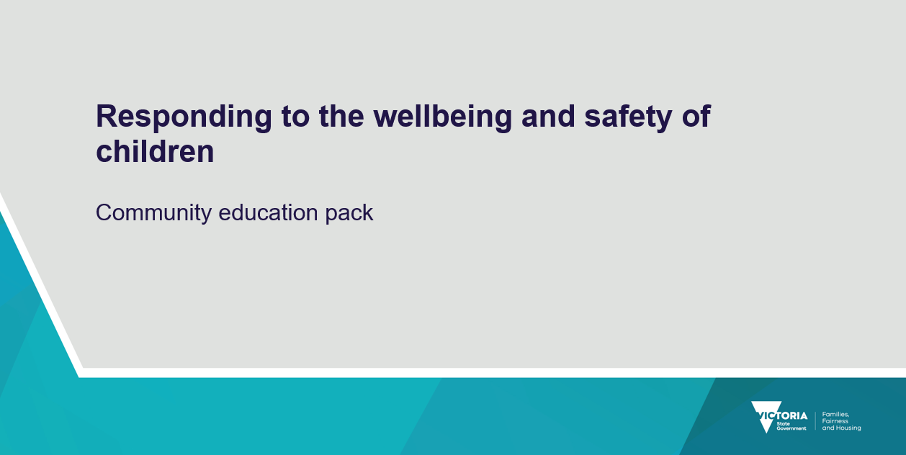

Slide 2

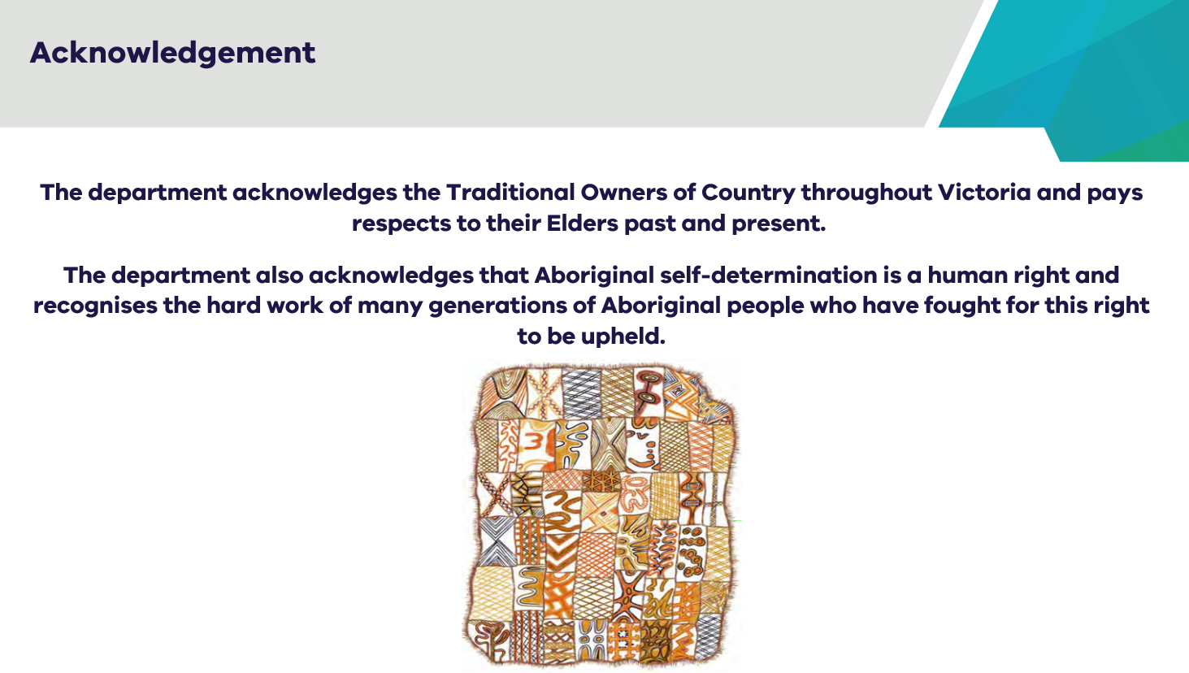

Slide 3
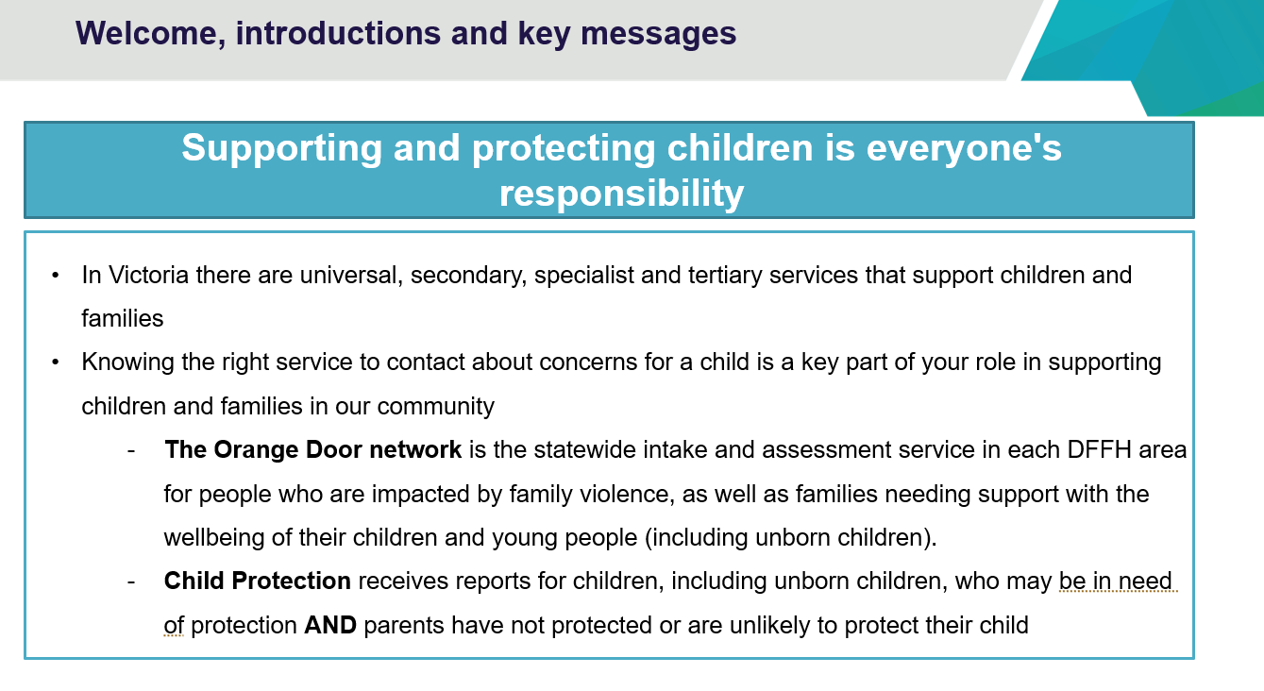

Slide 3 speaking notes.
- Thank you everyone for attending today.
- Introduce yourself as the presenter, if from the Department, your role within the department and anyone else who is co-presenting with you.
- Explain the purpose of the presentation – to inform the audience of the Victorian approach to supporting and protecting vulnerable children, including the role of universal services such as schools, early childhood services and health services, secondary services such as The Orange Door and tertiary services being Child Protection.
- Everyone has a responsibility to support and protect children where there are wellbeing and safety concerns. This presentation will discuss how you can respond if you have wellbeing concerns or concerns for the safety of a child and getting the right support at the right time for children and families.
- Victoria is undertaking significant reform to progress Aboriginal self-determination and a real commitment for Aboriginal people to be involved in the decision-making that affects their children, families, and communities. Today I am pleased to include in this presentation some exciting and ground-breaking reform that is happening.

Slide 4

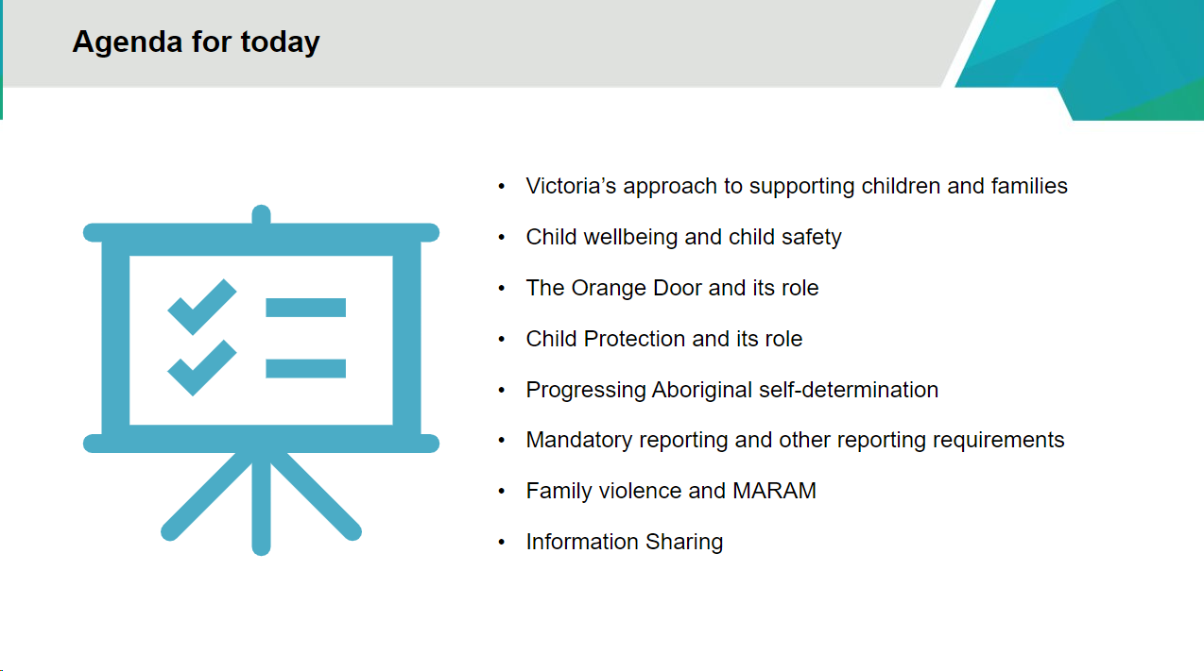

Slide 4 speaking notes.
The presentation will provide information on the following areas:
- Victoria’s approach to supporting children and families.
- Child wellbeing and child safety
- The Orange Door network and its role
- Child Protection and its role
- Progressing Aboriginal self-determination
- Mandatory reporting and other reporting requirements
- Family violence and MARAM
- Information sharing.

Slide 5

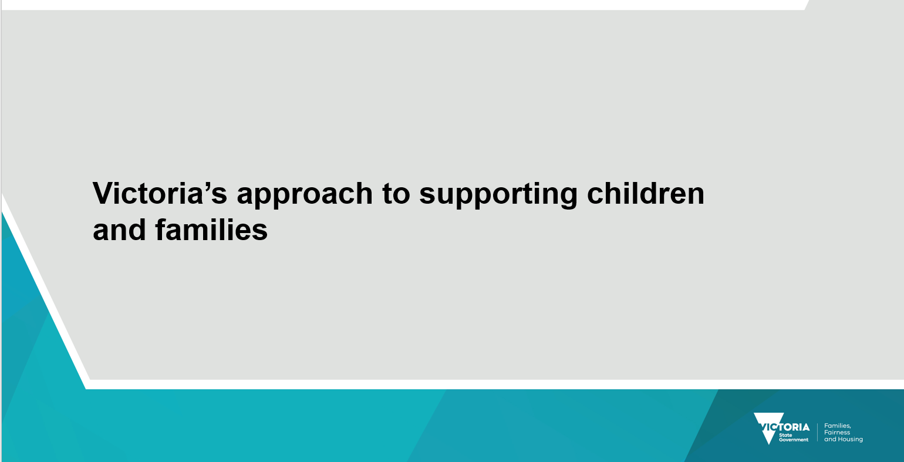

Slide 6

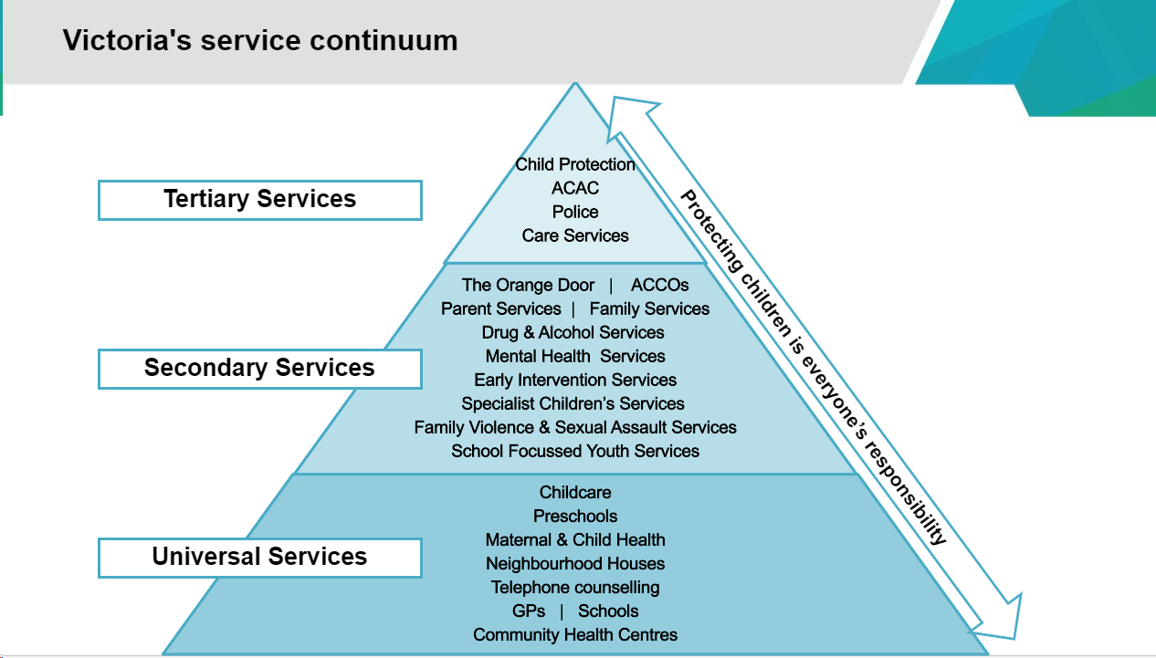

Slide 6 speaking notes.
The department wants people to receive the services they need, when they need them, and where possible avoid them entering the tertiary/statutory system.
Explain to participants that:
- Victorian approach to supporting and protecting vulnerable children, including the role of universal services such as schools, early childhood services and health services, secondary services such as The Orange Door and tertiary services being Child Protection.
- Everyone has a responsibility to support and protect children where there are wellbeing and safety concerns.
- Families, and families with multiple and complex needs have become the primary client group of Child Protection services.
- Victorian data shows family violence, substance abuse and mental illness as commonly co-occurring difficulties for families involved with Child Protection.
- Given the multiple, complex, and serious nature of the problems the families we work with experience AND the presence of numerous risk factors associated with child abuse and neglect, it makes sense for us all to be cognisant of cumulative harm and its impacts on children, and to be intervening early and intervening in decisive, collaborative, and comprehensive ways to prevent abuse and neglect and to support vulnerable children, parents, and families. We all have a role.
Key messages for facilitators
- Getting children and families the right support at the right time by the most appropriate service.
- Everyone has a responsibility to support and protect children where there are wellbeing and safety concerns.
- Understanding the differences between universal, secondary, and tertiary services that can be accessed by professionals and members of the community and how everyone has a role.
- Diverting reports from Child Protection to The Orange Door network and other services for children and families who do not need a statutory service but would benefit from secondary and universal services.
- Child Protection is the most intrusive intervention. Reports to Child Protection should be made when other support services cannot work with parents to protect children from SIGNIFICANT harm.

Slide 7

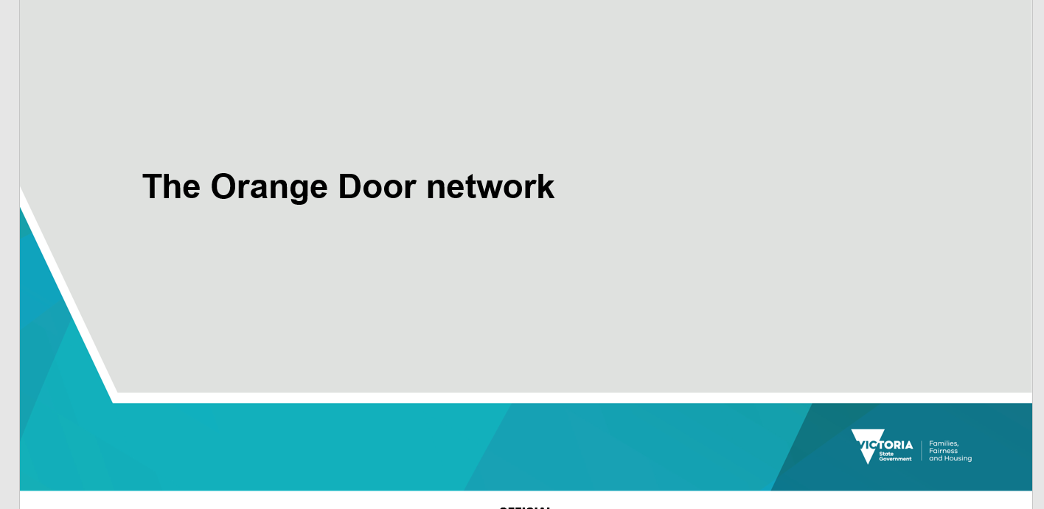

Slide 8

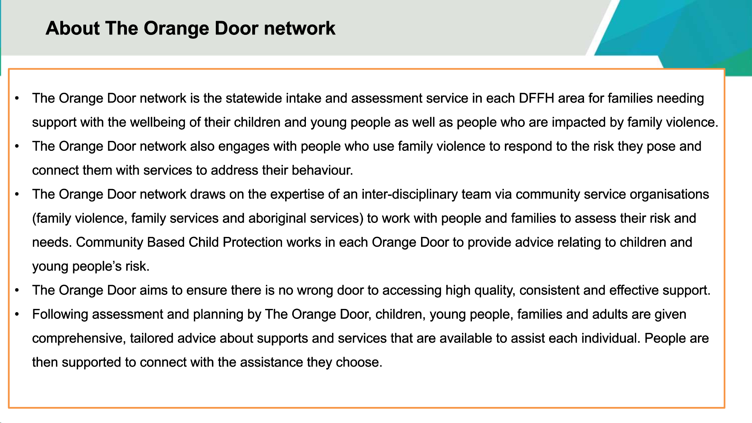

Slide 8 speaking notes.
The Orange Door is the access point for families who need assistance with the care and wellbeing of children and young people, including those experiencing family violence, to contact the services they need to be safe and supported. It is also the contact point when people have concerns about a child, young person and/or family.
The Orange Door have experienced co-located community-based child protection practitioners who support earlier and more effective intervention to vulnerable children, young people, and their families, that is, they provide advice to The Orange Door and family service on whether a Child Protection report is necessary or whether ongoing work by the service is more appropriate. The Community Based Child Protection practitioner may visit with a family service where required.

What services does The Orange Door provide?
Children, young people, and families can access a range of family violence and family services through The Orange Door either in person or over the phone.
The Orange Door brings together practitioners from:
- specialist family violence services
- family services
- Aboriginal services
- services for people who use violence.
Practitioners at The Orange Door work with people who use violence as well as people experiencing violence. Safety is the priority and practitioners will decide with families whether it is best to work with the person using violence:
- over the phone
- in another location family member using violence.
Practitioners at The Orange Door are trained and experienced in responding to family violence and supporting children, young people, parents, and families who need extra support with their care and wellbeing.
Practitioners at The Orange Door understand that every situation is different and that people who need their services may also be dealing with other issues, such as:
- financial
- legal
- health
- substance misuse
- housing
- employment
- education.

The Orange Door can connect you (professionals) with services that can help and support you with these issues too.

Referrals:

Referring to The Orange Door would be appropriate where families:

- are experiencing significant parenting problems that may be affecting the child's development.
- are experiencing family conflict, including family breakdown.
- are under pressure due to a family member's physical or mental illness, substance abuse, disability or bereavement.
- are young, isolated or unsupported.
- are experiencing significant social or economic disadvantage that may adversely impact on a child's care or development.
- The CYFA section 27 enables a confidential report or referral to be made about a child if there is a significant concern for the wellbeing of the child. It also allows for a report to be made about a significant concern about the wellbeing of a child before their birth (that is, an unborn child report, s29 CYFA).

Key message for facilitators
- The Orange Door network is an integrated service that anyone can make a referral to.
- The Orange Door network is the access point for families who need support with the care, wellbeing and safety of children and young people, including those experiencing family violence.
- Community-based Child Protection practitioners are co-located at The Orange Door who can provide consultation to The Orange Door and family service when needed. Having community-based Child Protection Practitioners co-located at The Orange Door enables a more collaborative approach.
- Anyone can attend at The Orange Door locations or call without a referral.

Slide 9
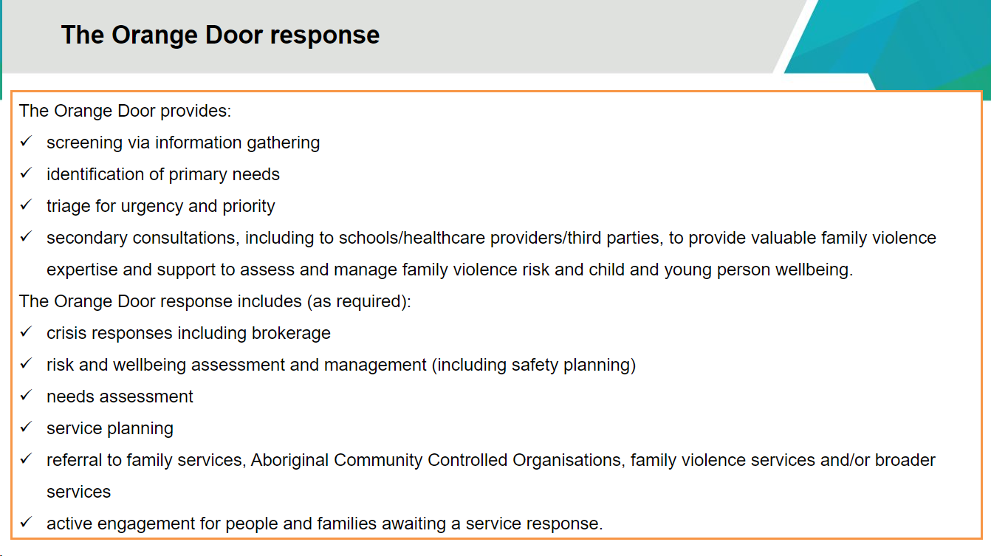

Slide 9 speaking notes.
The Orange Door draws on the expertise of an inter-disciplinary team via community service organisations (family violence, family services and Aboriginal services) to work with people and families to assess their risk and needs. The Orange Door response includes screening via information gathering, identification of primary needs and triage for urgency and priority. The Orange Door can provide: crisis responses including brokerage, risk and wellbeing assessment and management (including safety planning), needs assessment and service planning and allocation.

Slide 10
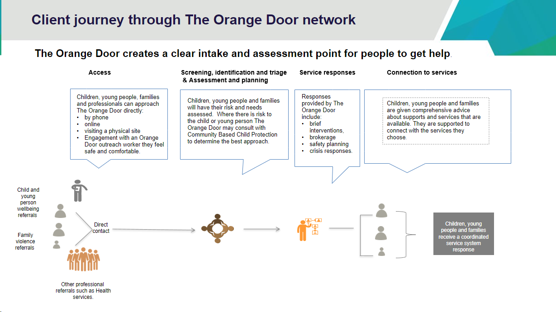

Slide 10 speaking notes.
The Orange Door network is an integral part of Victoria’s family violence and family service system. It is an intake and assessment service, designed to improve coordination and to streamline the client journey into longer term responses.
Access
- The Orange Door receives referrals to do with child and young person wellbeing concerns, and for family violence.
- Children, young people, families, and adults can self-refer by telephone, online, visiting a phiscal site or engaging with an Orange Door outreach worker.
- Alternatively, referrals may come through from a professional or the service system, for example from a teacher, healthcare worker or via a Police Report.
Once a referral is received, The Orange Door performs the following functions:
Screening, Identification and Triage (SIT):
- The SIT team reviews the person’s referral and service history and determines the urgency and priority for the referral.
- Where the person is seeking support from an Aboriginal Community Controlled Organisation (ACCO) a referral to the local service is prioritised.
Assessment and Planning
- The assigned Orange Door practitioner contacts the client where possible and appropriate.
- The practitioner completes comprehensive assessments, aligned with the Best Interests Case Practice Model (BICPM) and/or Family Violence Multi-Agency Risk Assessment and Management Framework (MARAM).
- In family violence cases they develop safety plans with the child, young person or adult.
- Practitioners make use of the Central Information Point and information sharing provisions as needed and appropriate.
- Where there is risk to the child or young person, The Orange Door may consult with Community Based Child Protection to determine the best approach.
- The practitioner develops a Service Plan with the client, based on their risk and needs assessment and their self-described goals.
Service responses
- The Orange Door practitioner can provide a direct response to help the client achieve their goals, for example:
  - Brokerage to enable the person to access a myki or crisis accommodation
  - Brief Intervention, such as emotional support, preparing a support letter or advocating with a young person’s school that they receive additional supports
  - Information or support such as connecting a young person with their local youth group
  - Crisis response such as supporting the person to organise a Centrelink crisis payment or get copies of important identification documents
Connection to services
- Based on their assessment and the client’s goals, the practitioner provides comprehensive advice about services available to them.
- The person is supported to connect to the services they choose, for example Integrated Family Services, a mental health program or an ACCO.

Slide 11
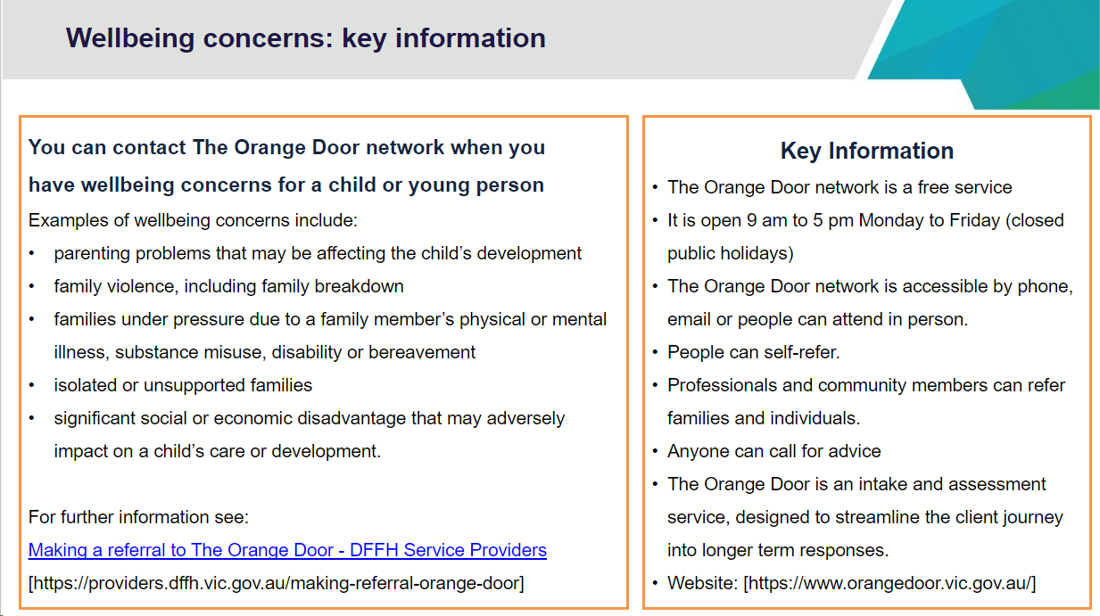

Slide 11 speaking notes.
It is appropriate to refer to The Orange when:
- There are concerns for a child or young person’s wellbeing.
- A family is experiencing significant parenting problems that may be affecting the child or young person's development.
- There is family conflict, including family breakdown.
- There is pressure due to a family member's physical or mental illness, substance use, disability, or bereavement.
- They are young, isolated, or unsupported.
- The family is experiencing significant social or economic disadvantage that may adversely impact on a child or young person's care or development.
Section 27 of the CYFA enables a confidential report or referral to be made about a child if there is a significant concern for the wellbeing of the child. It also allows for a report to be made about a significant concern about the wellbeing of a child before their birth (that is, an unborn child report, s29 CYFA).
Key messages for facilitators
- The Orange Door can connect and refer children, young people and families to support services for their wellbeing and for family violence.
- The Orange Door has co-located Community-Based Child Protection practitioners, which enables a collaborative approach. The Community Based Child Protection practitioners can support earlier and more effective intervention for vulnerable children, young people, and their families. They can provide advice to The Orange Door and family services on whether a Child Protection report is necessary or whether ongoing work by the service is more appropriate.
- The Orange Door is co-located with Aboriginal partners who can offer and provide support for Aboriginal families.

Slide 12

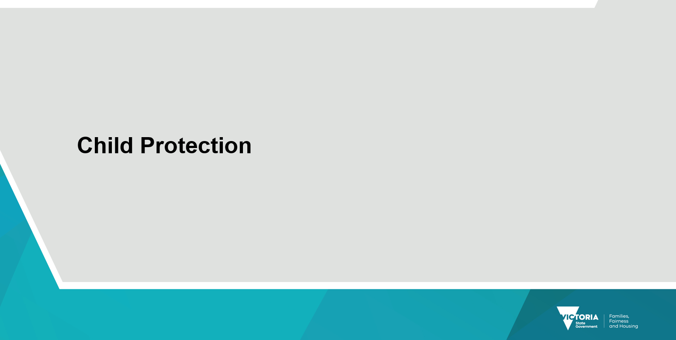

Slide 13

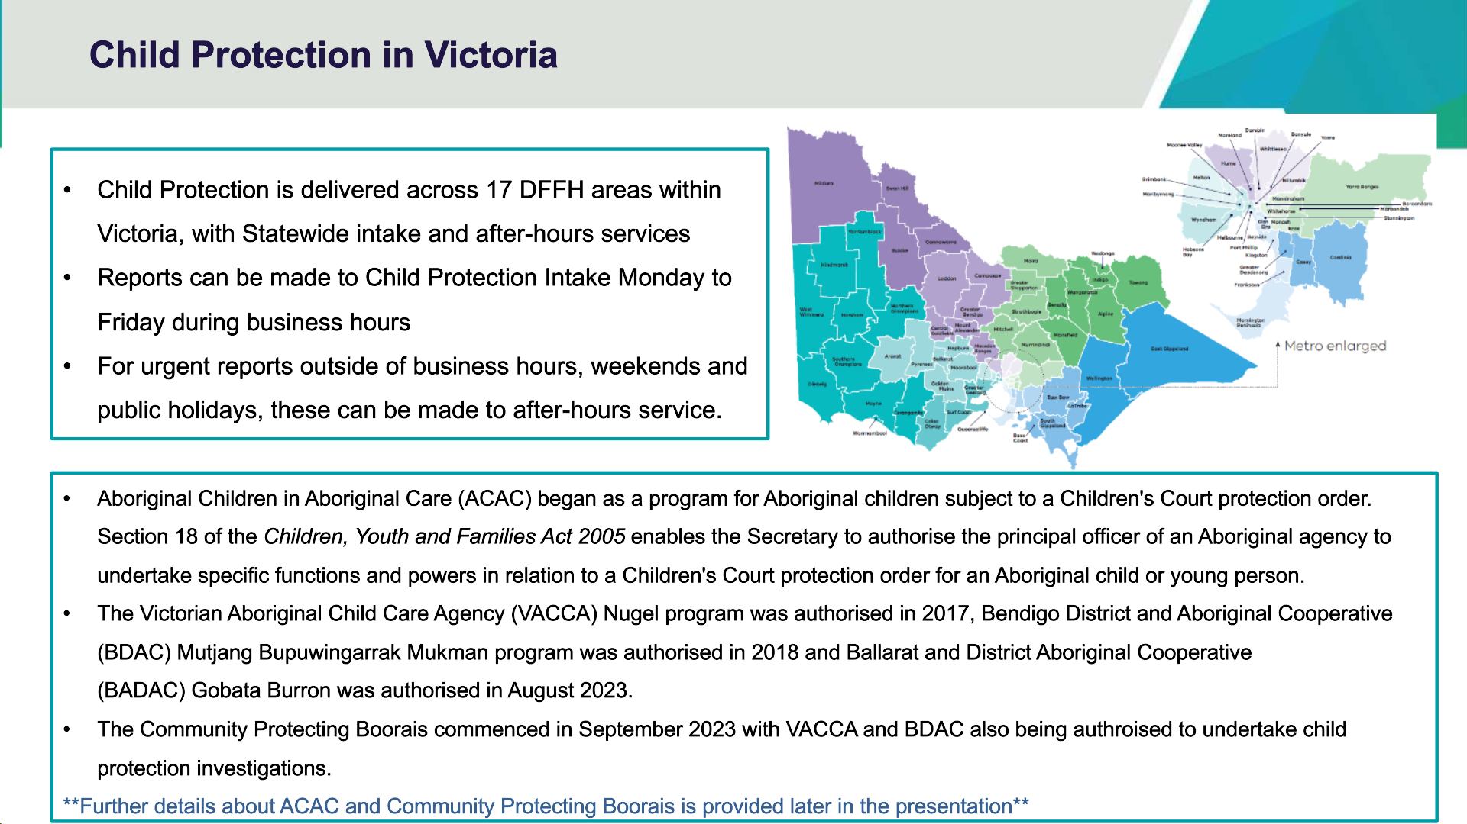

Slide 13 speaking notes.
There are four divisions in Victoria, West, North, East and South Division and in total 17 department areas that deliver Child Protection Across Victoria.
Reports relating to children at significant risk of harm can be made to the Statewide Intake service Monday to Friday during business hours.
Intake numbers are:
- North Division: 1300 598 521
- South Division: 1300 555 526
- East Division: 1300 360 452
- West Division: 1300 360 462
After Hours Child Protection is for urgent reports after business hours, weekends, and public holidays 13 12 78.
The Aboriginal Children in Aboriginal Care (ACAC) program gives authorised Aboriginal Community-Controlled Organisations (ACCOs) – under section 18 of the Children, Youth and Families Act 2005 – legal responsibility for Aboriginal children or young people who have been placed on a Children’s Court protection order.
Under this program, an authorised ACCO such has VACCA Nugel, BDAC and BADAC will actively work with the child’s family, community, and other professionals to develop a case plan to address protective concerns and achieve long-term objectives in a way that is culturally appropriate and in the best interests of the child.
The Statement of Recognition Act expanded the role of ACAC to enable some ACAC providers to be authorised to undertake investigative powers and functions, allowing for earlier intervention by ACCOs in an Aboriginal child and family’s journey. The Community Protecting Boorais commenced in September 2023 with VACCA and BDAC undertaking the investigations.

Slide 14

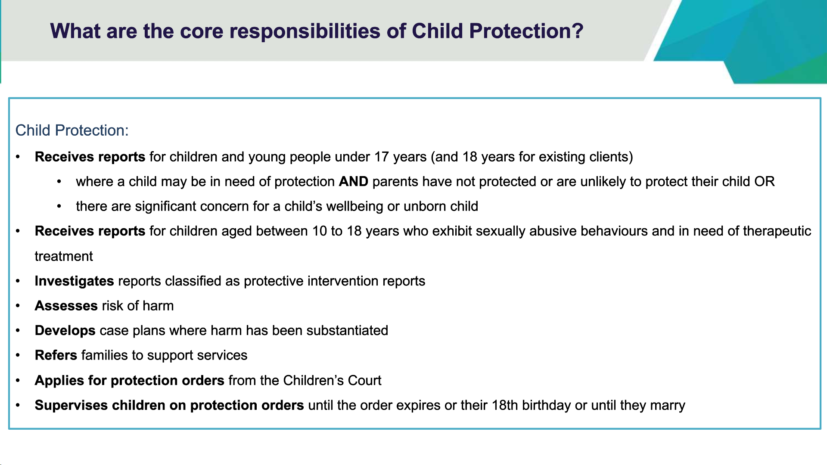

Slide 14 speaking notes.
Under the Children, Youth and Families Act 2005, Child Protection has a specific statutory role, which includes:
- Providing advice to people who report concerns about children and young people.
- Assessing reported concerns in relation to children where it is believed a child is at risk of significant harm.
- Engaging and working with children and families to promote safety, development and wellbeing of the child, and to strengthen family capacity.
- Making applications to, and attending, the Children’s Court and supervising protection orders.

Specifically, the role of Child Protection is to:
- Receive reports for children under the age of 17 years of age, usually by phone: where there is a significant concern for a child’s wellbeing or unborn child or a child may be in need of protection and parents, or caregivers are unable or unwilling to care for and protect their child.
- Receive reports on children aged between 10 to 18 years who exhibit sexually abusive behaviours and are in need of therapeutic treatment. (Over the last few years, the term sexually abusive behaviours has been interchanged with harmful sexual behaviours. The Act refers to the behaviours as sexually abusive behaviour. (For the purposes of this document, the term ‘sexually abusive behaviour’ will be used)
- Under the CYFA, Child Protection can, receive reports on an unborn child, provide advice to the person who made the report, provide advice and assistance to the mother of the unborn child, with her consent can refer the mother of the unborn child to a community-based child and family service or a service agency to provide advice, service, and support.
- Aboriginal child specialist advice and support service (ACSASS) provides consultation and advice for Child Protection practitioners involved with Aboriginal families from the point of a report being made to Child Protection through to case closure.
- Child Protection must consult with ACSASS regarding all significant decision regarding an Aboriginal child. ACSASS assists child protection practitioners or A&PC teams to comply with the Aboriginal Child Placement Principle and to meet the requirements under the CYFA regarding decision making and care arrangements for Aboriginal children.
- Assess risk of harm, may gather additional information.
- Investigate reports which include direct interviews with the child, young person, and parents.
- Refer families to support services such as The Orange Door.
- Apply for protection orders from the Children’s Court of Victoria.
- Supervise children on protection orders granted by the Children’s Court of Victoria and can have parental responsibility for some children on certain orders, up until the child’s 18th birthday or until they marry.
- Both Child Protection and Victoria Police are protective interveners and have the legal mandate to intervene when a child is in need of protection. There are times when a report requires a joint response from Child Protection and Victoria Police to protect children and young people from serious abuse and neglect. Victoria Police has responsibility for criminal investigations and Child Protection for the protective investigation.
- Victoria Police is responsible for the criminal investigation of alleged physical injury or sexual abuse of a child by a parent or carer, serious neglect of a child and sexual offences committed by children.

Key messages for facilitators
Key messages for facilitators
- The difference between Child Protections statutory role and other services.
- When a non-statutory service is more appropriate to provide support for the wellbeing of a child
- A statutory Child Protection Response is not always needed.

Slide 15

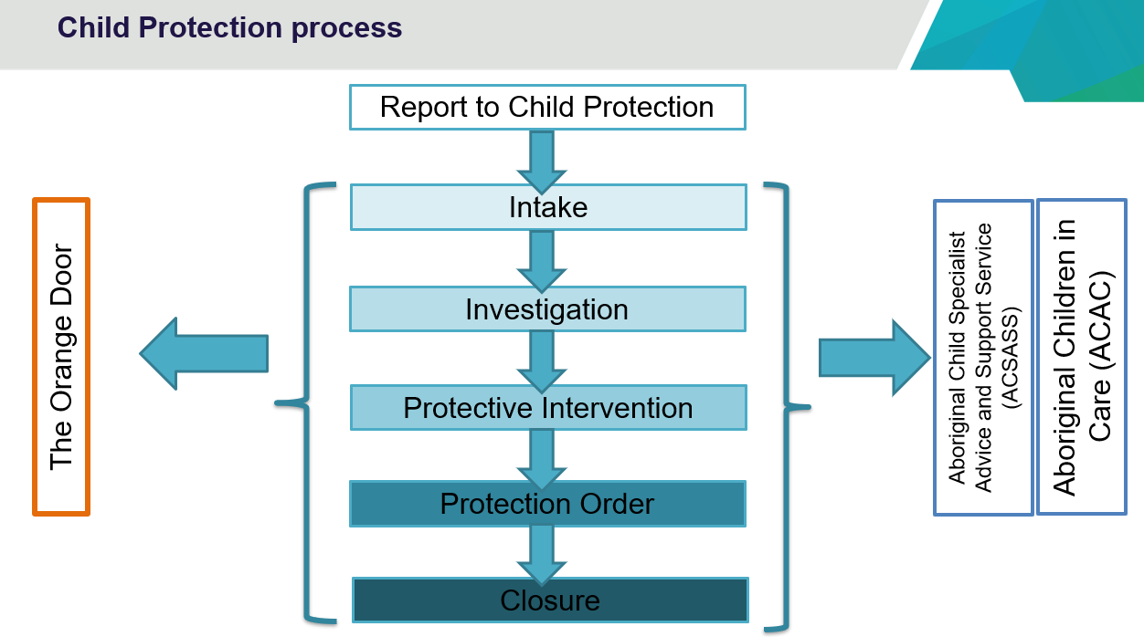

Slide 15 speaking notes.
Below explains the Child Protection process. (This can be tailored dependant on the audience you are presenting to.)

The intake phase in Child Protection includes:
- Child Protection receiving reports from people who believe that a child or young person is in need of protection.
- assessing risk of harm and determining appropriate level of service response by Child Protection
- gathering further information, as allowed for in legislation.
- contacting support services where appropriate such as maternal child health nurse, school, doctor, police, etc.
- referring cases to support services in the community where appropriate (wellbeing reports)
- transferring cases for investigation where required (classifying reports as protective intervention reports)
- informing reporters on the outcome of the report
- offering advice to the reporter.

The investigation phase in Child Protection involves:
- investigating reports of harm, abuse and neglect (referred from Intake) via direct contact with the family and child.
- determining if the child has suffered or is likely to suffer harm.
- possible outcomes – protective concerns substantiated OR not substantiated (which then determines next steps by Child Protection).
- referring cases to support services in the community where appropriate.
- applying to the Children’s Court for a protection order in cases of immediate and severe risk
- working with families and support services to address concerns where there is less risk of harm to the child

Protective intervention:
- Occurs if an investigation substantiates a report by finding that a child is in need of protection.
- In most situations, Child Protection work with the child and family by agreement to address the identified protective concerns, initially for up to 3 months.
- Direct casework with the child and family to address the concerns.
- Referral to specialist services.
- Close where a community safety plan has been developed.
- Issuing a protection application as required.

Case planning:
- Case planning (ss166-169 CYFA) is the process of making significant decisions in relation to a child during Child Protection involvement, from intake to closure. Planning stems from effective information gathering and analysis of the available information. It is directly informed by the current SAFER risk assessment of the child’s situation and lived experience, and directly informs any actions that need to be taken.
- Case planning in Child Protection practice specifically relates to the processes of planning with children and their families following substantiation of protective concerns.
- Case planning includes legislative and policy requirements relating to the preparation, provision and review of case plans and specific requirements and considerations for case planning for Aboriginal children including the requirement for cultural planning.
- All case plans must include a permanency objective for the child – the objective highest in the hierarchy that is consistent with the child’s best interests. The alignment of the permanency objective and court orders is required by legislation, and we will outline these in the next slide. The hierarchy of permanency objectives is set out in order of preference:
- family preservation
- family reunification
- adoption
- permanent care
- long-term out of home care.

Court action:
- Where the child or family is unwilling to work with Child Protection, or the child cannot safely remain in parental care, Child Protection may issue a protection application (PA) and bring the matter before the family division of the Children’s Court.
- The Court will usually make an interim accommodation order (IAO) and adjourn the matter. On average, it takes a number of months until the Court determines the outcome of the application and if proven grants a final protection order.
If the child is required to be placed in an out of home care placement, then kinship care is the preferred placement option which is reflected in legislation and policy.

Case Contracting
A case contract is a formal arrangement in the form of a written agreement, between Child Protection and another agency for the provision of case management for a child subject to a protection order. Contracting arrangements are designed to enable the most appropriate agency to support implementation of the case plan.
Child Protection may contract a community service to undertake total case management or specified functions only.

Aboriginal Children in Aboriginal Care (ACAC):
- Aboriginal Community Controlled Organisations (ACCO) are the experts and well placed to understand the needs of Aboriginal children and their families. Connection to culture, community and Country is fundamental to the safety of Aboriginal children.
- To support this, the care and case management of Aboriginal children and young people subject to a protection order is gradually transferring from the Department and non-Aboriginal organisations to ACCOs. ACCOs will also have increased responsibility for Aboriginal children under ACAC provided under section 18 CYFA which gives ACCOs the opportunity to undertake case planning and case management for Aboriginal children and young people subject to a Children’s Court protection order.
- Currently Bendigo District Aboriginal Co-op (BDAC), Victorian Aboriginal Child Care Agency (VACCA) and Ballarat and District Aboriginal Cooperative are authorised.
- ACAC is currently being expanded and two ACCOs, Bendigo District Aboriginal Co-op and Victorian Aboriginal Child Care Agency (VACCA) will undertake a number of protective investigations.
- The department funds and provides a wide range of services that assist vulnerable children and families. These funded services are required to meet standards set in service agreements or registration standards and are subject to periodic review. These include the Aboriginal Child Specialist Advice and Support Service (ACSASS), which is available statewide to give advice and information to child protection practitioners.
- It is also important to remember that your local ACCO is a great resource and has a role to play when working with families (for example, a meeting with the family could be held there instead of the departmental office). It is important to familiarise yourself with the full range of services that exist in the local ACCO. (More detailed information is available on slides 31 to 34)

Key messages for facilitators
- Understanding of intake processes and thresholds for Child Protection cases.
- Understanding the Child Protection process including phases of a case and when court becomes part of the process.
- Approximately 70% of reports made to Child Protection are not investigated, with a portion of these being referred to The Orange Door or other support services (approximately 30%).
- Of this 70% many of the reports made to child protection could have been a direct referral to The Orange Door.

Slide 16
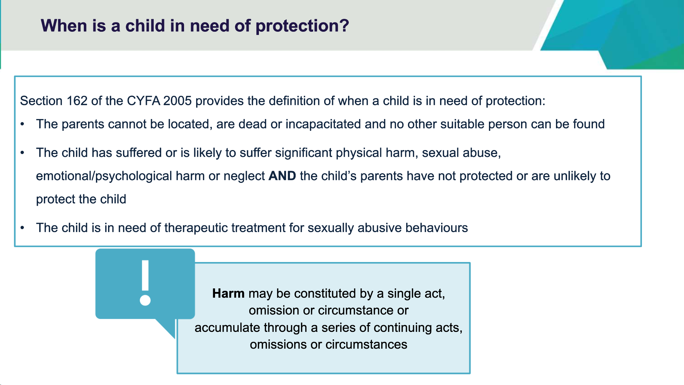

Slide 16 speaking notes.
CYFA section 162 provides a definition of a child in need of protection, which is the threshold for which child protection can intervene in a family:
- The parents of a child cannot be located, are dead or incapacitated and no other suitable person can be found.
- The child has suffered or is likely to suffer significant harm as a result of physical injury, sexual abuse, emotional/psychological harm or neglect, and the child's parents have not protected, or are unlikely to protect the child from harm of that type.
- the child’s physical development or health has been or is likely to be significantly harmed.
The threshold for intervention in these circumstances relies on ‘significant harm’. A matter before the Supreme Court identified significant as:
more than trivial insignificant, but need not be as high as serious…and (is) important or of consequence, to the child's development'…
'It is irrelevant that the evidence may not prove some lasting permanent effect or that the condition could be treated'.
The significance must be demonstrated in a way that is specific to the case. For example, the same level of bruising may be seen as causing significant harm for a three-month-old baby but not so if found on a 14-year-old child.
For harm to be regarded as significant it must be 'of consequence' or be of 'considerable amount, or effect, or importance’. This is an important factor for Child Protection to determine. For you as a reporter it might be helpful to think about the impact the abuse/the actions may have on the child, in context of the other factors you need to consider such as parents’ ability to protect, reasonable belief, etc.
Harm may be constituted by a single act, omission or circumstance or accumulate through a series of continuing acts, omissions, or circumstances.
Under the Children, Youth and Families Act 2005, child protection practitioners have a specific statutory role which includes:
- providing advice and consultation to people who report concerns about children and young people.
- assessing children and families where it is believed a child is at risk of significant harm.
- making applications to, and attending, the Melbourne Children’s Court
- engaging and working with children and families to promote safety, stability, and development of the child, and to strengthen family capacity.

Therapeutic treatment for sexually abusive behaviours
The child is in need of therapeutic treatment for sexually abusive behaviours:
- A therapeutic treatment order requires the child to participate in an appropriate therapeutic treatment program and may include a condition directing the parent of the child to take any necessary steps to enable the child to participate in a therapeutic treatment program; and
- directing the child to permit reports of his or her progress and attendance at the therapeutic treatment program to be given to the Secretary; and any other conditions that the Court considers appropriate.
- A child in need of therapeutic treatment is defined in the Children Youth and Families Act 2005 section 244 as over the age of 10 and under the age of 18 and has exhibited sexually abusive behaviours.

Key messages for facilitators
- To understand CYFA section 162 definition of a child in need of protection, which is the threshold for Child Protection to intervene.
- To understand the definition of harm/s for Child Protection.

Slide 17
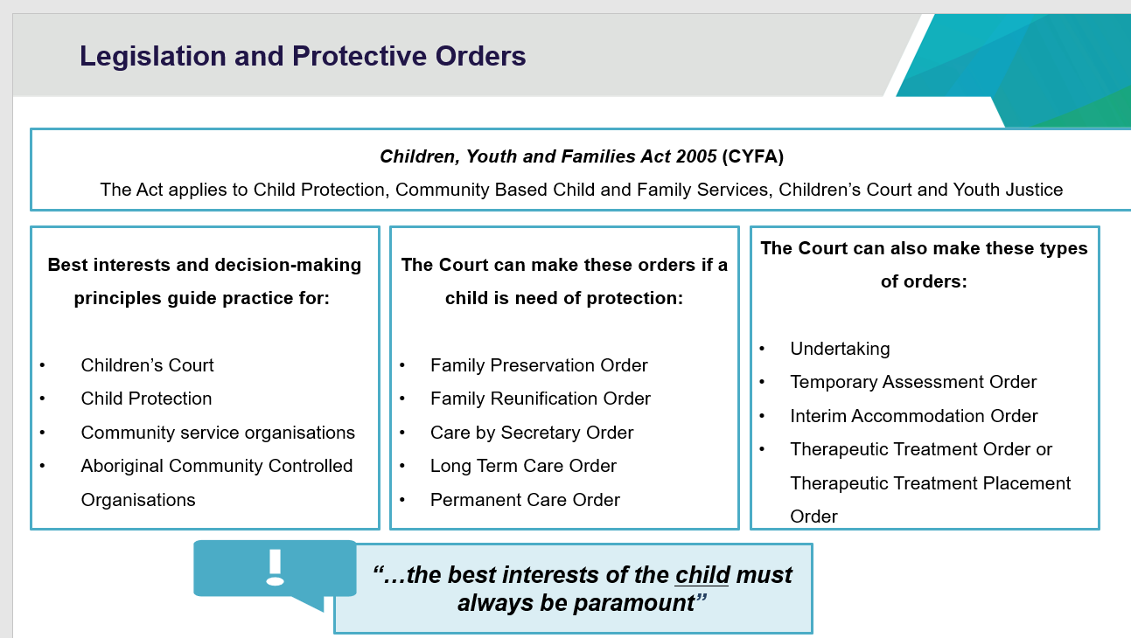

Slide 17 speaking notes.
- Explain that the Children Youth and Families Act 2005 provides for Child Protection, Community Service Organisations, ACCOs, the Children’s Court, and Youth Justice.
- The CYFA has best interests and decision-making principles that the Children’s Court, Child Protection and community service organisations must comply with. The Act stipulates when child protection can intervene where a child is in need of protection. The legal term “a child in need of protection” will be explained during the presentation and it will provide you with an understanding of the circumstances when a report to child protection may be appropriate or when it may be more appropriate to refer the family to support services.
- You may wish to provide some examples of best interest and decision-making principles such as:
  - The best interests of the child must always be paramount, and always include protecting from harm and promoting the child’s rights and development.
  - Desirability of family preservation and reunification, continuity and permanence of care, family contact, preservation of cultural identity and connection.
  - Desirability of the child being supported to gain access to appropriate educational services, health services and accommodation and to participate in appropriate social opportunities.
  - The effects of cumulative harm on a child’s safety, wellbeing and development.
To access legislation, visit the Victorian legislation website www.legislation.vic.gov.au.

Key messages for facilitators
The CYFA has best interests and decision-making principles that the Children’s Court, Child Protection and community service organisations must comply with.
The Act stipulates when Child Protection can intervene where a child is in need of protection.

Slide 18

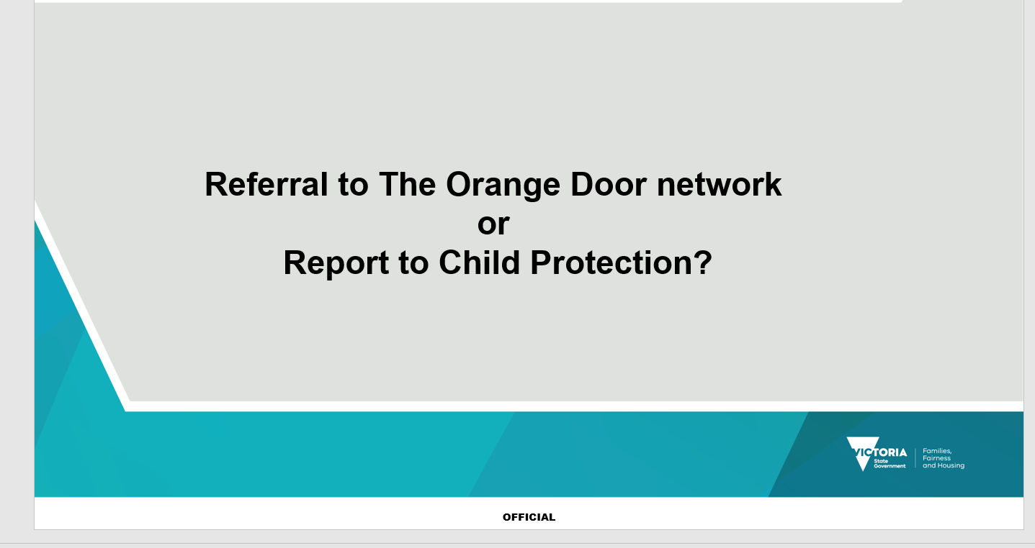

Slide 19
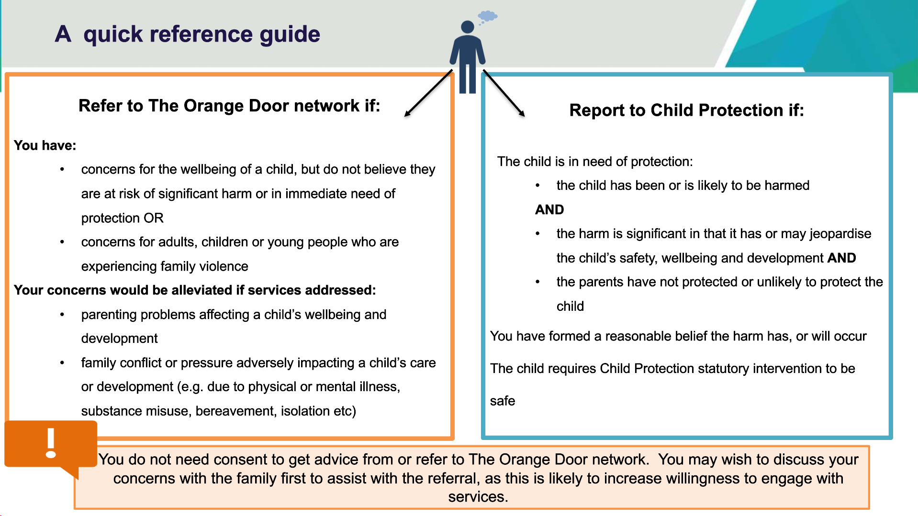

Slide 19 speaking notes.
The Orange Door partners have access to a Community Based child protection practitioner who they can consult with regarding risk issues for children and young people. This function supports The Orange Door in identifying and managing lower levels of safety risks to children and young people, including making decisions as to when the risk escalates to a point where a statutory child protection response is required.
Child Protection intervention should be a last resort and being a statutory body can be very intrusive and stigmatising for families.
For the statutory system to effectively respond to children it is important for children and families to be referred, where possible, to the most appropriate service or professional the first time.

Key messages for facilitators
- The Orange Door and partners have access to a co-located community-based child protection practitioner which allows for a collaborative approach for consultation and identifying wellbeing concerns and risks for children and families.
- For the service system to effectively respond to children and young people it is important for them and their families to be referred, where possible, to the most appropriate service or professional the first time.
- Everyone has a responsibility to support and protect children and young people from wellbeing and safety concerns.
- Getting families to the right support they need earlier.
- Child Protection should be a last resort for children and families.

Slide 20

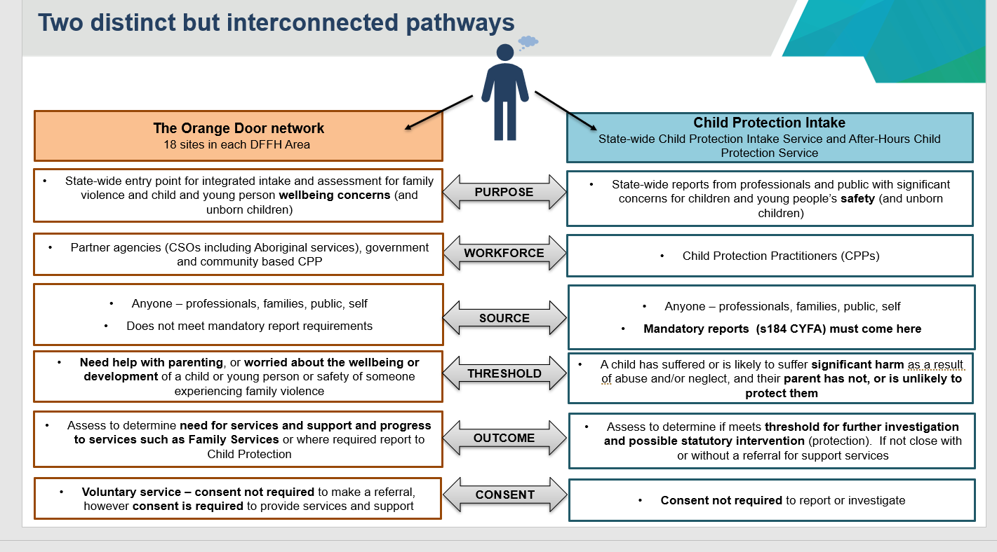

Slide 20 speaking notes.
When considering whether to make a referral to The Orange Door or a report to Child Protection, individuals should consider the best interests of the child, whether the concerns relate to wellbeing or safety and the outcomes to be achieved.
The two pathways have different roles and responsibilities.
The Orange Door is a voluntary service which seeks to engage parents/carers and children and young people and link them to services to address wellbeing and safety concerns that do not meet the threshold for Child Protection.
Child Protection delivers a statutory service where there are concerns for the safety of the child and where significant harm is likely or has occurred.

Key messages for facilitators
- Professionals should consider the best interest of the child when making a report, is it wellbeing or safety concerns?
- The Orange Door is a voluntary service that can address wellbeing and safety concerns that do not meet the child protection threshold.
- Child Protection is a statutory service that focuses on the safety of a child where significant harm is likely or has occurred.
- Both services work collaboratively and intersect with one another to protect the safety and wellbeing of vulnerable children.

Slide 21

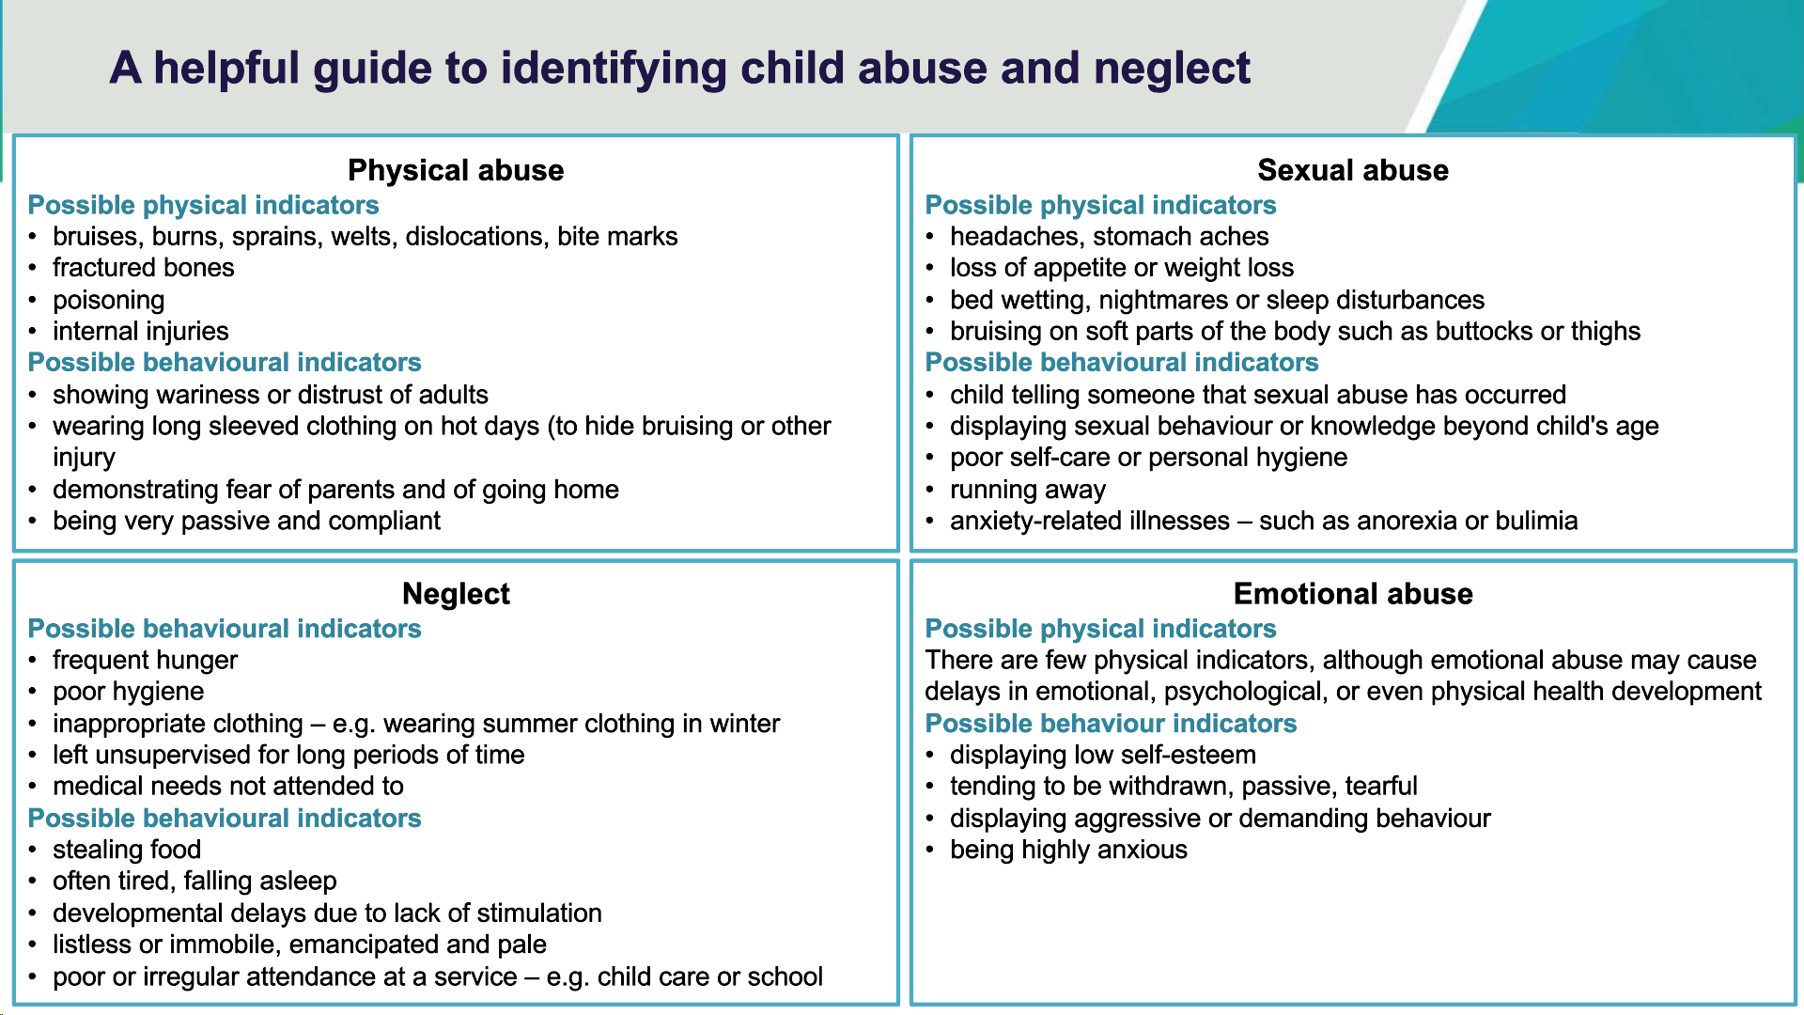

Slide 21 speaking notes.

Practice Definitions
Child abuse is any action, or lack of action, that significantly harms the child's physical, psychological, or emotional health and development. The CYFA enables consideration of the pattern and history of harm and the impacts on a child's safety, development and wellbeing. There is now an overwhelming body of evidence to indicate that neglect, abuse and family violence are harmful and have a cumulative and detrimental effect on a child's safety and development.
Although the abuse types are described separately below for the purposes of definition, in reality many of the following forms of harm may occur within one substantiated case.
As per the police protocol, Child Protection must inform Victoria Police when a child has been physically injured, sexually abused or is suffering from serious neglect.

Physical abuse
Physical abuse consists of any non-accidental form of injury or serious physical harm inflicted on a child by any person.
Physical abuse does not mean reasonable discipline though it may result from excessive or inappropriate discipline.
Physical abuse can include beating, shaking, burning and assault with weapons.
Physical injury and significant harm to a child may also result from neglect by a parent or caregiver or within the context of family violence.
The failure of a parent or caregiver to adequately ensure the safety of a child may expose the child to extremely dangerous or life-threatening situations, which result in physical injury and significant harm to the child. Physical abuse also includes Fabricated Illness Syndrome (previously Munchausen's Syndrome by Proxy).

Emotional abuse
Emotional abuse occurs when a child is repeatedly rejected, isolated, frightened by threats or is experiencing family violence. It also includes hostility, derogatory name-calling and put-downs, or persistent coldness from a person to the extent where the behaviour of the child is disturbed, or their emotional development is at serious risk of being impaired.

Sexual abuse
A child is sexually abused when any person uses their authority over the child to involve the child in sexual activity. Child sexual abuse involves a wide range of sexual activity including fondling genitals, masturbation, vaginal or anal penetration by a finger, penis or any other object, voyeurism, and exhibitionism. It can also include exposure to or exploitation through pornography or prostitution. Failure to protect a child from sexual abuse may in part relate to parental impairment or lack of parental competence to protect the child from such harm.

Neglect
Neglect includes failure to provide the child with an adequate standard of nutrition, medical care, clothing, shelter, or supervision to the extent where the health or development of the child is significantly impaired or placed at risk. A child is neglected if they are abandoned or left uncared for over unreasonable periods of time that is inconsistent with their age, stage, and development.

Serious neglect
Serious neglect in this context potentially constitutes a criminal offence on the part of a parent and includes situations where a parent fails to meet the child's basic needs for food, shelter, hygiene, or adequate supervision to the extent that the child's health and physical safety is jeopardised.
For example, the child's home environment is filthy or hazardous in the extreme and poses a threat the child's immediate safety or development and is characterised by the presence of animal or human faeces or urine, decomposing food, syringes or other dangerous drug paraphernalia; or where the child is provided with consistently insufficient or inadequate food or nourishment for the child's healthy development; or where a child has a serious medical condition for which the parent has consistently failed to obtain treatment or dispense prescribed medication; or where a parent consistently leaves a child unattended, exposed to or in the care of strangers who may harm the child.

Medical neglect
Neglect of medical care refers to a situation where a parent's refusal of, or failure to seek treatment or agree to a certain medical procedure leads to an unacceptable deprivation of the child's basic rights to life or health.

Key message for facilitators
- Understanding abuse definitions, which will support knowing when to report to Child Protection.
- These definitions are available in the Child Protection manual.
- https://www.cpmanual.vic.gov.au/

Slide 22

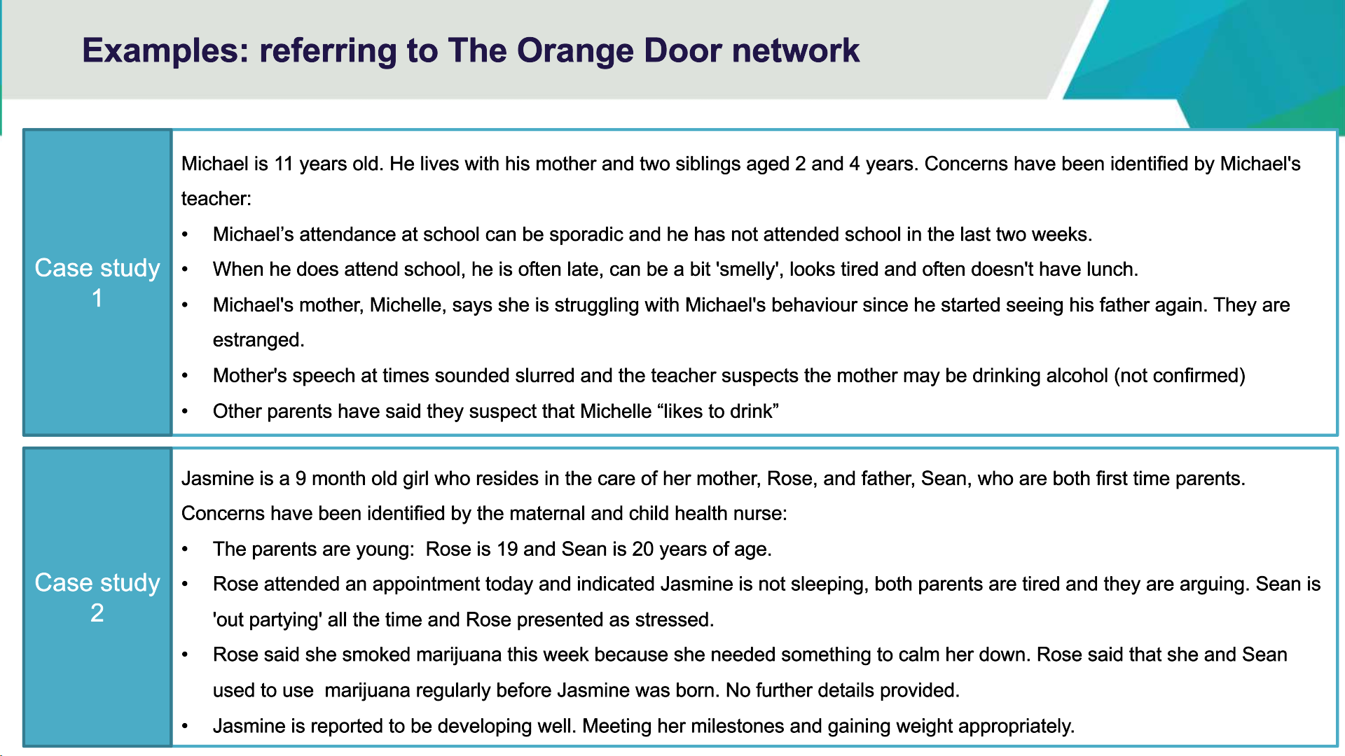

Slide 22 speaking notes.
Refer to slide and discuss when it is appropriate to refer to the Orange Door.
Example 1:
- The Orange Door would be able to engage Michael's mother around parenting, refer to her relevant supports and work with the school to improve Michael's attendance at school.
- There is no information now to support concerns in relation to mother's alcohol use, however this is a conversation that could occur between the mother and Family Services workers. Support for alcohol use may be required, however it is unclear now.
- A Family Support worker could discuss the impact of recent contact between Michael and his father.
Example 2:
- While it is worrisome that both parents appear to be experiencing some challenges associated with becoming new parents and the maternal and child health nurse is concerned that the parents are arguing, the father does not always appear to be present in the home and there is some level of marijuana use by Jasmine's mother, a referral to The Orange Door appears appropriate. Despite the challenges, Jasmine appears to be developing well.
- The Orange Door could work with both parents to address some of the issues self-reported by Jasmine's mother.
The Orange Door practitioners in both examples can work and support parents experiencing parenting challenges. Should staff from The Orange Door have concerns they do not feel they can manage, they are able to consult with the co-located Community Based child protection practitioner to look at additional supports and/or to determine the need for a report to Child Protection.

Slide 23
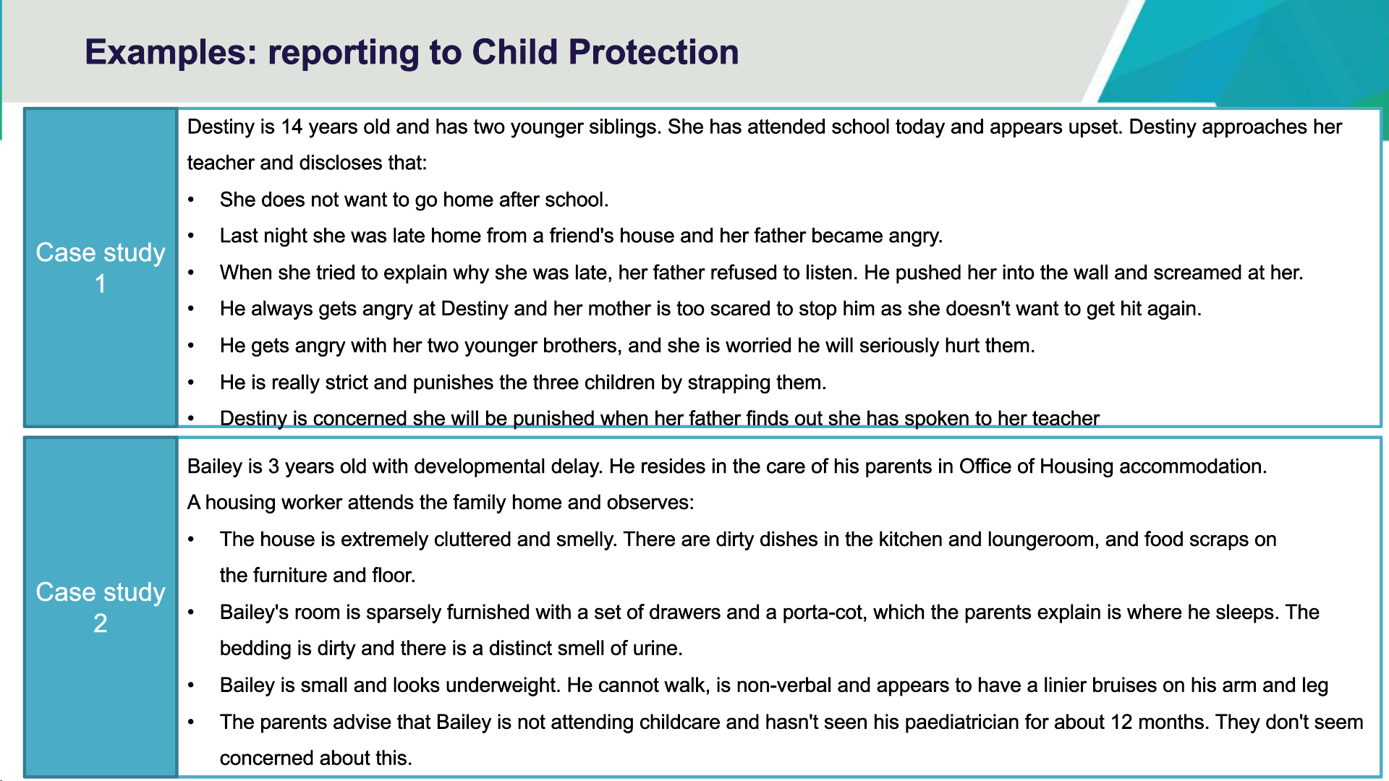

Slide 23 speaking notes.
Refer to slide and discuss when it is appropriate to make a report to Child Protection.
In both examples, these concerns are reported to Child Protection. They demonstrate a significant impact on the children and on the children's physical and emotional safety.
Child Protection intervention is required to assess these serious concerns and to take action as required.

Slide 24

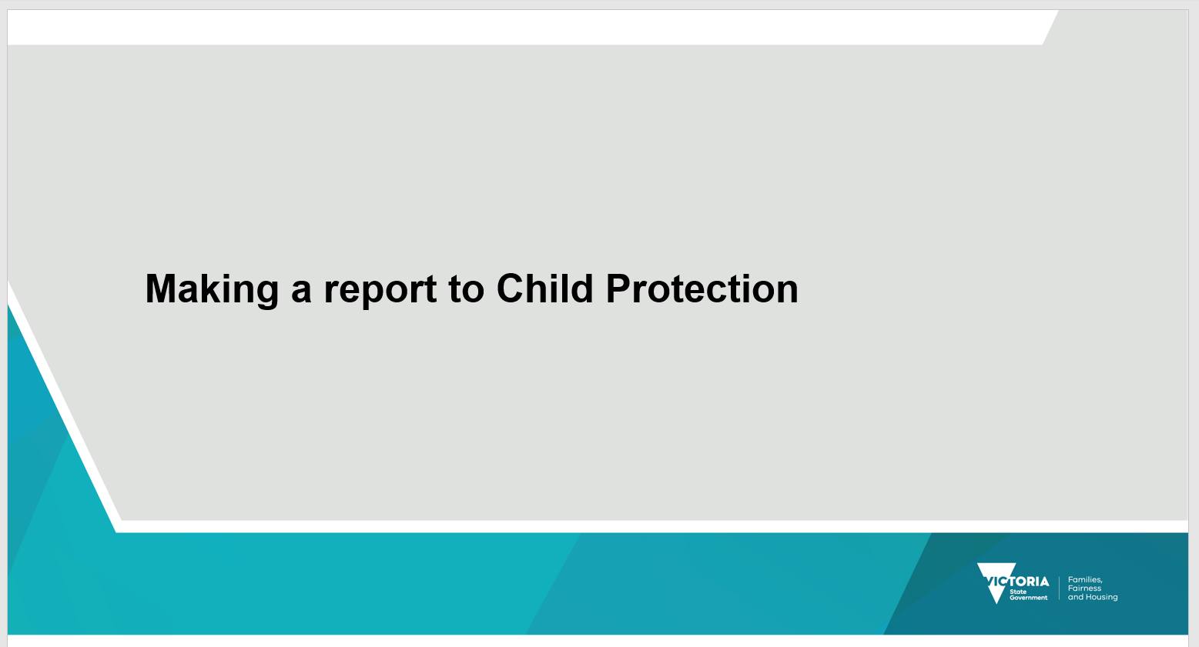

Slide 25
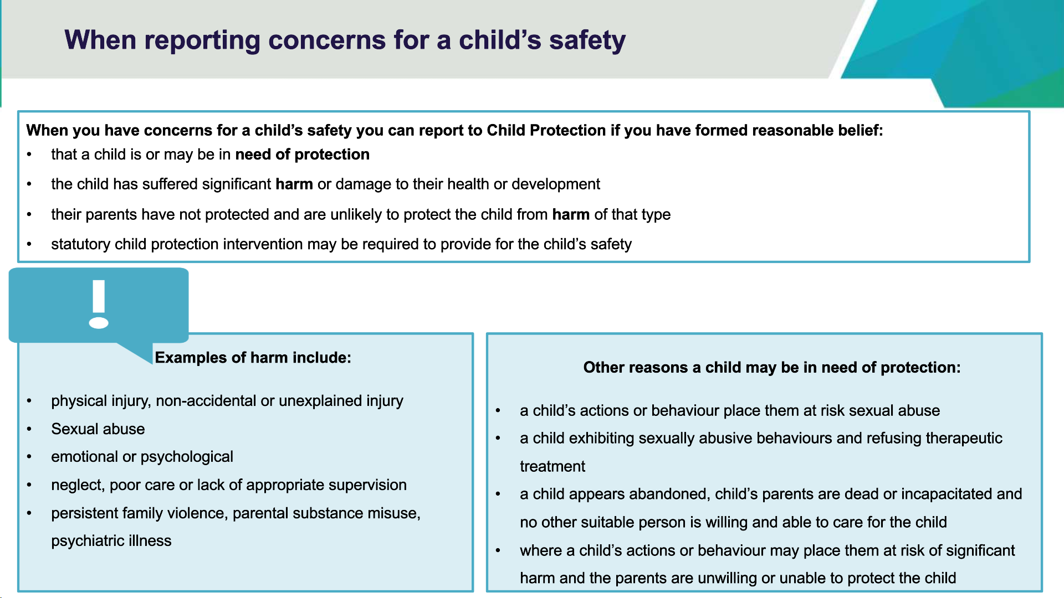

Slide 25 speaking notes.
Summarise what has been presented so far:
- Child Protection receive reports about children when there are concerns the child is in need of protection.
- A child in need of protection is a child who has suffered or is likely to suffer significant harm because of abuse or neglect, and their parent has not protected or is unlikely to protect the child from harm of that type. The threshold is: has suffered or is likely to suffer significant harm. The Supreme Court identified significant as:
  - 'More than trivial or insignificant, but need not be as high as serious…and
  - (is) important or of consequence, to the child's development'…
  - 'It is irrelevant that the evidence may not prove some lasting permanent effect or that the condition could be treated'.
- Reports to Child Protection should be made when the child’s parent has not protected or is unlikely to protect the child from harm of that type in any of the following circumstances:
  - physical abuse of, or non-accidental or unexplained injury to, a child (mandatory reporters must report)
  - a disclosure of sexual abuse by a child or witness, or a combination of factors suggesting the likelihood of sexual abuse – the child exhibiting concerning behaviours, e.g., after the child's mother takes on a new partner or where a known or suspected perpetrator has unsupervised contact with the child (mandatory reporters must make a report to child protection)
  - emotional abuse and ill treatment of a child – impacting on the child's wellbeing and healthy development.
  - significant neglect, poor care, or lack of appropriate supervision – where there is a likelihood of significant harm to the child, or the child's wellbeing and development.
  - significant family violence or parental substance misuse, psychiatric illness, or intellectual disability – where there is a likelihood of significant harm to the child, or the child's wellbeing and development
  - where a child's actions or behaviour may place them at risk of significant harm and the parents are unwilling, or unable to protect the child.
  - where a child appears to have been abandoned, or where the child's parents are dead or incapacitated and no other person is caring properly for the child.
Many cases will not fit neatly into these categories, so the following questions may help you decide on the best course of action.
Other factors to consider:
- What specifically has happened to the child that has caused your concerns and what is the impact on their safety, stability, health, wellbeing and development?
- How vulnerable is the child?
- Is there a history or pattern of significant concerns with this child or other children in the family?
- Are the parents aware of the concerns, capable and willing to take action to ensure the child's safety and stability, and promote the child's health, wellbeing, and development?
For harm to be regarded as significant it must be 'of consequence' or be of 'considerable amount, or effect, or importance'.
To make a report to Child Protection a person needs to have formed a reasonable belief that a child has suffered or is likely to suffer significant harm as a result of abuse or neglect, and that their parent has not protected or is unlikely to protect the child from harm of that type.
Information provided to Child Protection when a report is made, should be sufficiently detailed for child protection practitioners to identify if the child is at risk of harm. Where concerns relate to an alleged perpetrator of abuse, who may pose a risk more generally to all children, the concerns should be reported to Victoria Police.

Key message for facilitators
- Knowing when to make a report to Child Protection.
- To make a report to Child Protection a person needs to have formed a reasonable belief that a child has suffered or is likely to suffer significant harm as a result of abuse or neglect, and that their parent has not protected or is unlikely to protect the child from harm of that type.

Slide 26
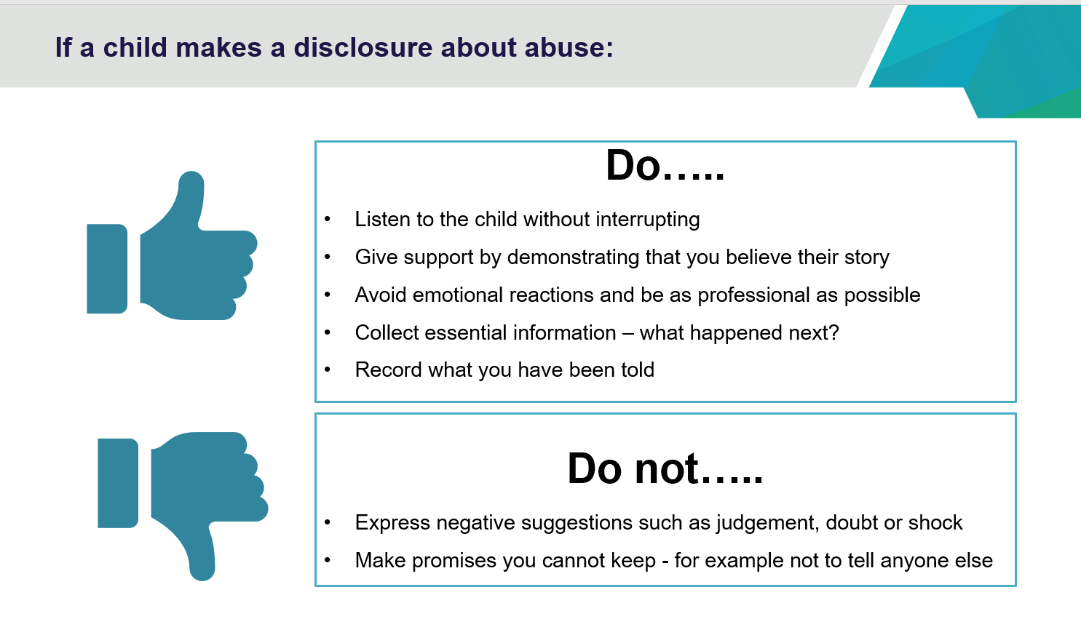

Slide 26 talking notes.

Key messages for facilitators
- Be aware of what a child might be telling you.
- Your reaction and responses are crucial.

Slide 27

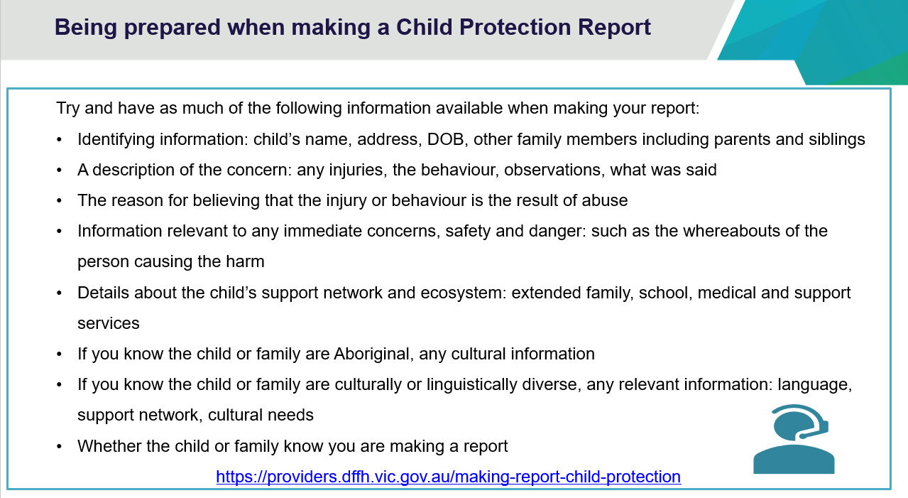

Slide 27 speaking notes.
- When you have made the decision to make a report to Child Protection, it is good to have your notes with you as you will be asked many questions by Child Protection. Questions you are likely to be asked by the Child Protection Intake team will include:
- Child’s name, address, etc.
- A description of the injury or behaviour observed.
- The reason for believing that the injury or behaviour is the result of abuse.
- An assessment of immediate danger to the child such as the whereabouts of the alleged abuser.
- Information about the child, family, school, support services.
- Cultural needs if the child is Aboriginal. It is important that Child Protection identify Aboriginal children early as there are specific legislative obligations. For example, section 12, which provides for additional decision-making principles for Aboriginal Children and section 13, which provides for the Aboriginal Placement Principle; and program obligations, such as, consulting with ACSASS, with which they must comply. ACSASS provides consultation and advice for child protection practitioners involved with Aboriginal families from the point of a report being made to child protection through to case closure.
- Cultural needs if the child is CALD.
- Does the family know you are making a report?
- Safety issues?

The DFFH website https://providers.dffh.vic.gov.au/making-report-child-protection

Key messages for facilitators
- When making a report to Child Protection, providing as much detail as possible assists the child protection practitioners to make assessments that will assist to determine any outcomes and responses.

Slide 28

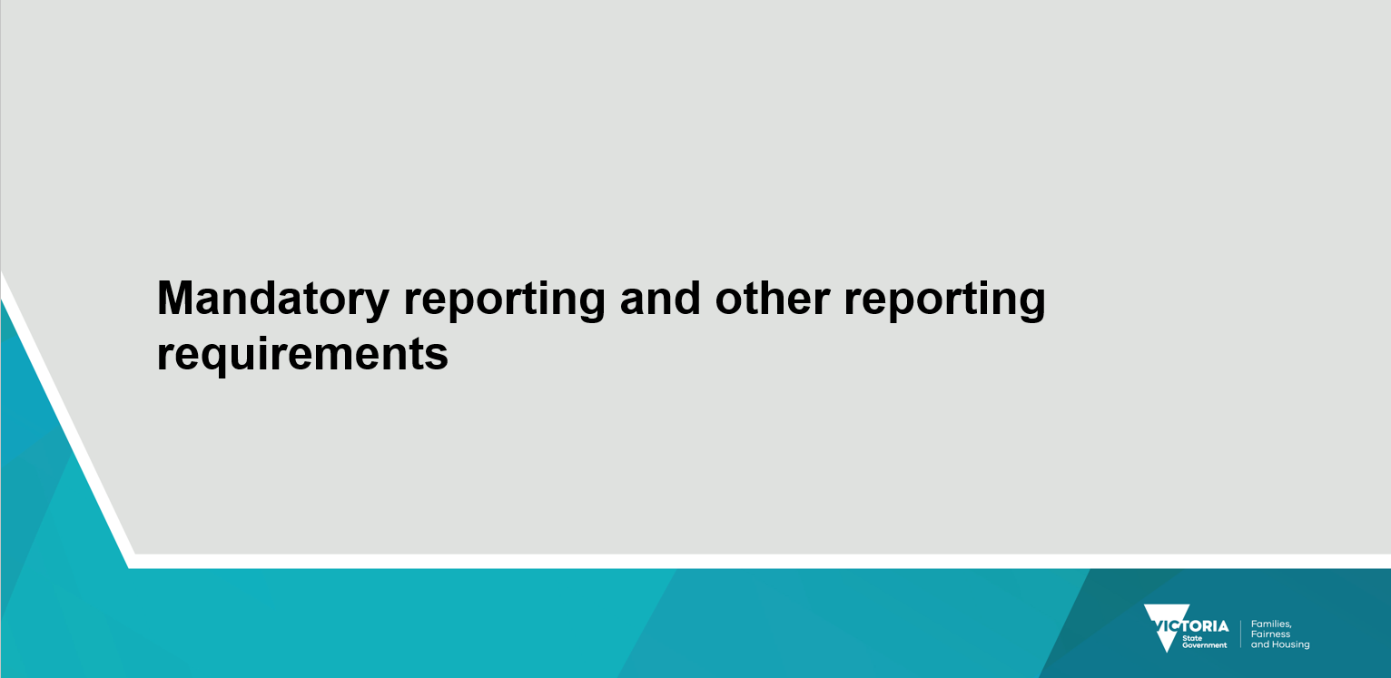

Slide 29

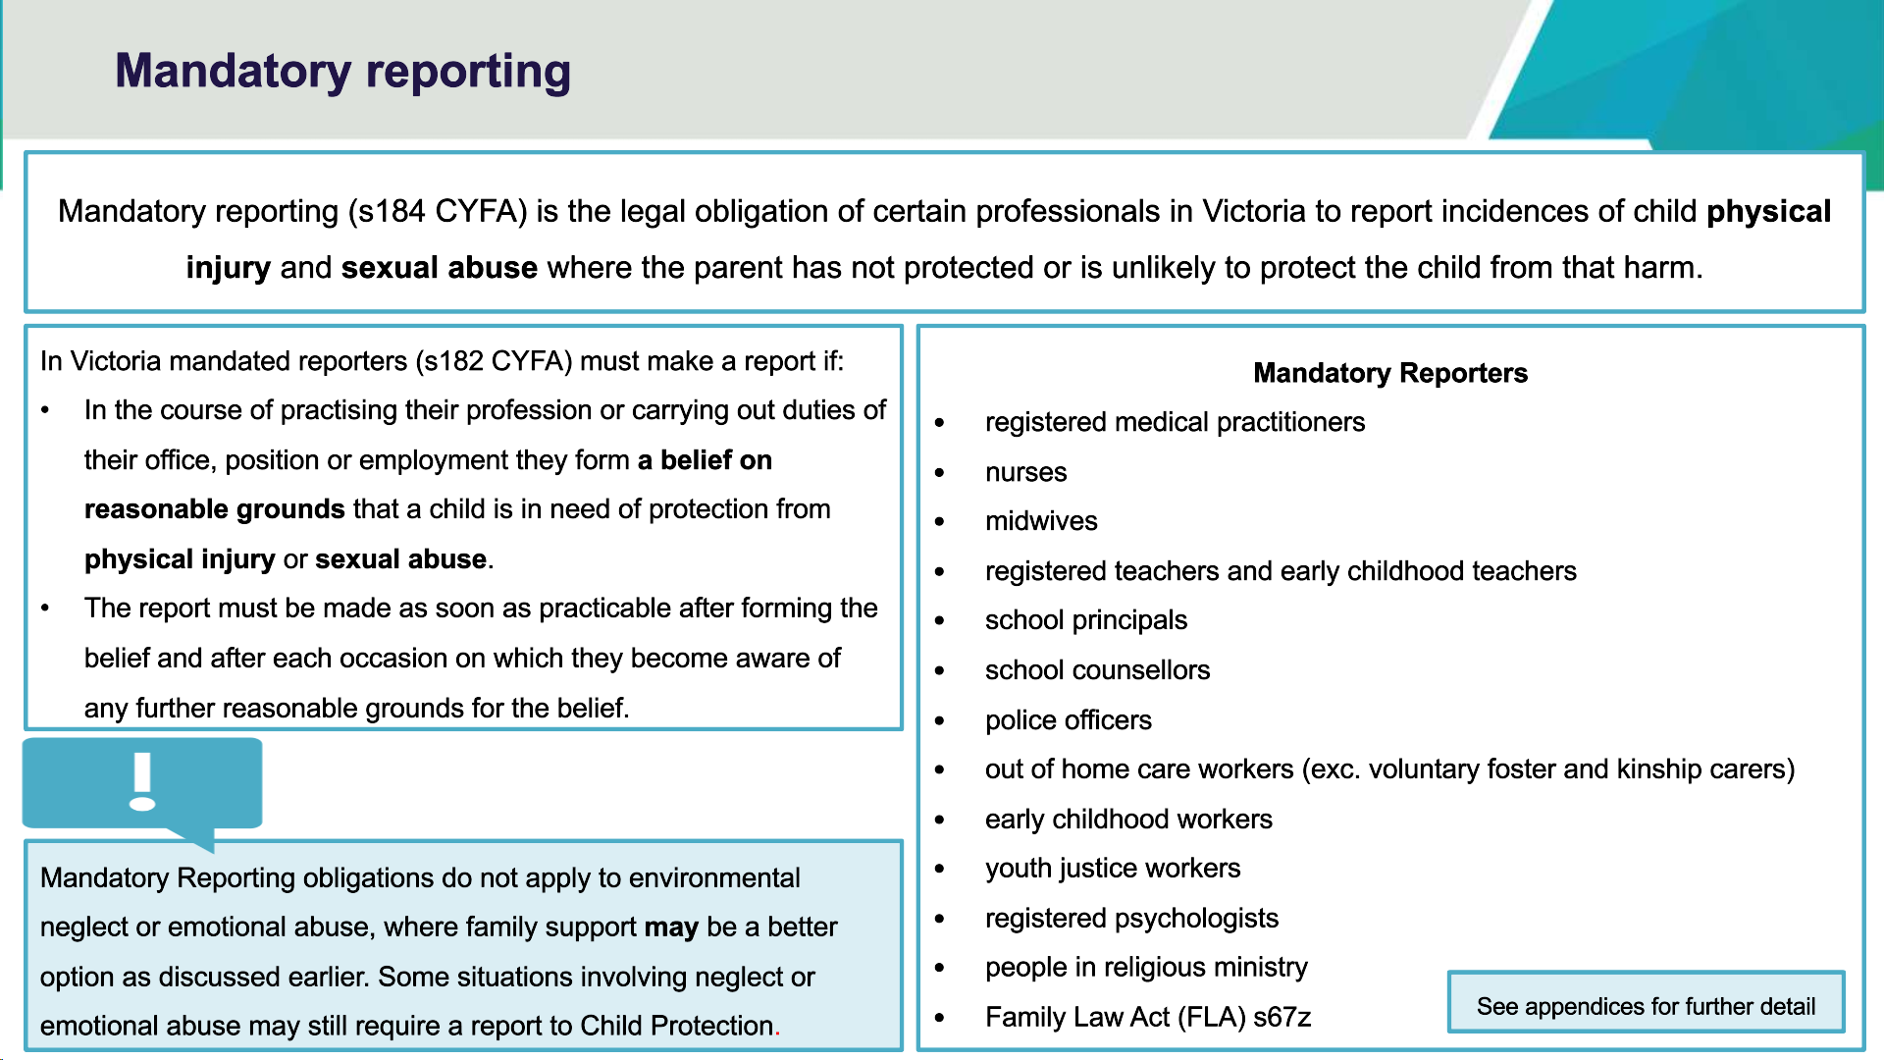

Slide 29 speaking notes.
- Mandatory reporters must make a report to Child Protection if they form a belief on reasonable grounds that a child is in need of protection because of physical or sexual abuse.
- Other concerns can still be reported but are not mandatory.
- Mandatory reporting relates to children under the age of 17 years unless the young person is subject to a child protection order and under 18 years.
Identified mandatory reporters (s182 CYFA) are:
- registered medical practitioners, including psychiatrists, paediatricians
- nurse, including MCHN
- midwife
- teacher and principal
- police
- Family Law Act 67Z
- early childhood
- psychologist
- youth justice
- out of home care workers
- school counsellors.
Optional information: You may wish to provide additional detailed information:
Family Law Act (FLA) s67Z:
Under the FLA (s. 67ZA), the Registrar or Deputy Registrar of the Family Court of Australia or the Family Court of Western Australia, a Registrar of the Federal Circuit Court, family consultants, family counsellors, family dispute resolution practitioners or arbitrators, and independent children's lawyers are mandatory reporters.
Under the FLA, mandated reporters must make a report to Child Protection if they suspect on reasonable grounds that a child has been abused or is at risk of being abused.
Additional information:
Refer participants to the DFFH website on mandatory reporting, specifically to the fact sheets for the mandatory reporter groups that commenced from 1 March 2019 and the FAQs document. For more information, please visit the Mandatory reporting webpage providers.dffh.vic.gov.au/mandatory-reporting.

Key messages for facilitators
Mandatory reporters must make a report to Child Protection if they form a belief on reasonable grounds that a child is in need of protection because of physical or sexual abuse.
Other concerns can still be reported but are not mandatory. Mandatory reporting does not apply to environmental neglect or emotional abuse, where family support may be a better option.
Mandatory reporting relates to children under the age of 17 years unless the young person is on a child protection order and under 18 years.

Slide 30

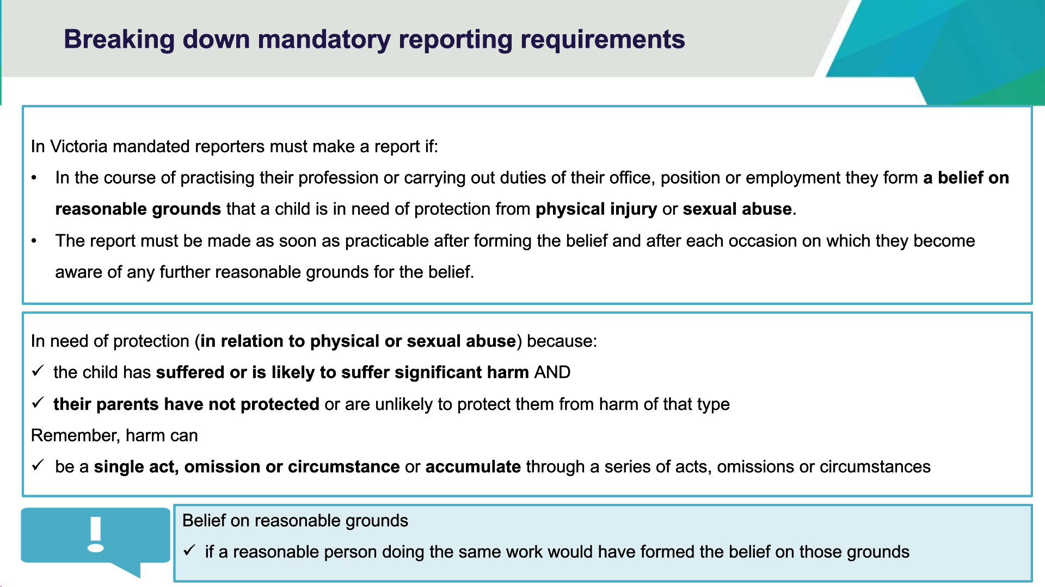

Slide 30 speaking notes.
- Summarise the definition of in need of protection.
  - The child has suffered or is likely to suffer significant harm, and their parents have not protected or are unlikely to protect them from harm of that type.
- You have formed a belief on reasonable grounds when:
  - a child tells you they have been abused.
  - someone else, such as a sibling, relative, friend or acquaintance, tells you that the child has been abused.
  - a child tells you they know someone who has been abused (the child could possibly be referring to themselves)
  - your own observations of the child’s physical condition and/or behaviour led you to suspect that the child has suffered abuse (the presence or absence of an indicator does not mean a child is in need of protection)
  - other circumstances lead you to suspect that a child has been abused.
- A ‘reasonable belief’ is not the same as having proof.
- A ‘reasonable belief’ is formed if a reasonable person in the same position would have formed the belief on the same grounds.
- Grounds for belief refers to any matters which the person has become aware in the course of practising his or her office, position or employment and any opinions based on those matters.
- Law states that “a belief is a belief on reasonable grounds if a reasonable person practising the profession or carrying out the duties of the office, position or employment, as the case requires, would have formed the belief on those grounds.”
- Mandatory reporters must make a report after each occasion.
** For more details on mandatory reports see appendices for more detailed information on mandatory reporting and who is mandated

Key messages for facilitators
- Understanding when mandatory reports are required.

Slide 31

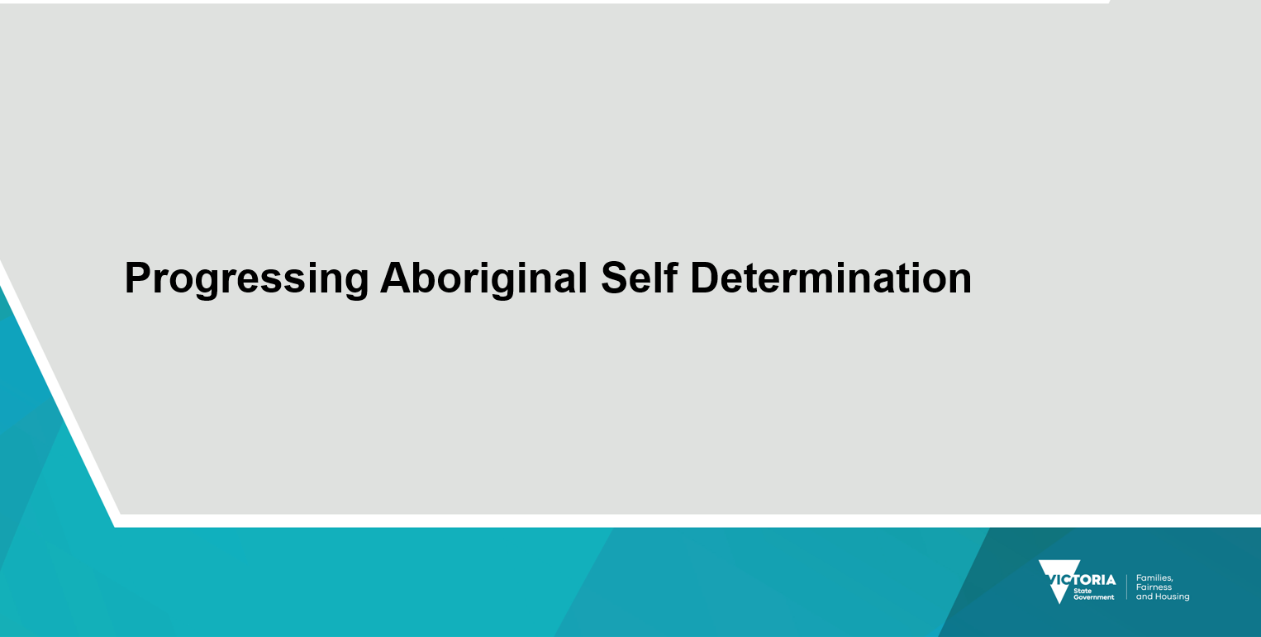

Slide 32

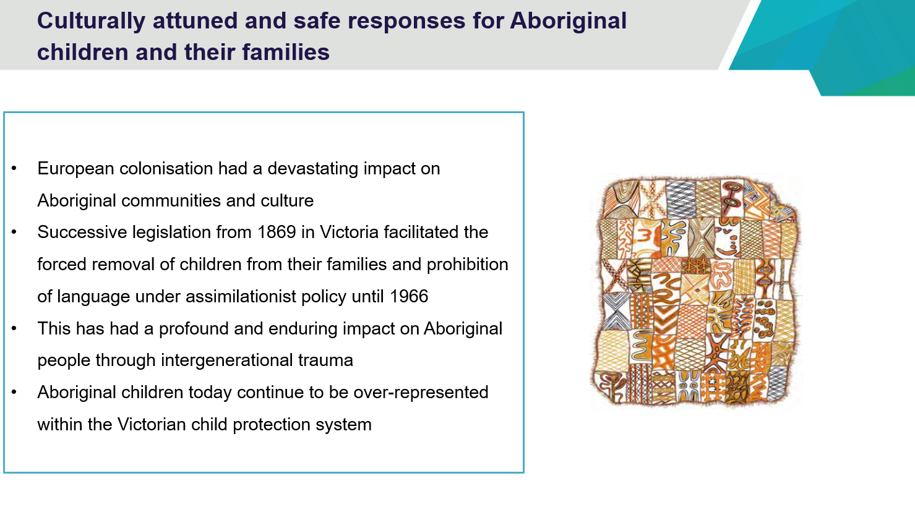

Slide 33

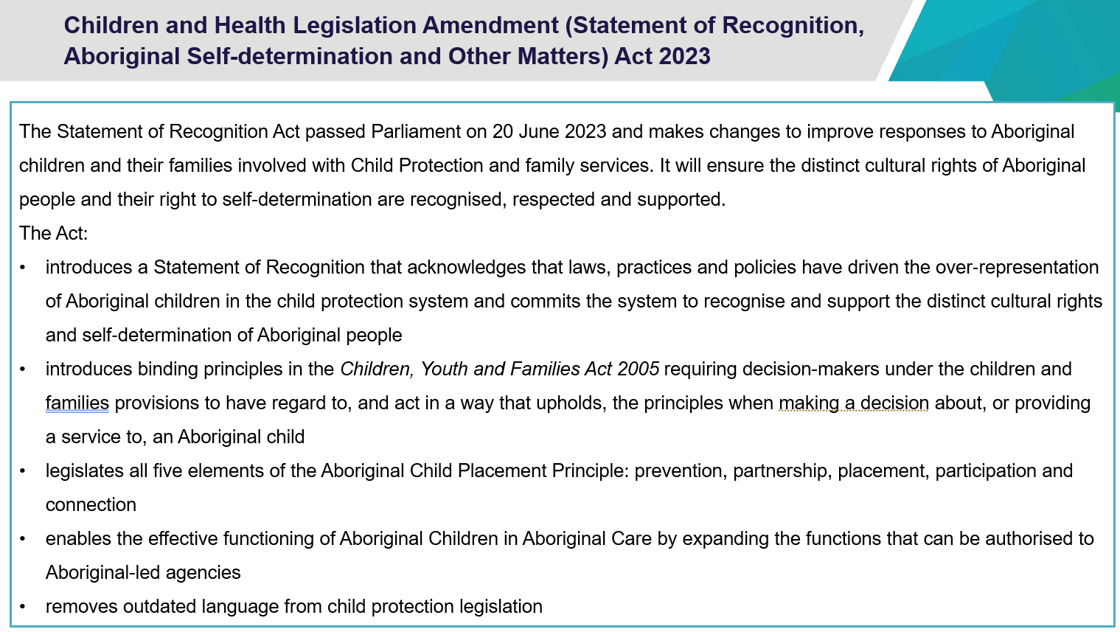

Slide 33 speaking notes.
Sadly, Aboriginal children have and continue to be over-represented in the Child Protection system. Victoria has one of the highest rates of over-representation in Australia.
Successive legislation from the Aborigines Protection Act 1869 (Vic) onwards facilitated the forced removal of children from their families and prohibition of language for openly assimilationist purposes for over a hundred years.
It was not until 1966 that Government policy changed from assimilation of Aboriginal children to accepting that they should remain with their families.
Today Aboriginal people continue to experience the trauma of the forced removal of their children for almost 100 years. They experience fear and mistrust of government authorities.
However, in recent years, there is a strong commitment by Government for Aboriginal Communities to make decisions that affect their lives and an acknowledgement that Aboriginal people are best placed to make the best decisions for their children.

Key message for facilitators
Victoria has a strong commitment for Aboriginal Communities to make decisions that affect their lives and an acknowledgement that Aboriginal people are best placed to make the best decisions for their children.

Slide 34

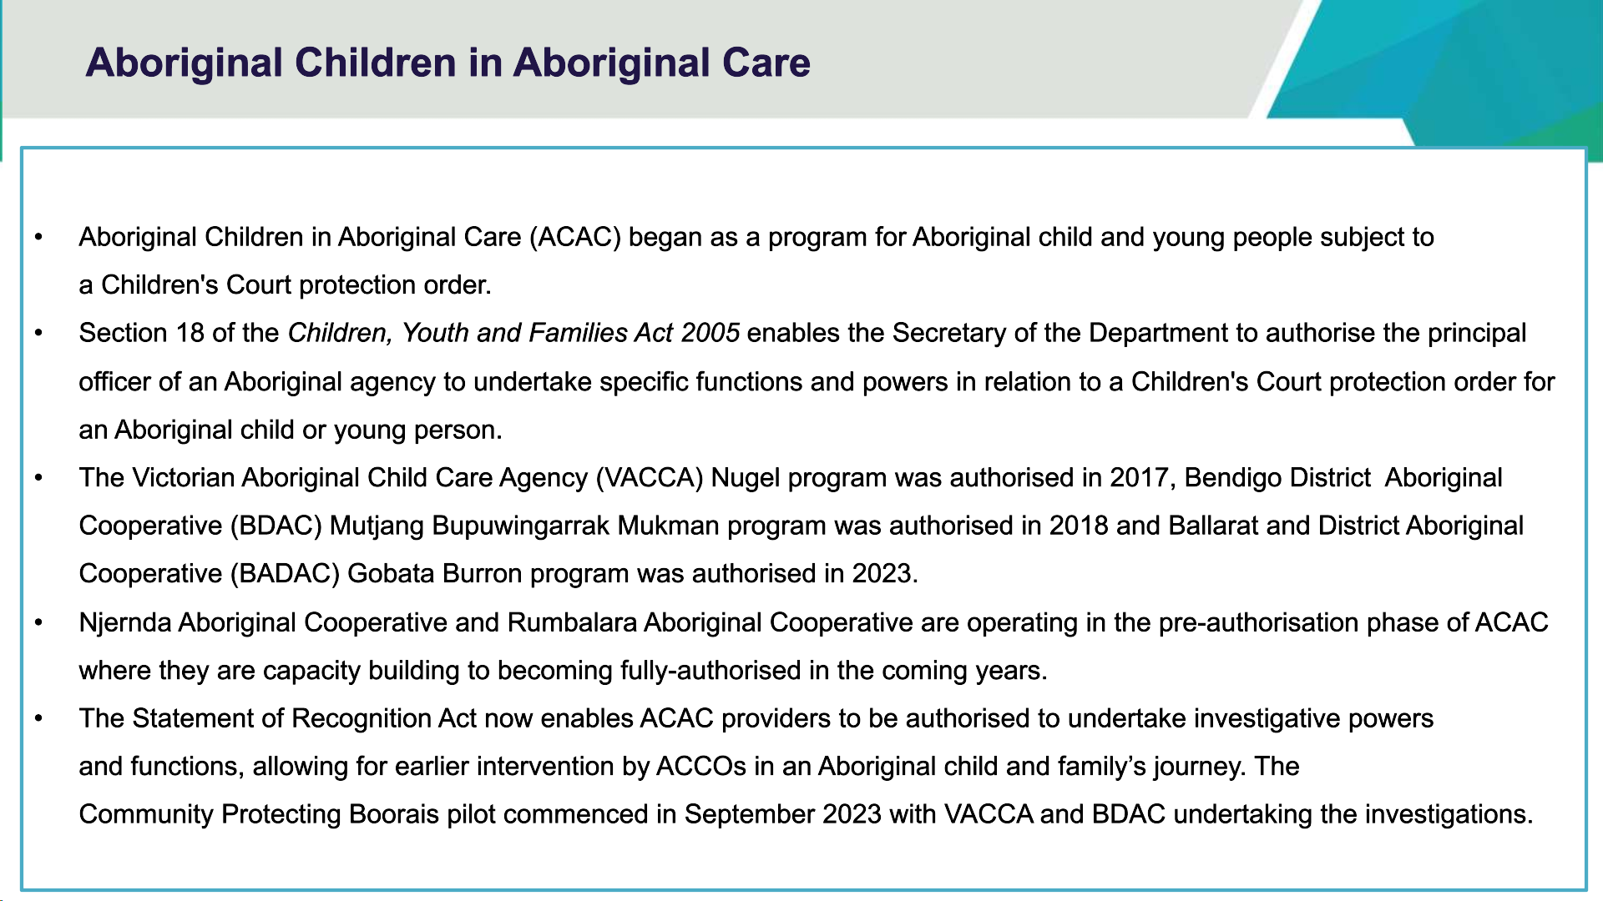

Slide 34 speaking notes.

- Since 2017, progressive responsibility for managing Aboriginal children and young people has shifted to ACCOs with the aim of culturally attuned practice and better outcomes.
- The 2023-24 State Budget has invested $140 million over 4 years to grow the Aboriginal Children in Aboriginal Care (ACAC) program from 10 teams to an additional 21 teams by 2027 with the ability to manage up to 1,156 children.

Slide 35

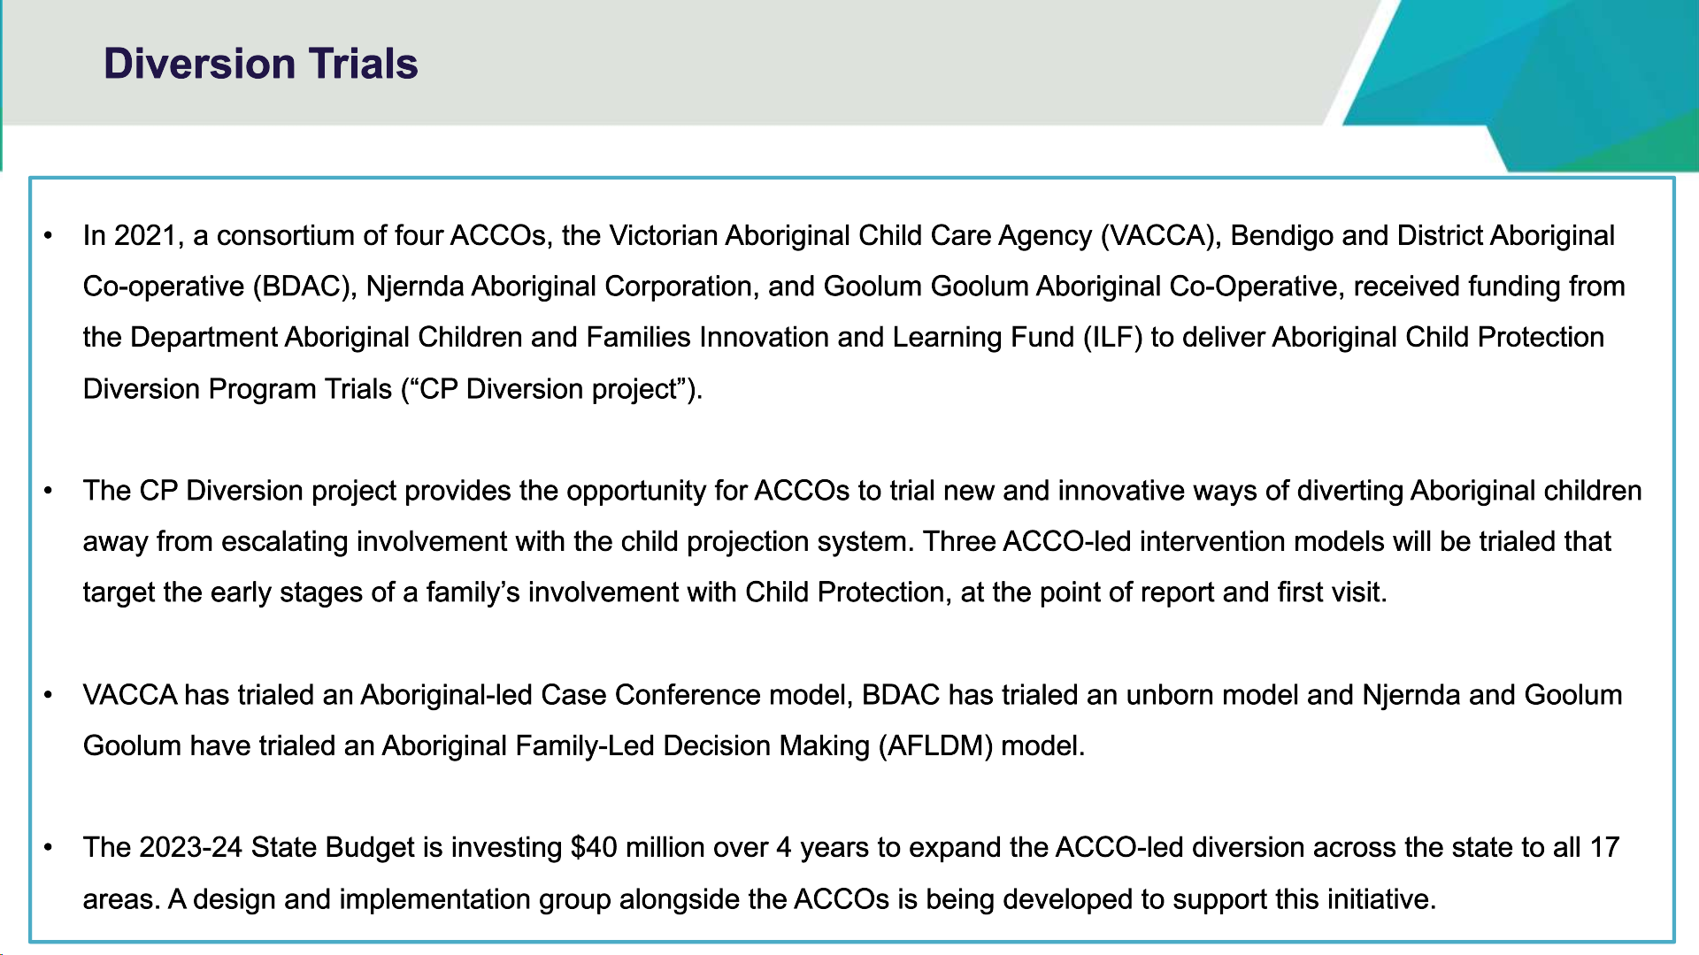

Slide 35 speaking notes.
The Aboriginal-led Case Conference delivered by VACCA, and the Njernda/Goolum Goolum Aboriginal family Led Decision Making (AFLDM) model accepts referrals from Child Protection only. This is an internal Child Protection pathway for families assessed as requiring this response.
IMPORTANT: Reporters should not make a report to Child Protection in the hope that the outcome is a referral to one of these services; that decision will sit with Child Protection and be based on a range of variables that may not be visible to the reporter.
The unborn trial being delivered by BDAC accepts referrals from community, family services and Child Protection. Referrals may be directly made to BDAC.

Slide 36



Slide 37

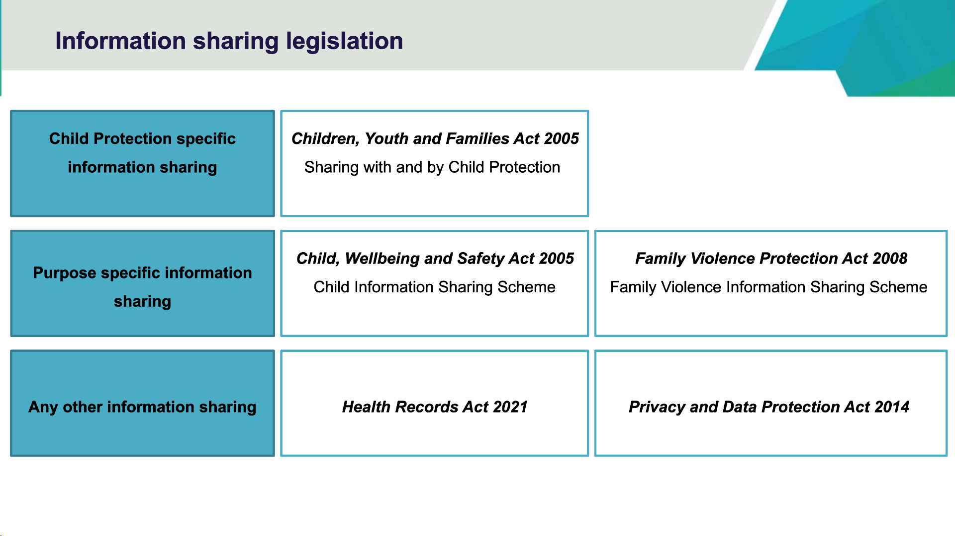

Slide 37 speaking notes.
The legislation that governs information sharing with and by child protection is:
- Children, Youth and Families Act 2005 - provides for when and how information sharing is authorised restricted or prohibited in Child Protection cases. If Child Protection believes on reasonable grounds that information is required, they may request information from, disclose information to or receive information from an information holder, service agency, registered community service, or any other individual. Child Protection cannot reveal the identity of the reporter unless under specific circumstances including with the written permission of the reporter, to another protective intervener (police or another child protection practitioner), a community-based child and family service (The Orange Door), in court proceedings where leave granted by the court/tribunal.
The information sharing schemes are provided for in the following two pieces of legislation:
- Child Wellbeing and Safety Act 2005 - establishes the Child Information Sharing Scheme - enables prescribed professionals and organisations to share information to promote the wellbeing and safety of children. Child Protection is an information sharing entity (ISE).
- Family Violence Protection Act 2008 - establishes the Family Violence Information Sharing Scheme - enables information sharing entities to share information to assess or manage risk of family violence. Child Protection is a prescribed information sharing entity for both family violence risk assessment and management purposes.

Child Protection information sharing:
Explain that Child Protection (CP) can request, respond, and proactively share information under the schemes and like all ISEs, is obliged to respond to requests from other ISEs.
Other information sharing laws to consider:
- Where there are no specific information sharing provisions in the CYFA governing the circumstances you are considering, and neither the Child Information and Family Violence Sharing Scheme apply, information sharing must be consistent with the Information Privacy Principles in the Privacy and Data Protection Act or the Health Privacy Principles Health Records Act:
  - Health Records Act deals with health information.
  - Privacy and Data Protection Act deals with all other personal information, including sensitive information.
  - 'Personal information' is information or an opinion that is recorded about a person and which identifies or may identify that person.
  - 'Sensitive information' is more tightly regulated personal information and includes racial, ethnic, political.
Dependent in the participants, you may wish to present these slides which outlines more detailed information sharing with and by Child Protection.
CYFA s192 Provision of information
- If Child Protection believes on reasonable grounds that it is required to perform their duties or functions or exercise their powers, they may request information from, disclose information to, or receive information from:
  - the Secretary
  - a protective intervener
  - an information holder
  - a service agency
  - a registered community service.
  - And in some cases, another individual.
- Disclosure of information made in good faith does not constitute unprofessional conduct or a breach of professional ethics or expose the person to any liability (CYFA s198-202).
CYFA S197 Refusal or failure to comply with requirement A person must not, without reasonable excuse, refuse or fail to comply with a requirement of an authorised officer under this Division.
Penalty: 10 penalty units.

Slide 38

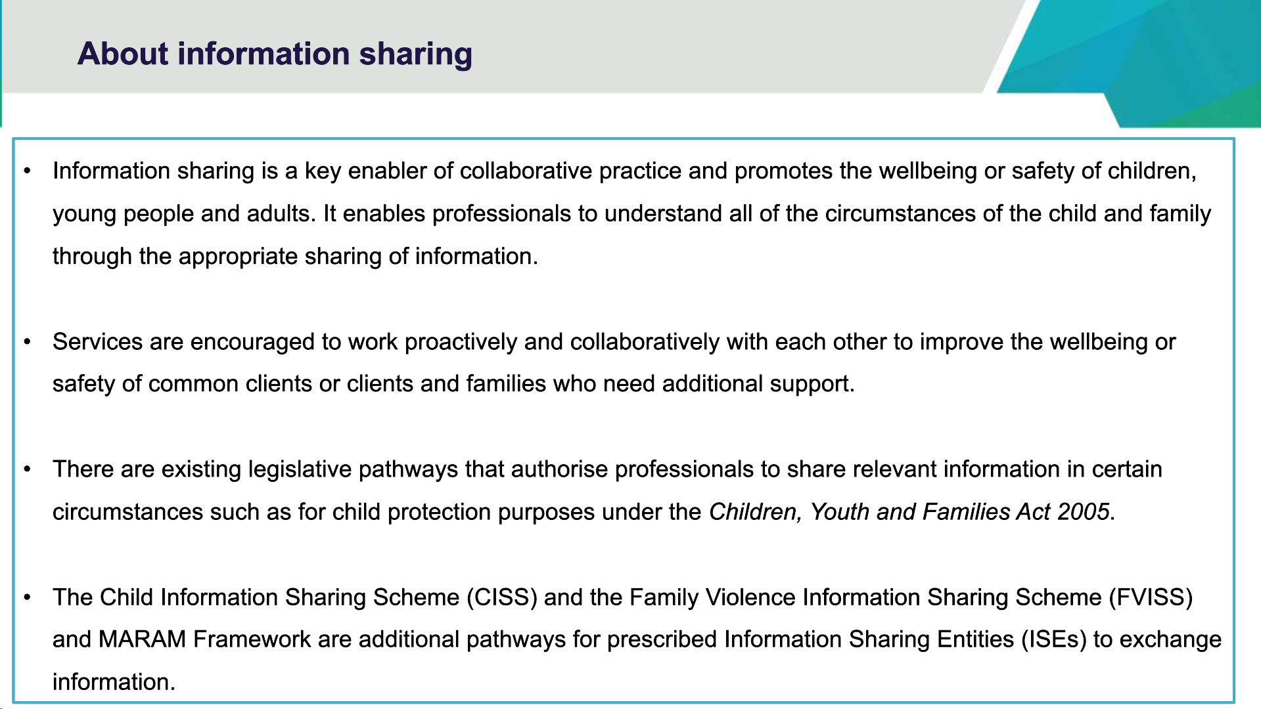

Slide 39

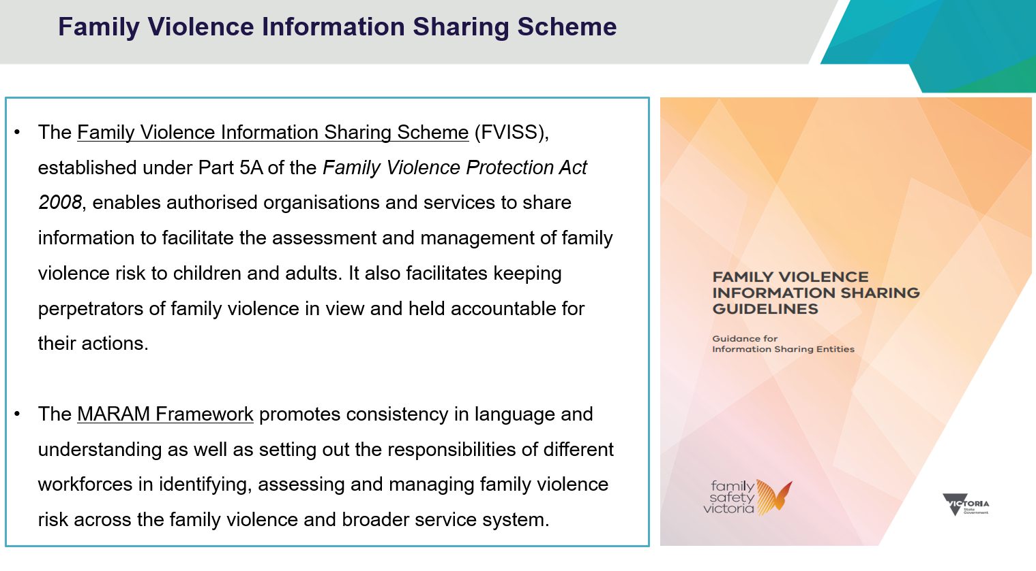

Slide 40

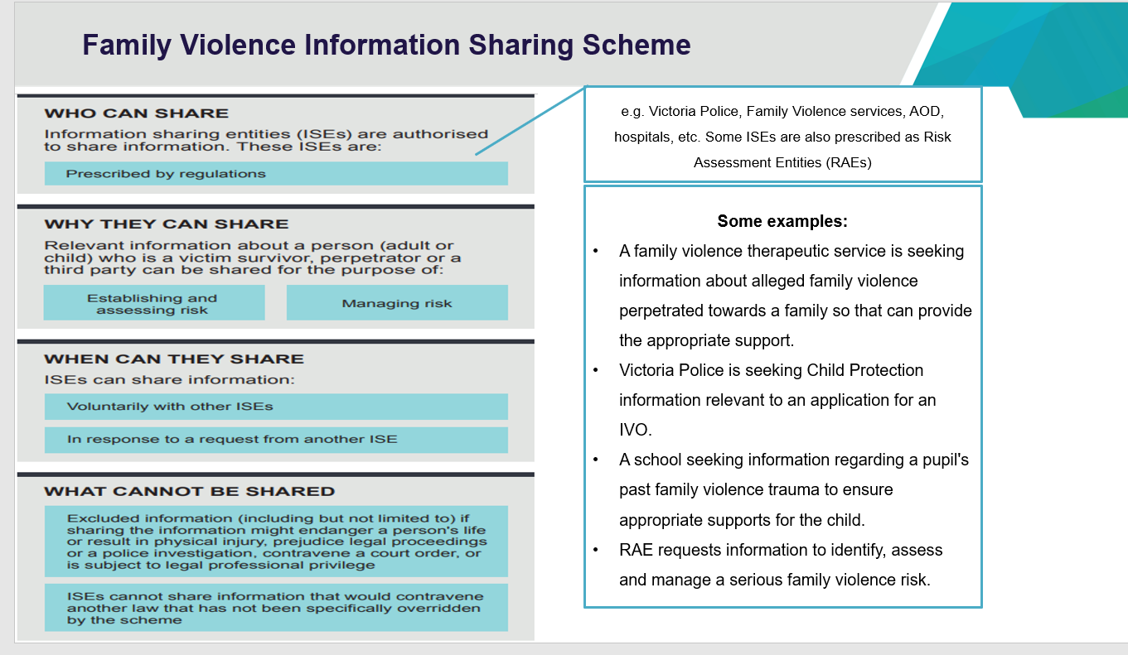

Slide 41

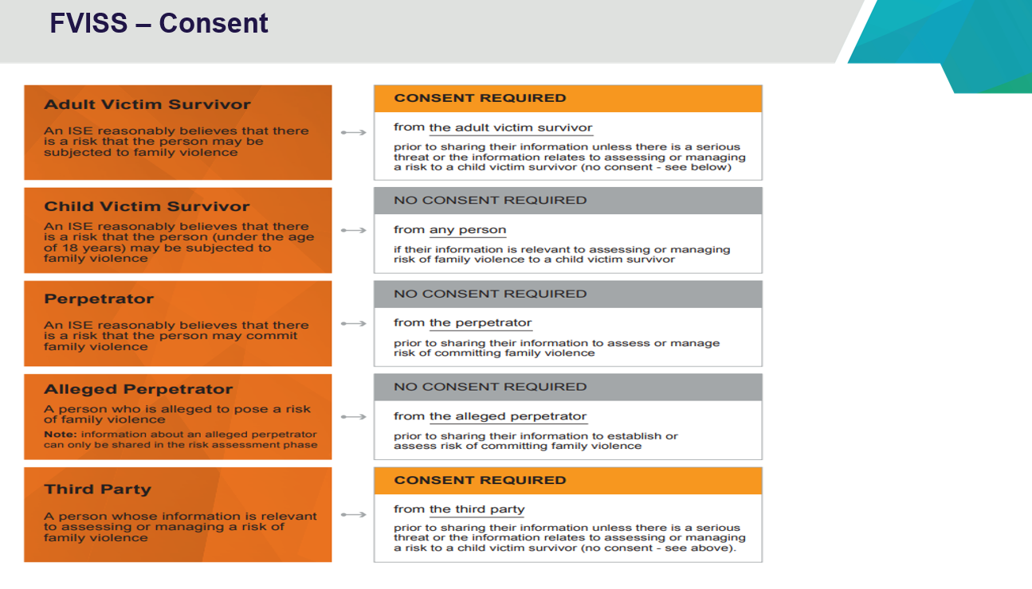

Slide 41 speaking notes.

Family Violence information sharing Scheme talking notes.

The key elements of the scheme are:
- If you can already share under other laws – then continue to do so.
- Requests must be complied with unless exemptions apply.
- Consent is not required from anyone when the victim is a child; where there are no children, you have adult victim or third-party consent, unless there is serious risk to a person's safety.
- Information Sharing Entities (ISEs) can share information without perpetrator consent.
- In relation to categories of excluded information, information that could prejudice an investigation, the Act refers to an ongoing investigation and so would include a police investigation but could also include a Child Protection investigation or Reportable Conduct investigation by the CCYP.

Overview of the FVISS
The Royal Commission into Family Violence acknowledged that organisations that work with victims and perpetrators of family violence collect a wide variety of information to keep victims safe and hold perpetrators to account.
The Commission also identified barriers that prevent information from being shared as effectively as it could be and found that the failure to share crucial information with frontline workers can have catastrophic consequences.
In response to the Commission’s findings, a family violence information sharing scheme has been created by the new Part 5A of the Family Violence Protection Act 2008.
The scheme began on 26 February 2018, and it authorises a select group of prescribed information sharing entities (ISEs) to share information between themselves for family violence risk assessment and risk management.
The scheme does not interfere with existing legislation that allows information to be shared, such as privacy or child protection legislation.
Changes have also been made to Victorian privacy legislation that information can be shared in order to lessen or prevent a serious threat to the life, health, safety or welfare of a person.
The key elements of the scheme are:
- If you can already share under other laws – then continue to do so.
- Requests must be complied with unless exemptions apply.
- Consent is not required from anyone when victim is a child; where there are no children, you must have adult victim or third-party consent, unless there is serious risk to a person’s safety.
- Information Sharing Entities can share information without perpetrator consent.
- In relation to categories of excluded information, information that could prejudice an investigation, the Act refers to an ongoing investigation and so would include a police investigation but could also include a CP Investigation or Reportable Conduct investigation, both of which would be very relevant to a CP audience.

Slide 42
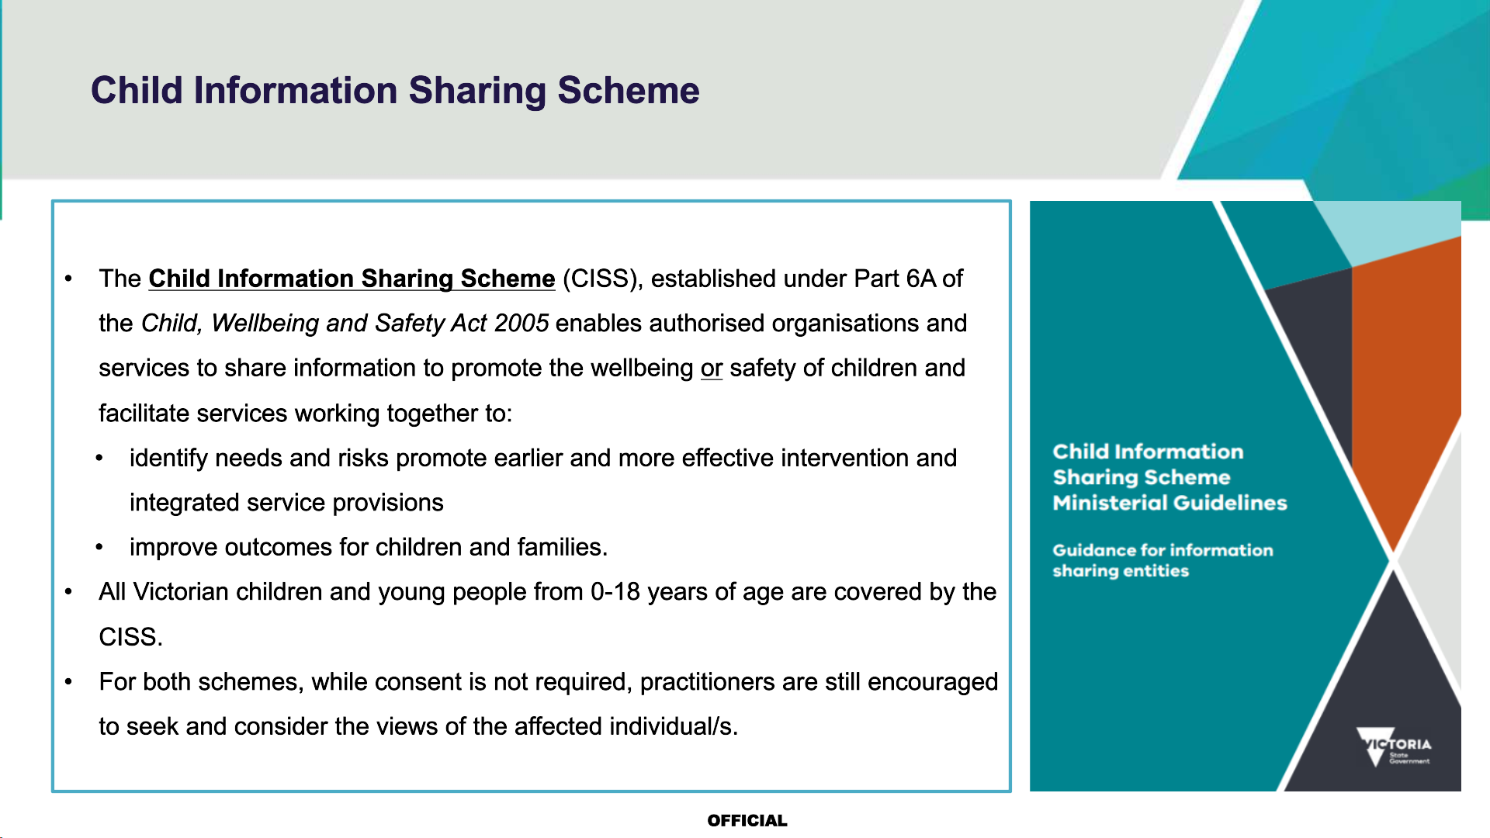

Slide 43
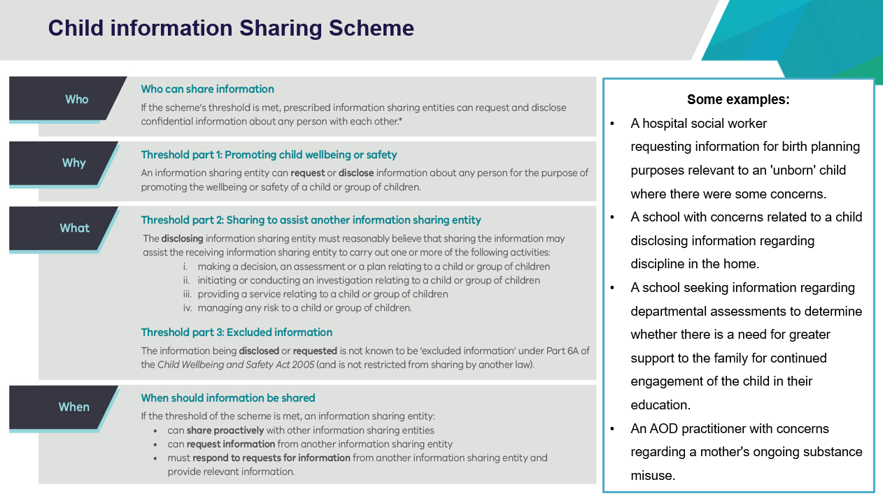

Slide 43 speaking notes.
Child Information sharing scheme (CISS) talking notes.
The Child Information Sharing Scheme reform responds to more than a decade of reviews and enquiries recommending reform to the way information is shared about children including:
- McClellan Royal Commission into Institutional Responses to Child Sexual Abuse
- The Commission for Children and Young People’s annual reports
- Royal Commission into Family Violence
- Victorian Auditor-General Office reports into vulnerable children and families
- Multiple coroner’s inquests and reports
- Protecting Victoria’s Vulnerable Children inquiry, often known as the Cummins Inquiry.
These inquiries have all recommended streamlining Victoria’s information sharing arrangements to improve outcomes for children by promoting shared responsibility for their wellbeing and safety and increasing collaboration across the service systems.
They also identified the need to modify a risk-averse culture, which has resulted in some practitioners being hesitant to share information even when it would benefit children to do so.
The key elements of the scheme are:
Requests must relate to promoting the wellbeing or safety of children.
Threshold 1
‘Promotion’ in this context is predicated on reducing the risk to children. Wellbeing and Safety are not defined concepts under the Scheme.
Safety is concerned with protecting children from risks of harm or incidents of harm. However, the concept of wellbeing is broader than safety and requires more than the absence of harm or risks of harm.
As a multifaceted concept, ‘wellbeing’ could include:
- Physical, psychological, and emotional health and access to and engagement with services to support a child’s health and development.
- Engagement in supportive relationships, particularly supportive family relationships, involvement in activities that enable a child’s personal, social, and cultural development and connection to their culture and community.
- Participation in education and access to resources that support the child to learn and develop.
- Access to adequate, appropriate, and safe accommodation, nourishment, protection from the elements and safe and stable environments in which to live, learn and grow.
Threshold 2
Making a decision, an assessment or a plan relating to a child or group of children: for example, developing a support or learning plan or assessing progress against an existing plan.
Initiating or conducting an investigation relating to a child or group of children: for example, sharing information to support a reportable conduct investigation or other investigation related to a child’s wellbeing or safety.
Providing a service relating to a child or group of children: for example, providing a Maternal and Child Health service.
Managing any risk to a child or group of children: for example, managing a risk to a child’s social or emotional wellbeing.
Threshold 3
Excluded information and information that is restricted from being shared under another law cannot be shared.
Other notable aspects of the scheme include:
- No consent required but encourage seeking the views of children where it is safe, appropriate, and reasonable to do so.
- Organisations must respond to all requests.
- Complaint about privacy breaches can be made to the Victorian Information Commissioner or the Health Complaints Commissioner.
A good faith defence exists for workers when they are sharing information with good faith and reasonable care.

Key messages for facilitators
This is an opportunity for potential reporters to collect information to support a service response or to assess if there is a need for a report to Child Protection.

Slide 44

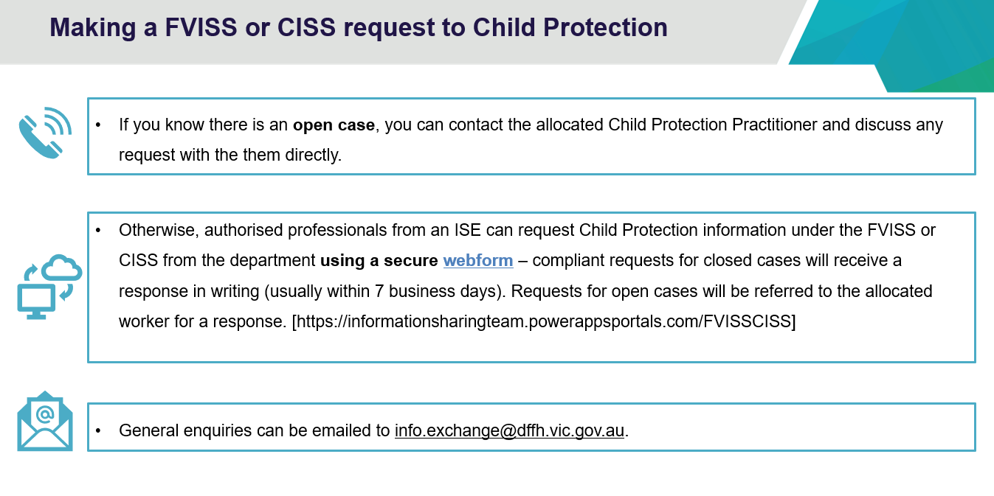

Key messages for facilitators
ISEs can request Child Protection information for closed cases under the FVISS or CISS.

Slide 45
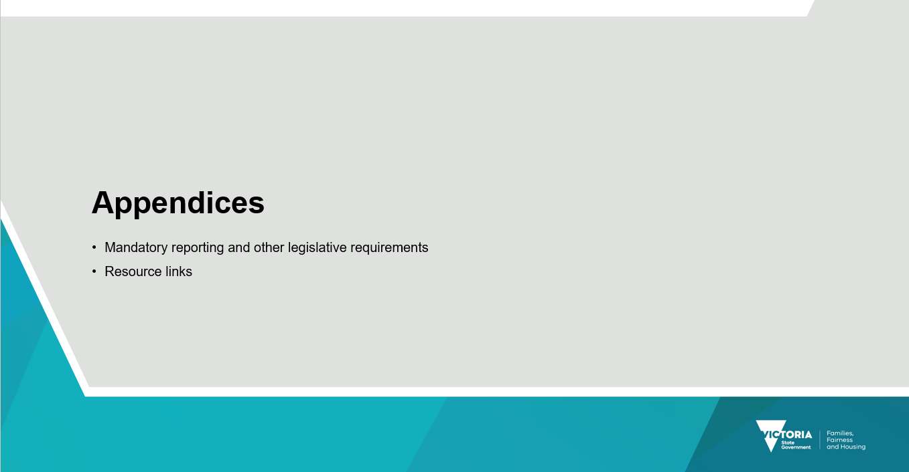

Slide 46

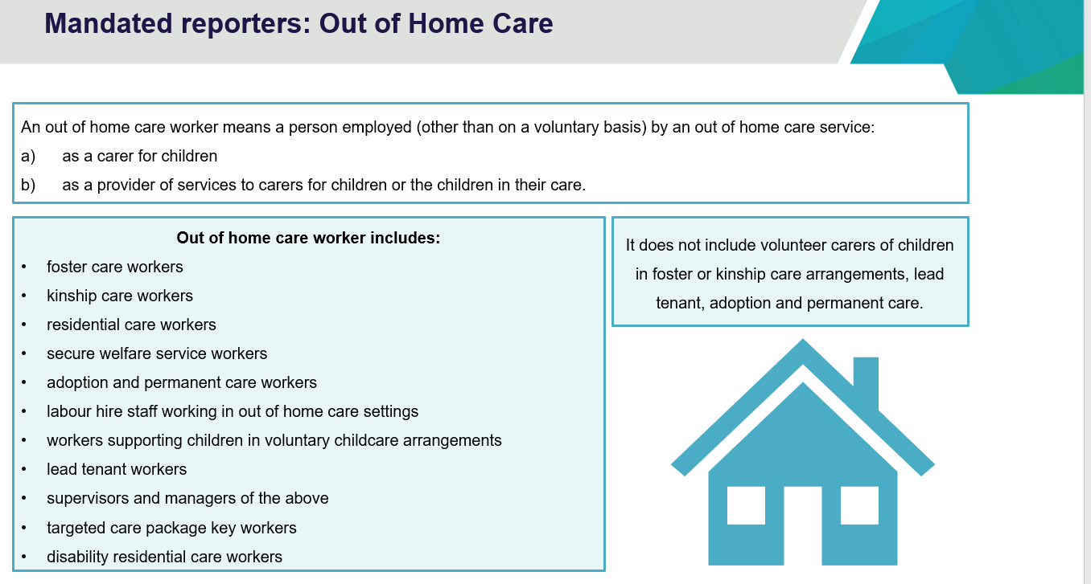

Slide 46 speaking notes.
An out of home care service is defined in the legislation. It is a community service that is registered as an out of home care service or a community service established and operated by the department to provide out of home care services, including secure welfare services.
An out of home care worker means a person employed (other than on a voluntary basis) by an out of home care service:
(a) as a carer for children (b) as a provider of services to carers for children or the children in their care.
Out of home care workers is a broad term referring to professionals who are working in roles, such as:
- foster care workers
- kinship care workers
- residential care workers
- secure welfare service workers
- adoption and permanent care workers
- labour hire staff working in out of home care settings
- workers supporting children in voluntary childcare arrangements
- lead tenant workers, supervisors, and managers of the above
If working in a registered out of home care service:
- targeted care package key workers
- disability residential care workers.
This list is not exhaustive and may include other roles consistent with the definition. It does not include volunteer carers of children in foster or kinship care arrangements, lead tenant, adoption, and permanent care.
Refer participants to the DFFH website on mandatory reporting, specifically to the fact sheet for out of home care workers and the FAQs document, available on the Mandatory reporting webpage. providers.dffh.vic.gov.au/mandatory-reporting.
If there are any questions that you are unsure of the answer, direct participants to their management, OOHC branch or their peak body Centre for Excellence in Child and Family Welfare.

Slide 47
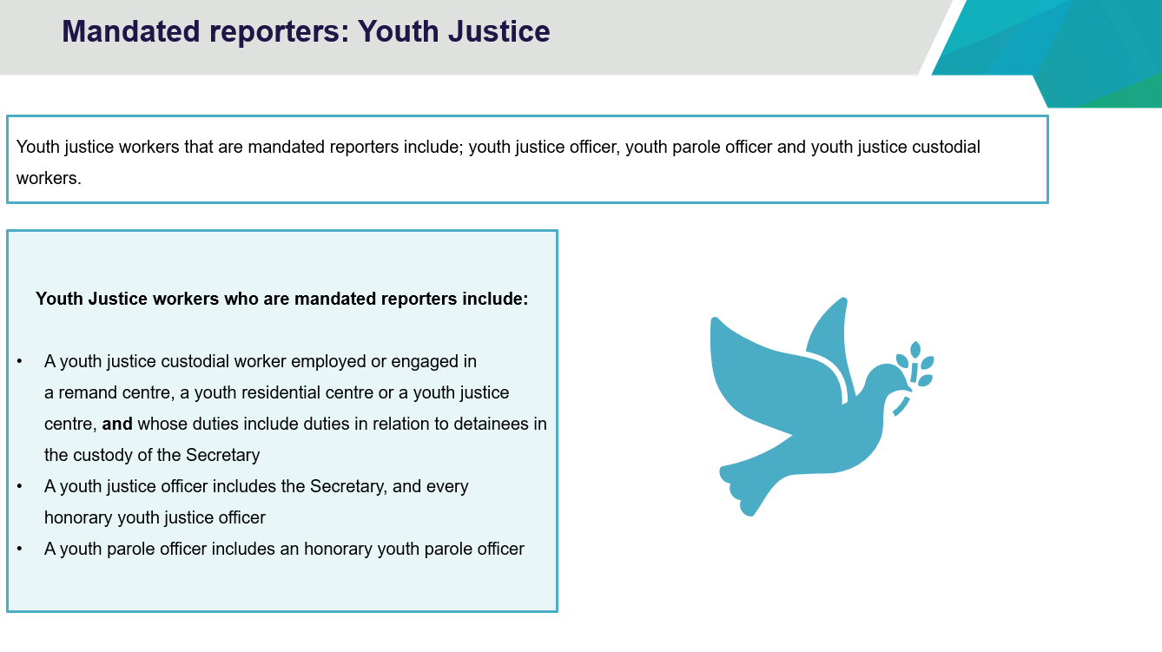

Slide 47 speaking notes.
Which youth justice workers are mandated reporters?
- youth justice officer
- youth parole officer
- youth justice custodial workers.
How is a youth justice worker defined?
- A youth justice custodial worker means a person:
- who is employed or engaged by the Secretary to the Department of Justice and Community Safety in a remand centre, a youth residential centre or a youth justice centre, and
- whose duties include duties in relation to detainees in the custody of the Secretary.
- A youth justice officer includes the Secretary, and every honorary youth justice officer.
- A youth parole officer includes an honorary youth parole officer.
If work for a community service as a youth justice support worker, am I mandated to report to Child Protection?
- While not mandated to report, all people working in community services who form a reasonable belief that a child or young person is in need of protection from abuse or neglect are able to make a report to Child Protection.
- Refer participants to the DFFH website on mandatory reporting, specifically to the fact sheet for youth justice and the FAQs document, available on the Mandatory reporting webpage
- Inform youth justice participants that there is an eLearning module on mandatory reporting.
- If there are any specific questions that you are unable or unsure of the answer, it might be worthwhile to ask participants to direct those questions to Department of Justice and Community Safety, Youth Justice branch.

Slide 48

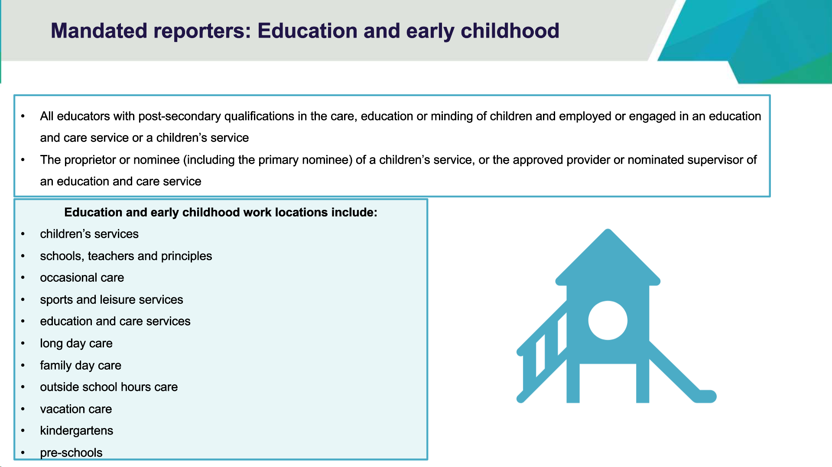

Slide 48 speaking notes.
In the Children, Youth and Families Act 2005, early childhood staff members are defined as:
- the proprietor of, or a person with a post-secondary qualification in the care, education or minding of children who is employed by, a children’s service to which the Children’s Services Act 1996 applies or a person who is a nominee within the meaning of that Act for the children’s service;
- The approved provider or nominated supervisor of, or a person with a post-secondary qualification in the care, education or minding of children who is employed or engaged by an education and care service within the meaning of the Education and Care Services National Law (Victoria);

Who are early childhood staff members?
Early childhood workers and other persons are people who work in either:
- a children’s service licensed under the Children’s Services Act 1996 including occasional care, or
- an early childhood education and care service approved under the Education and care Services National Law Act 2010 including long day care, outside school hours care and family day care.
Settings that mandated early childhood staff members work include:
- children’s services
- occasional care
- sports and leisure services
- education and care services
- long day care
- family day care
- outside school hours care
- vacation care
- kindergartens
- pre-schools.
Although mandatory reporters have special obligations to report, all early childhood staff have a duty of care to report child abuse and neglect to Child Protection authorities.
Refer participants to the DFFH website on mandatory reporting, specifically to the fact sheet for early childhood and the FAQs document, available on the Mandatory reporting webpage.
Refer early childhood staff to the Department of Education (DE) website, specifically PROTECT, the early childhood section and their regulatory body Quality Assessment and Regulation Division.
Advise early childhood participants that DE has an eLearning module on mandatory reporting.

Slide 49

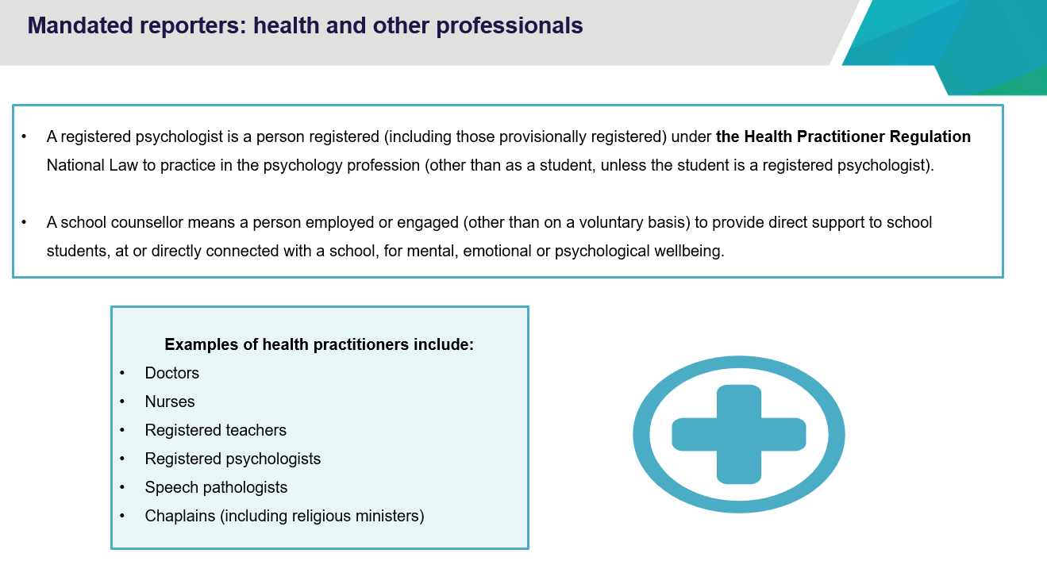

Slide 49 speaking notes.
Does this apply to psychologist in private practice?
- A registered psychologist is a person registered (including those provisionally registered) under the Health Practitioner Regulation National Law to practise in the psychology profession (other than as a student unless the student is a registered psychologist).
- Mandatory reporting requirements apply to all registered psychologists in Victoria, whether you are working in the public sector, an agency, non-government organisation, a school or in private practice.
What about client confidentiality?
- Mandatory reporting is a legal requirement consistent with the Australian Psychological Society APS Code of Ethics (Section A.5.2) requires psychologists to comply with any legal obligations regarding the disclosure of confidential information.
- Refer participants to the DFFH website on mandatory reporting, specifically to the fact sheet for registered psychologists and the FAQs document, available on the Mandatory reporting webpage.
- If there are any specific questions that you are unable to answer, it might be worthwhile directing participants to their regulatory body Australian Health Practitioner Regulation Agency (AHPRA) or peak body Australian Psychological Society (APS).

For more information on who is a mandatory reporter in Victoria below is the list of mandatory reporters as noted on the DFFH children and families mandatory reporting web page
- registered medical practitioners.
- nurses
- midwives
- registered teachers and early childhood teachers
- school principals
- school counsellors
- police officers
- out of home care workers (excluding voluntary foster and kinship carers)
- early childhood workers
- youth justice workers
- registered psychologists
- people in religious ministry.

Slide 50

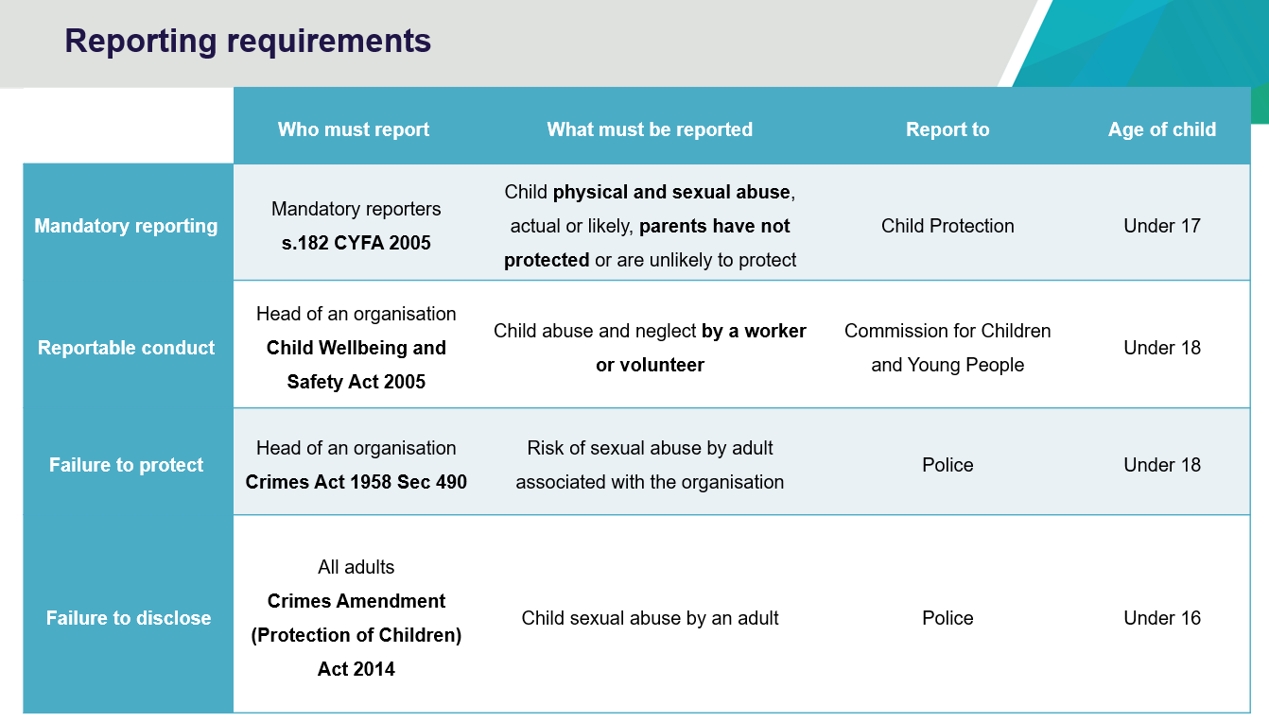

Slide 50 speaking notes.
Refer participants to the Fact Sheets and FAQ document located on the DFFH website including any other obligations that may apply to them as an organisation (such as Child Safe Standards) and professional group (such as code of ethics/conduct etc).
For information on mandatory reporting, please visit the Mandatory reporting webpage.
Optional information: A summary of reporting obligations:
Reportable conduct requires:
- some organisations to respond to allegations of child abuse (and other child-related misconduct) made against their workers and volunteers, and to notify CCYP of any allegations.
- enables CCYP to independently oversee those responses.
- facilitates information sharing between organisations, their regulators, Victoria Police, the Department of Justice and Community Safety, and Regulation’s Working with Children Check Unit and CCYP.
Failure to protect a child from sexual abuse offence applies to people within organisations.
- if they hold a position of authority
- within a relevant organisation that works with children
- they know of a substantial risk another adult associated with the organisation may commit a sex offence against a child under 16 within the organisation’s care.
- they have the power or responsibility to remove or reduce that risk.
- BUT they negligently fail to do so.
Failure to protect children from sexual abuse – criminal offence not to act to reduce or remove risk. Maximum 5 years imprisonment
What is a 'relevant organisation'?
A relevant organisation is one that exercises care, supervision, or authority over children, whether as part of its primary function or otherwise.
Person in authority is dependent on the degree of supervision, power, or responsibility to remove or reduce substantial risk posed by an adult associated with the organisation. For example, CEOs, board, council and committee members, principals, residential house supervisors, religious leaders.
A person associated with the organisation includes an employee, volunteer, or contractor. For example, it would include a parent who volunteers at kinder to assist in the classroom or on an excursion.
Substantial risk includes the likelihood a child will become a victim – the legal test is whether a ‘reasonable person’ would have judged the risk.
Negligently failing to reduce or remove risk refers to inaction knowing there is a substantial risk. Could also include action such as moving an adult associated with the organisation to another location where they will still have contact with children.
Failure to disclose child sexual abuse offence that requires adults to report to police a reasonable belief that a sexual offence has been committed against a child (unless they have a reasonable excuse for not doing so).
It establishes that reporting child sexual abuse is a community-wide responsibility.
The law states that all adults must report to police:
- any reasonable belief that a sexual offence has been committed.
- by another adult (over 18)
- against a child under the age of 16.
unless there is a reasonable excuse, or an exemption applies.
Failure to disclose does not change mandatory reporting obligations. Maximum penalty is 3 years imprisonment.
What is a ‘reasonable belief’?
A ‘reasonable belief’ is not the same as having proof. A ‘reasonable belief’ is formed if a reasonable person in the same position would have formed the belief on the same grounds.
For example, a ‘reasonable belief’ might be formed when:
- a child states that they have been sexually abused.
- a child states that they know someone who has been sexually abused (sometimes the child may be talking about themselves)
- someone who knows a child states that the child has been sexually abused.
- professional observations of the child’s behaviour or development leads a professional to form a belief that the child has been sexually abused.
- signs of sexual abuse led to a belief that the child has been sexually abused.
A reasonable excuse includes:
- A fear for safety, either to the victim or another person as a result of the disclosure
- The information has already been disclosed to police (for example, because a mandatory report has been made to Child Protection)
It does not include a concern for ‘perceived interests’, such as reputation, legal liability, or financial status.
Other exemptions include:
- the victim requests confidentiality (exemption does not apply if the victim is under 16 at the time of disclosing the abuse, or has an intellectual disability and is unable to make an informed decision about the disclosure)
- the person is a child when they formed a reasonable belief.
- the information would be privileged (for example, client legal privilege)
- the information is in the public domain.

Slide 51
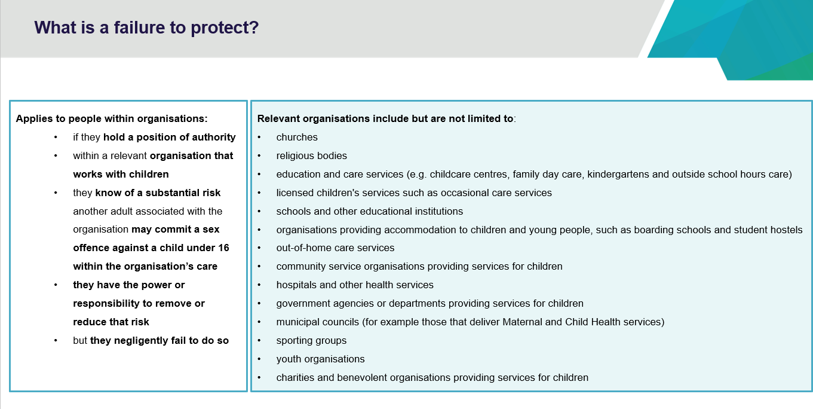

Slide 51 speaking notes.
Failure to protect a child from sexual abuse offence applies to people within organisations:
- if they hold a position of authority
- within a relevant organisation that works with children
- they know of a substantial risk another adult associated with the organisation may commit a sex offence against a child under 16 within the organisation’s care.
- they have the power or responsibility to remove or reduce that risk.
- BUT they negligently fail to do so.
Maximum penalty of 5 years imprisonment.
Put simply…. failure to protect children from sexual abuse is a criminal offence where you do not to act to reduce or remove risk.
What is a 'relevant organisation'?
A relevant organisation is one that exercises care, supervision, or authority over children, whether as part of its primary function or otherwise.
Person in authority is dependent on the degree of supervision, power, or responsibility to remove or reduce substantial risk posed by an adult associated with the organisation. For example, CEOs, board, principals, residential house supervisors, religious leaders.
A person associated with the organisation includes an employee, volunteer, or contractor. For example, it would include a parent who volunteers at kinder to assist in the classroom or on an excursion.
Substantial risk includes the likelihood a child will become a victim – the legal test is whether a ‘reasonable person’ would have judged the risk.
Negligently failing to reduce or remove risk refers to inaction knowing there is a substantial risk. Could also include action such as moving an adult associated with the organisation to another location where they will still have contact with children.
For further information, please see the Department of Justice and Community Safety’s ‘Failure to protect offence’ factsheet on the Failure to protect: a new criminal offence to protect children from sexual abuse webpage www.justice.vic.gov.au/safer-communities/protecting-children-and-families/failure-to-protect-a-new-criminal-offence-to.

Slide 52

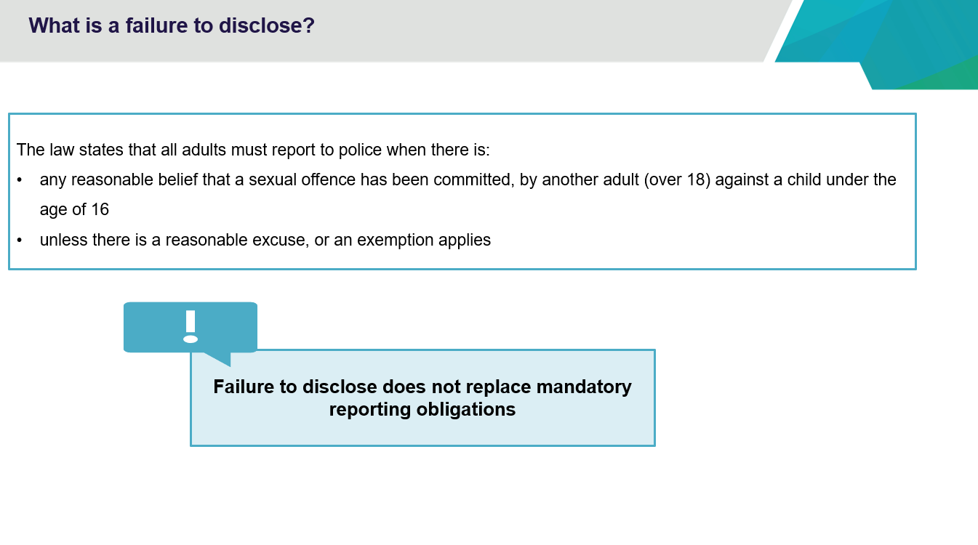

Slide 52 speaking notes.
Failure to disclose child sexual abuse offence requires adults to report to police a reasonable belief that a sexual offence has been committed against a child (unless they have a reasonable excuse for not doing so).
It establishes that reporting child sexual abuse is a community-wide responsibility.
The law states that all adults must report to police:
- any reasonable belief that a sexual offence has been committed.
- by another adult (over 18)
- against a child under the age of 16.
unless there is a reasonable excuse, or an exemption applies.
Maximum penalty is 3 years imprisonment.
Failure to disclose does not change mandatory reporting obligations.
What is a ‘reasonable belief’?
A ‘reasonable belief’ is not the same as having proof. A ‘reasonable belief’ is formed if a reasonable person in the same position would have formed the belief on the same grounds.
For example, a ‘reasonable belief’ might be formed when:
- a child states that they have been sexually abused
- a child states that they know someone who has been sexually abused (sometimes the child may be talking about themselves)
- someone who knows a child states that the child has been sexually abused.
- professional observations of the child’s behaviour or development leads a professional to form a belief that the child has been sexually abused
- signs of sexual abuse led to a belief that the child has been sexually abused.
A reasonable excuse includes:
- A fear for safety, either to the victim or another person as a result of the disclosure
- The information has already been disclosed to police (for example, because a mandatory report has been made to child protection)
- It does not include a concern for ‘perceived interests’, such as reputation, legal liability, or financial status.
- Other exemptions include:
  - the victim requests confidentiality (exemption does not apply if the victim is under 16 at the time of disclosing the abuse, or has an intellectual disability and is unable to make an informed decision about the disclosure)
  - the person is a child when they formed a reasonable belief.
  - the information would be privileged (for example, client legal privilege)
  - the information is in the public domain.
For further information, please see the Department of Justice and Community Safety’s Failure to disclose offence webpage.

Slide 53

